REEF OPERATIONS PLATFORM
Work Integrated Learning · Part 1 Documentation
INSY7315 · Information Systems 3E
Prepared for: Resource Energy Engineering Fuels (REEF)
Team Number | Group 3
Team Name | Codal Reef
Client | Resource Energy Engineering Fuels (REEF)

Group member | Student number
Bradley Rwafa (Group 1) | ST10458380
Tshepo Kau (Group 3) | ST10454055
Tayler Usmar (Group 2) | ST10445063
Joe Leo Van Niekerk (Group 3) | ST10445055
Tlamelo Mothupi | ST10460421


[

Contents
1. Introduction 7
2. Requirements 8
2.1 Functional Requirements 8
Maintenance and repairs 8
Stock control and ordering 8
Production and cost reporting 8
Downtime and performance 9
Workforce 9
Access and accounts 9
Assistant 9
Out of scope for Phase 1 9
2.2 User Roles 9
2.2.1 Definition of each role 10
2.2.2 Permission matrix 11
2.2.3 Mapping to REEF job titles 11
2.3 User Stories 12
2.3.1 Stories of the Worker 12
2.3.2 Stories of the Manager 13
2.3.3 Stories of the Owner-Administrator 14
2.4 User Experience Journey Map 15
2.5 Work Breakdown Structure 16
2.5.1 The three assessed milestones 17
2.5.2 Allocation of work across the team 17
2.5.3 Governance, cadence and the verification model 18
2.5.4 Standards applied to every package 19
2.5.5 The work breakdown structure 19
2.5.6 Sprint schedule 32
2.5.7 Critical path, float and the principal schedule risks 32
3. Non-Functional Requirements 33
Performance Efficiency 34
Compatibility and Interoperability 35
Interaction Capability 36
Reliability 36
Availability Measurement and Testing 37
Offline Availability and Data Synchronisation 39
Offline Worker Activities 39
Local Storage and Device Security 40
Synchronisation Behaviour 40
Synchronisation Statuses 41
Duplicate Prevention and Safe Retry Handling 41
Conflict Identification and Resolution 42
Stale Information 42
Lost, Stolen or Reassigned Devices 43
Cache Removal 43
Offline Testing 43
Offline Quality Requirements 44
Security 44
Authentication 45
Password Protection 45
Role-Based Access Control and Least Privilege 46
Session Management 46
Encryption in Transit 47
Secure Offline Storage 47
Audit Trails 48
Secure Application Logging 48
Secrets and API-Key Management 49
Account Removal and Access Revocation 50
Lost or Stolen Devices 50
Security Testing 50
Security Incident Response 51
Security Requirements Catalogue 52
Data Integrity and Accuracy 52
AI Governance and Compliance 53
Gemini’s Use 53
REEF AI Rollout Phases 53
Keeping the Gemini Integration Secure 54
Making Sure Output Is Accurate and Reviewed 54
Protecting Data Integrity 54
Accountability and Reporting 54
Handling Downtime and Failures 55
AI Governance Requirements 55
Maintainability 55
Flexibility and Scalability 56
Safety 56
Backup and Recoverability 56
Responsibilities Before and After the Team Hands Over the System 57
Recovery Testing 57
Privacy and Legal Compliance 58
Verification and Measurement 58
4. Analysis Artifacts 59
4.1 Domain Modelling 59
4.1.1 Purpose of each domain class 60
4.1.2 Concepts absent from the supplied model, and the requirements they defeat 61
4.2 Design Artifacts 62
4.2.1 Design decisions and the reasoning that supports them 64
4.2.2 Alignment with the data schema in Section 6 65
5. Implementation 65
Notation conventions applied throughout 66
5.1 Sequence Diagrams 67
5.1.1 SD-1 — Worker logs a maintenance event offline, then syncs on reconnect 67
5.1.2 SD-2 — Stock usage crosses the reorder threshold and raises a supplier order 68
5.1.3 SD-4 — Owner requests the automatically generated monthly report 69
5.2 State Diagrams 69
5.2.1 ST-2 — Queued log entry lifecycle 70
5.2.2 ST-1 — Supplier order lifecycle 71
5.2.3 ST-3 — Equipment component lifecycle 72
5.3 Traceability of Documented Flows 72
5.4 Deployment Plan 73
5.4.1 Purpose and Scope 73
5.4.2 Deployment Topology 73
5.4.3 Environment Strategy 74
5.4.4 Build and Release Pipeline 75
5.4.5 Database Migration Strategy 75
5.4.6 Configuration and Secrets Management 75
5.4.7 Constraints of the Zero-Cost Tier and Their Mitigations 76
5.4.8 Rollback Strategy 76
5.4.9 Post-Deployment Verification 76
6. Data Schema 77
6.1 Choice of Technology 77
6.1.1 Why Relational 77
6.1.2 Why Supabase 77
6.1.3 Alternatives Considered 78
A document store such as MongoDB was the main alternative and was rejected for the reasons above. It suits data that is naturally hierarchical and read as whole documents. REEF's data is neither. It is worth noting that the project brief only asks for JSON schemas if a document store is used, so choosing relational removes that requirement rather than avoiding it. 78
6.1.4 Scalability 78
6.2 Entity Relationship Diagram 78
6.2.1 Clients and Mines 80
6.2.2 Equipment and Maintenance 80
6.2.3 Stock and Procurement 81
6.2.4 Production, Cost and Downtime 81
6.2.5 Workforce and Identity 81
6.2.6 Constraints and Enumerated Types 81
7. Architecture Artifacts 83
7.1 Design Patterns 83
7.1.1 Introduction 83
7.1.2 Repository 83
7.1.3 Adapter 85
7.1.4 Singleton, Lazy Initialisation and Proxy 86
7.1.5 Guard 88
7.1.6 Trigger-Based Hooks 89
7.1.7 Facade 89
7.1.8 Conclusion 91
7.2 Architecture Patterns 91
7.2.1 Introduction 91
7.2.2 Three-Tier Architecture 92
7.2.3 Client-Server Architecture 93
7.2.4 RESTful API 93
7.2.5 Module Composition and Separation of Concerns 94
7.2.6 Repository Pattern 94
7.2.7 Offline-First (Store-and-Forward) 95
7.2.8 Role-Based Access Control 95
7.2.9 Adapter with Graceful Degradation 95
7.2.10 How the Patterns Operate Together 96
7.2.11 Alternatives Considered and Rejected 96
7.2.12 Suitability of the Architecture for REEF 97
7.2.13 Conclusion 97
7.2.14 Summary of the patterns applied, and the alternatives cross-checked 98
7.3 Cloud Architecture 100
7.3.1 The zones and the services deployed within them 102
7.3.2 Protocols governing the permitted flows 103
7.3.3 Technology decisions and their consequences 103
7.3.4 The direct client path in the Task 1 prototype, and its withdrawal 103
8. Security 104
8.1 Least Privilege and Row Level Security 104
8.2 Secure Defaults and the Prevention of Cross-Site Scripting 105
8.3 Network Security: the approach adopted 106
8.4 Boundary one: the public network and the application tier 108
8.5 Boundary two: the application tier and the data platform 109
8.6 Boundary three: the application tier and the third-party services 110
8.7 Monitoring, and the residual risk that remains 111
9. DevOps 112
9.1 Introduction 112
9.2 GitHub for Version Control 112
9.3 Branching Strategy 113
9.4 Development Workflow 113
9.5 Pull Requests and Code Review 114
9.7 Automated Testing within Continuous Integration 115
9.9 Dependency Installation 117
9.11 Automated Tests in the GitHub Actions Pipeline 117
9.12 Build Verification 118
9.13 Handling Failed Pipeline Checks 118
9.14 Successful Pipeline Execution 118
9.15 Merge into the Main Branch 119
9.16 Deployment 119
9.17 Security in the DevOps Process 120
9.18 Example of a REEF Feature Moving Through the Pipeline 120
9.19 Contribution to Rapid Deployment 121
9.20 Contribution to Application Quality 121
9.21 Continuous Integration and Continuous Deployment 122
9.22 Conclusion 122
10. Running Costs 124
10.1 Cost Model and Assumptions 124
10.4 Caveats — Why This Is an Initial Plan 126
11. Change Management 126
11.1 Why Change Management Looks Different for REEF 127
11.2 Adoption Strategy 127
11.3 Training Plan 127
11.4 Handover Plan 128
12. Appendices 128
12.1 Declaration of Authenticity 128
12.2 Prototype 134
References 141

1. Introduction
Author: Joe Leo Van Niekerk (ST10445055)
Resource Energy Engineering Fuels currently runs its coal washing plant operations on paper records, spreadsheets and verbal reporting. Equipment maintenance, stock consumption, production output, downtime and workforce information are captured in different places, by different people, in different formats, and very little of it is connected. The result is that questions REEF's management should be able to answer immediately, such as which site costs more to run per ton, whether a piece of equipment is due for service, or why a stock item ran out, currently require someone to manually gather information from several sources and calculate the answer by hand.
The REEF Operations Platform has been developed to replace this fragmented process with a single connected system. Rather than treating maintenance, stock control, production reporting and workforce management as separate concerns, the platform ties them together so that information captured in one area automatically informs the others. A repair logged against a piece of equipment reduces stock automatically, a stock item falling below its reorder point raises a purchase order for a manager to approve, and production, cost and downtime figures roll up into a report the owner can read without anyone assembling it by hand.
Three realities of REEF's operating environment shaped how the system was built. First, mine sites do not have reliable connectivity, so the mobile application used by workers is designed to keep working offline and to synchronise once a connection returns, rather than requiring a constant network connection to function. Second, REEF's information, employee records, financial figures and operational data, needs to be protected and made available only to the people authorised to see it, so access is controlled by role and enforced at the system level rather than only in the interface. Third, the platform has been built and will be hosted at effectively zero recurring cost, which is appropriate for REEF's current scale but is documented honestly, including where that choice introduces trade-offs such as slower response after a period of inactivity.
The sections that follow set out the requirements gathered from REEF's current way of working, the quality standards the system is held to, how the system was analysed and designed, how it behaves, how its data is structured, how it is architected and secured, and what it will cost to run. Together they describe not only what has been built for Part 1, but the reasoning behind each decision, so that REEF's management can see that the platform was designed around the way the business actually operates rather than around a generic template.

2. Requirements

2.1 Functional Requirements
Author: Tayler Usmar (ST10445063), Bradley Rwafa (ST10458380), Joe Leo Van Niekerk (ST10445055)
Functional requirements describe what the system has to do. This section sets out the REEF Operations Platform's requirements grouped by the business area they serve, drawn from the project brief and from what the team learned about how REEF currently works. Surveys, interviews, observations and questionnaires were answered and conducted on-site and recorded in support of further decisions.
Questionnaire results below:
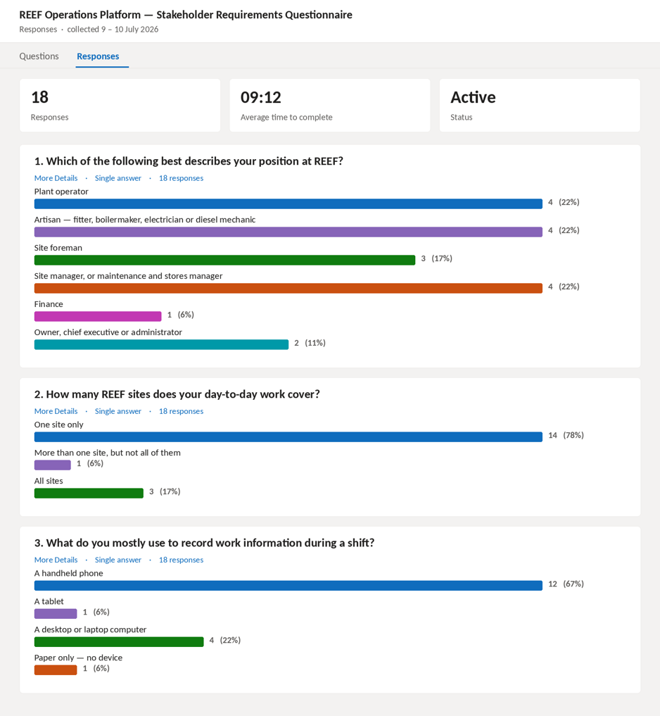
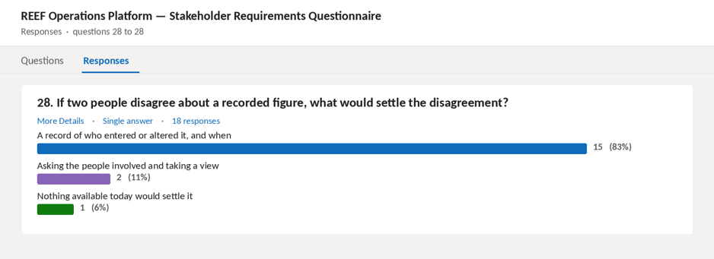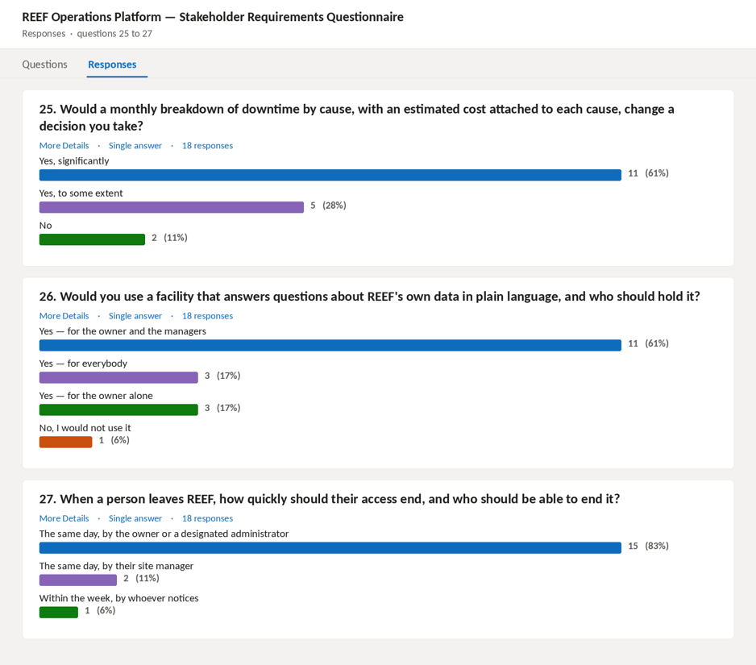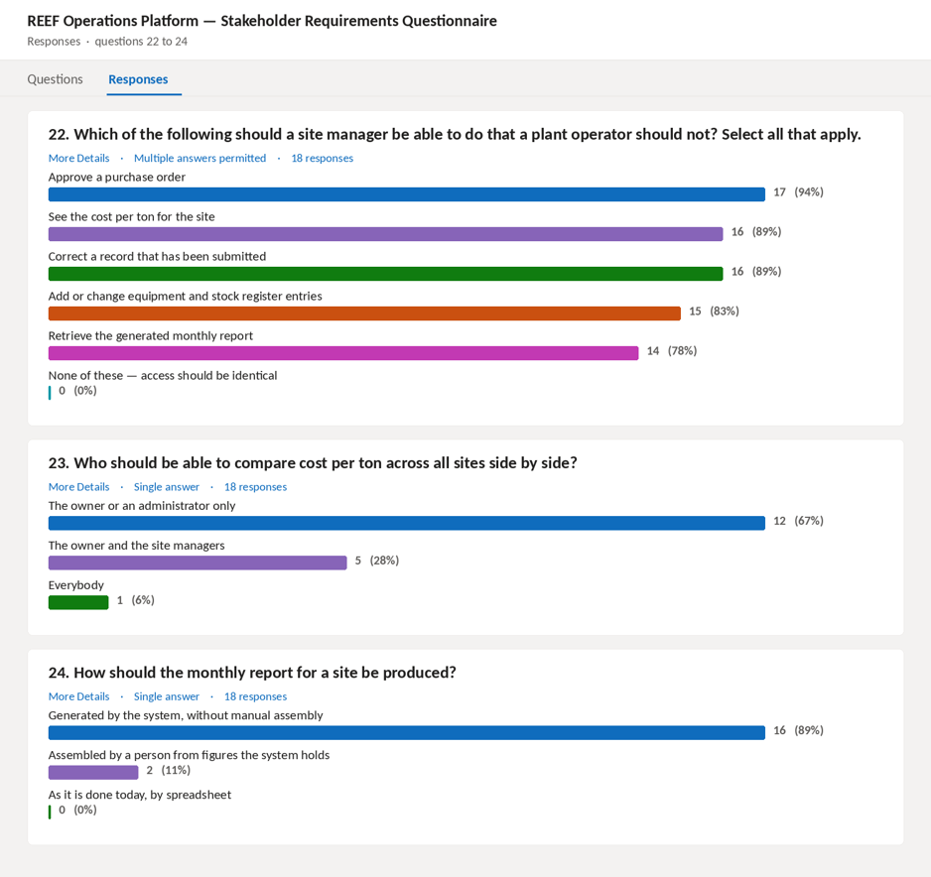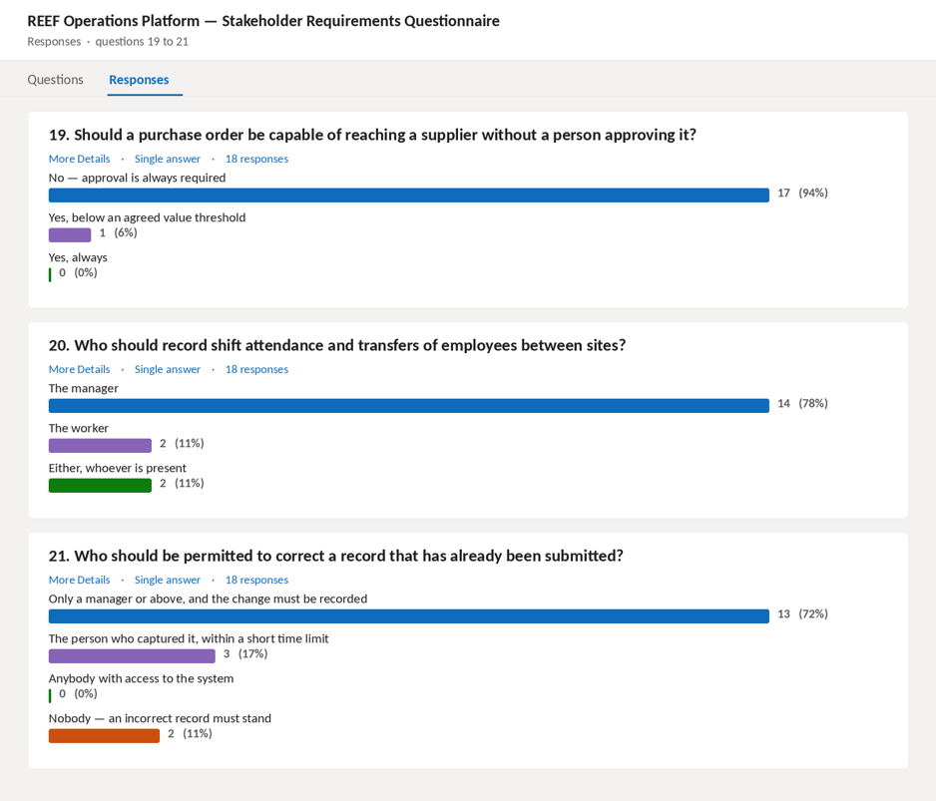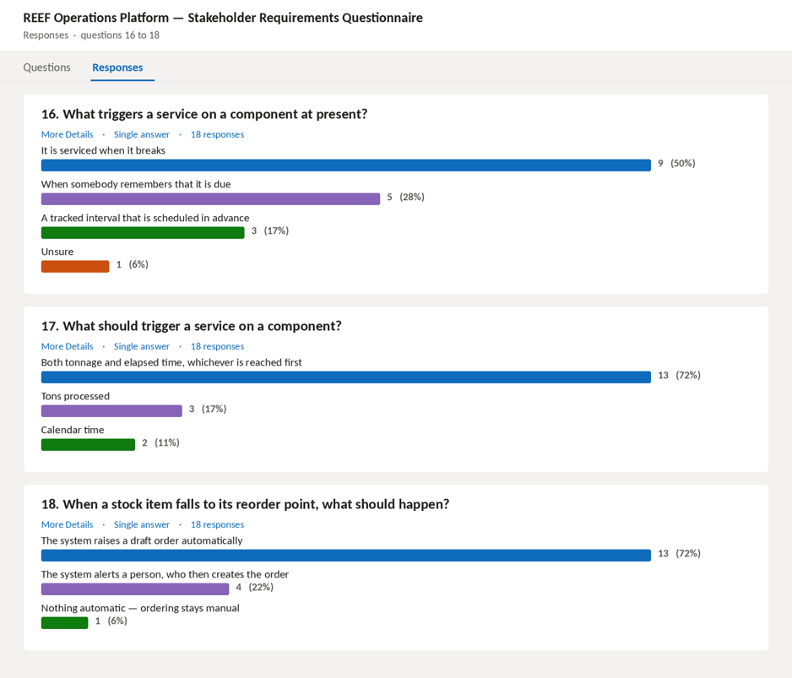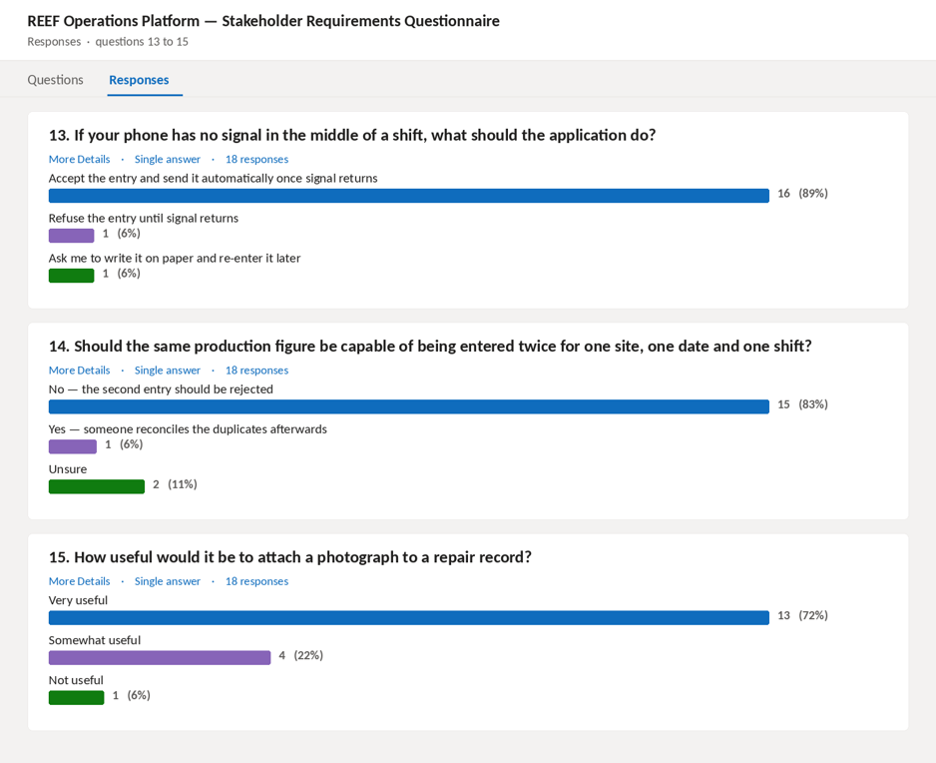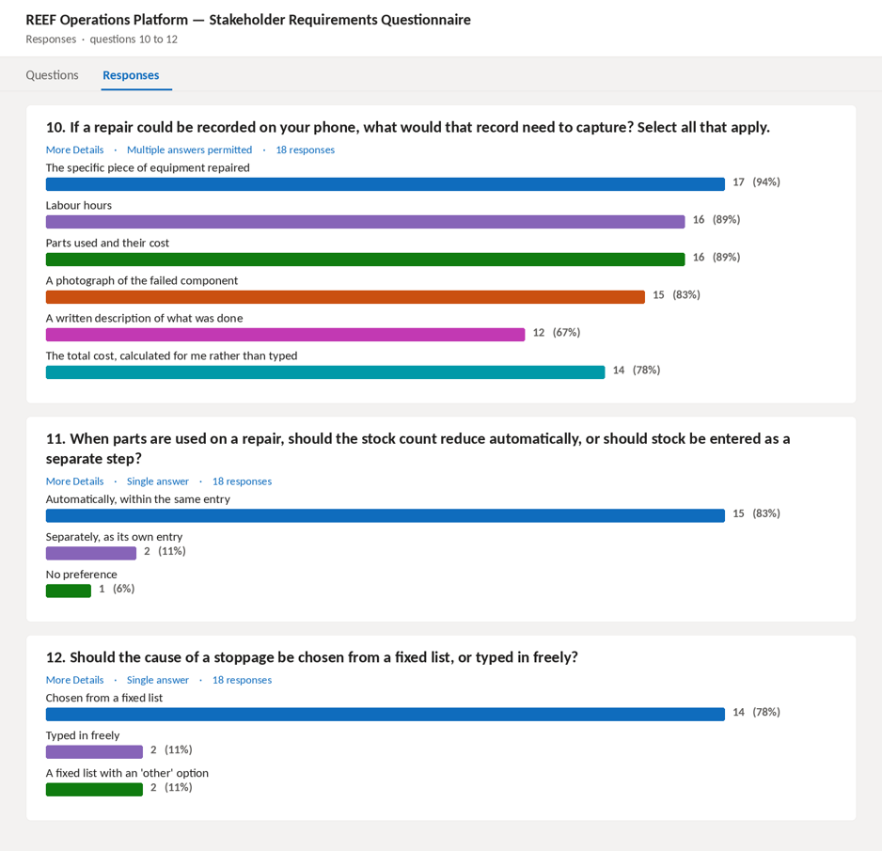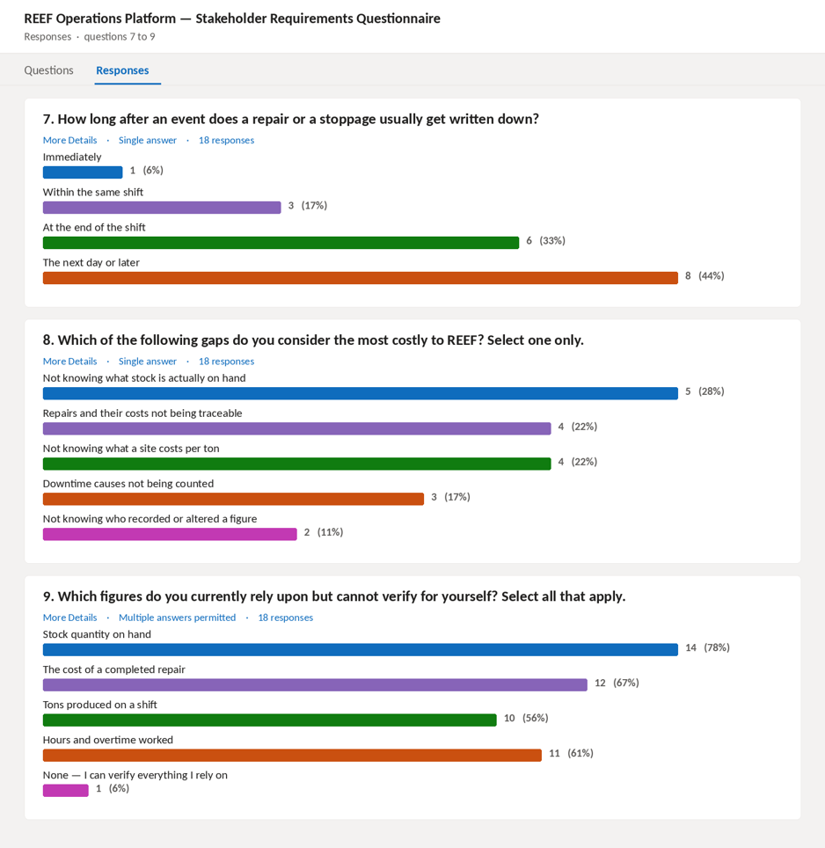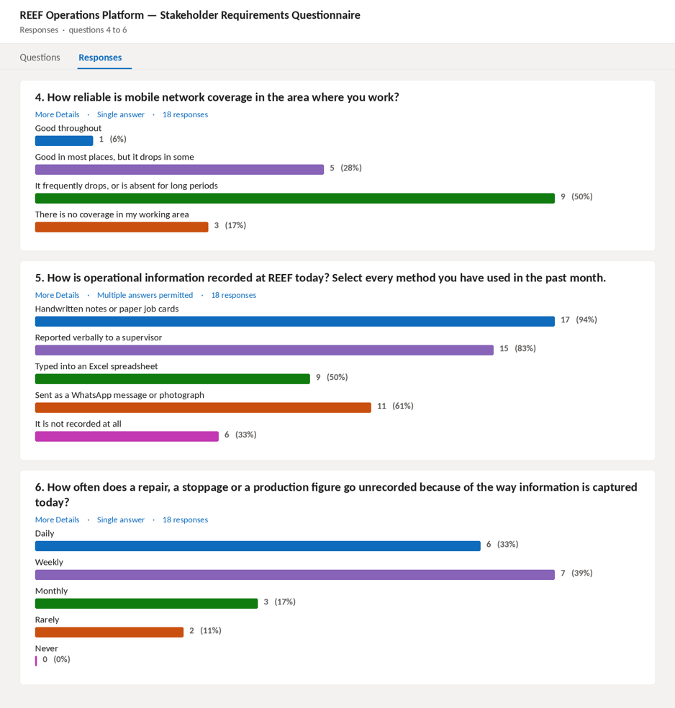
The important context is that REEF runs entirely on paper, spreadsheets and memory. There is no existing system to replace, which means these requirements describe the first one. Everything below exists because a specific thing currently either does not get recorded, or gets recorded somewhere nobody else can see it.

Maintenance and repairs
FR-1: The system will maintain a register of equipment for each mine site, recording install date, expected life in tons and hours, and service intervals.
FR-2: A worker will be able to record a repair against a specific piece of equipment, capturing what was done, labour hours, labour cost and parts cost.
FR-3: The system will record which stock items were consumed on a repair and in what quantity.
FR-4: The system shall calculate the total cost of each repair from its labour and parts costs.
FR-5: The system shall track accumulated wear against each piece of equipment, measured in tons processed and hours run.
FR-6: The system shall flag equipment as due for service when either its tonnage interval or its calendar interval is reached.
FR-7: A worker shall be able to attach photographs to a repair record.

Stock control and ordering
FR-8: The system shall maintain a live quantity on hand for every stock item.
FR-9: Consumption of stock during a repair shall reduce the recorded quantity automatically, without a separate stock entry.
FR-10: Each stock item shall carry a reorder point and a reorder quantity.
FR-11: When a stock item falls to or below its reorder point, the system shall raise a draft purchase order automatically.
FR-12: Where an open draft order already exists for the same supplier, the system shall add a line to that order rather than creating a second one.
FR-13: A purchase order shall require approval by a manager or owner before it can be sent to a supplier.
FR-14: Receiving a purchase order shall increase the recorded quantity of the items on it.

Production and cost reporting
FR-15: A worker shall be able to record daily production for a site, capturing tons produced, magnetite used and its cost, and overtime hours and cost.
FR-16: The system shall record fixed monthly costs per site by category, separately from variable costs.
FR-17: The system shall calculate cost per ton for a site over a chosen period, combining fixed and variable costs against tons produced.
FR-18: The system shall allow the owner to compare cost per ton across sites.
FR-19: The system shall generate a monthly report per site without anyone assembling it by hand.

Downtime and performance
FR-20: A worker shall be able to record a downtime event, capturing its duration, its cause, and the equipment involved where applicable.
FR-21: Causes shall be selected from a defined list rather than entered freely, so that downtime can be analysed by cause.
FR-22: The system shall report total downtime per site per month, broken down by cause, with an estimated cost.

Workforce
FR-23: The system shall maintain an employee register including position, shift, assigned site and hourly rate.
FR-24: The system shall record daily attendance per employee per shift, including hours worked and overtime.
FR-25: The system shall record transfers of employees between sites, preserving the history rather than overwriting the current site.
FR-26: The system shall record fuel issued, capturing litres, cost, the vehicle or equipment fuelled and the employee who drew it.

Access and accounts
FR-27: Users shall authenticate before reaching any operational data.
FR-28: The system shall support three levels of access: worker, manager, and owner or administrator.
FR-29: Workers shall be able to capture operational data but shall not see cross-site financial comparison.
FR-30: Access restrictions shall be enforced by the system itself, not only by hiding options in the interface.

Assistant
FR-31: The owner and managers shall be able to ask questions about their own operational data in plain language.
FR-32: The assistant shall answer only from recorded data and shall not produce figures that are not in the system.
FR-33: The assistant shall be limited to the same data the person asking is permitted to see.

Out of scope for Phase 1
Offline capture and background synchronisation, predictive maintenance based on accumulated wear history, and export of reports to PDF or spreadsheet are all specified but scheduled for Phase 2. They are documented here so that the requirement is recorded, not because they are delivered.

2.2 User Roles
Authors: Bradley Rwafa (ST10458380) and Joe Leo Van Niekerk (ST10445055)
The roles set out below were not derived from preference but from the access decisions that the functional requirements already oblige the system to make. Requirement FR-28 establishes three levels of access, FR-29 withholds cross-site financial comparison from the worker, and FR-30 requires that the restriction be enforced by the system as opposed to being concealed within the interface. A role, for the purposes of this document, is therefore understood as a named collection of permissions that is assigned to a person by virtue of the function that the person performs, which is the construction upon which role-based access control rests (ISO, 2022b; OWASP, 2025). A role so constructed is able to be tested, given that the permissions attaching to it are enumerable, whereas a role described only in prose proves to be an assertion that no verification is able to confirm.
Three roles prove to be sufficient for the operation as it presently stands, and they are the three that requirement FR-28 names: the Worker, the Manager and the Owner-Administrator. A fourth is deliberately excluded, namely a distinct financial role. REEF employs forty-two people across three active client sites, and the introduction of a separate finance role would create a permission set held by a single individual, which adds administrative weight without adding control in the manner in which a genuine separation of duty would. The permissions that the finance function requires are in any event the permissions the Manager role already carries, and Section 2.2.3 records the mapping between the system roles and REEF's job titles. Should REEF later separate that duty, the model is able to accommodate the addition without structural change, given that permissions are assigned to roles as opposed to being written into the code that enforces them.

2.2.1 Definition of each role
Role | Who holds it | Purpose of the role | Principal permissions
Worker | Plant operators, artisans and the site foreman, working at a client mine and, in the ordinary case, using a handset. | To record what actually occurred during a shift at the point at which it occurred, so that the operational record is produced as a by-product of the work rather than being reconstructed afterwards. | Record a repair, consume stock against that repair, capture daily production, log a downtime event, attach a photograph, and read the equipment register for the site to which the worker is assigned.
Manager | The individual accountable for one or more client sites. | To supervise the operational record for the sites within the remit of the manager, and to exercise the approval that stands between an automatically raised order and a commitment of REEF funds. | The whole of the Worker permission set for the assigned sites, together with approval of purchase orders, maintenance of the equipment and stock registers, sight of cost per ton for the assigned sites, and receipt of reorder and service notifications.
Owner-Administrator | The proprietor of REEF, together with any individual whom the proprietor designates as an administrator. | To see the whole of the operation at once, which is the deficiency that the platform exists to remedy, and to hold the authority to administer accounts. | Unrestricted read access across every site, cross-site comparison of cost per ton and of team performance, the generated monthly report, and the creation, amendment, suspension and deactivation of user accounts.
One property of the model warrants explicit statement. The Manager is not a superset of the Worker in an unqualified sense but only in respect of the sites to which the manager is assigned, and the Owner-Administrator alone holds authority that is unbounded by site. This distinction matters because REEF operates at mines belonging to separate clients, and the commercial position of one client is not a matter into which the staff of another are entitled to see. The scoping of a permission by site is therefore a confidentiality control as opposed to a convenience of navigation, and it is enforced in the manner in which every other restriction is enforced, namely upon the server and for each request.

2.2.2 Permission matrix
The matrix below states the position for each operation that the system exposes. It is reproduced here because a role definition expressed only in prose proves to be untestable, whereas a matrix of this form is able to be converted directly into the authorisation tests that the build will be obliged to satisfy.

Operation | Worker | Manager | Owner-Administrator
Record a repair, a production figure or a downtime event | Permitted, assigned site only | Permitted, assigned sites | Permitted
Consume stock against a repair | Permitted, assigned site only | Permitted, assigned sites | Permitted
Amend or correct a submitted record | Denied | Permitted, with the change recorded | Permitted, with the change recorded
Create or amend an equipment or stock register entry | Denied | Permitted, assigned sites | Permitted
Approve a purchase order | Denied | Permitted, assigned sites | Permitted
View cost per ton for a single site | Denied | Permitted, assigned sites | Permitted
Compare cost per ton or team performance across sites | Denied | Denied | Permitted
Retrieve the generated monthly report | Denied | Permitted, assigned sites | Permitted
Interrogate the assistant in plain language | Denied | Permitted, within the data the role may already see | Permitted, unrestricted
Create, suspend or deactivate a user account | Denied | Denied | Permitted
Read the audit trail | Denied | Denied | Permitted

The assistant occupies the final row of substance and is treated with deliberate caution. Requirement FR-33 confines the assistant to the data that the person posing the question is already permitted to see, with the consequence that the assistant is not able to become an indirect route by means of which a worker obtains a figure that the matrix withholds. This is an instance of the general principle that a new interface upon existing data inherits the access rules of that data as opposed to establishing rules of its own.

2.2.3 Mapping to REEF job titles
The three system roles above are access levels, not job titles, and the distinction has to be stated because the remainder of this document uses both vocabularies. Sections 10 and 11 describe REEF's actual job titles, namely site manager, finance and owner, while Sections 2.1, 7.2.8 and 8 describe the system roles those titles are assigned to. The mapping below is the bridge between the two, and it is recorded here so that a reader encountering the phrase site manager in Section 10 and the role name Manager in this section is not left to infer whether the same person is meant.

System role | REEF job title that holds it | What the mapping means in practice
Worker | Plant operators, artisans and the site foreman | Capture at the plant. The role is scoped to the single site at which the person works, and it holds no financial visibility of any kind, which is the restriction FR-29 imposes.
Manager | Site manager, and the finance function | Supervision of the operational record for the sites within the remit. Finance is a job title assigned to this role rather than a role of its own: the permissions the finance function needs, namely order approval, correction of a submitted record and sight of cost per ton, are exactly the permissions this role already carries, and creating a fourth role for a function held by one or two people would add administrative weight without adding control.
Owner-Administrator | Owner and chief executive, Dave Goddard, together with any designated administrator | The whole of the operation at once. This is the only role whose authority is unbounded by site, and the only one permitted to compare cost per ton across sites, which is the comparison FR-18 requires and FR-29 withholds from everyone else.

One consequence of the mapping deserves to be made explicit, since it is the point at which a reader is most likely to be misled. A person whose job title is site manager may hold either of the first two system roles depending upon what REEF asks of them: a site manager who only records what happens at their own plant holds the Worker role, whereas one who also approves orders and reviews cost for a group of plants holds the Manager role. The system assigns permissions to the role and the role to the person, so a change in responsibility is a change of assignment rather than a change of code.

2.3 User Stories
Authors: Bradley Rwafa (ST10458380) and Tayler Usmar (ST10445063)
The stories set out below are expressed in the conventional form, in which the role, the desired capability and the reason for the capability are each stated, upon the principle that a requirement which does not carry its own justification is not able to be prioritised in an informed manner (Cohn, 2004). Each story is accompanied by acceptance criteria, given that a story unaccompanied by a statement of the conditions under which it is to be regarded as satisfied is a description of an intention as opposed to a specification, and each is traced to the functional requirement from which it proceeds, which is the practice that bidirectional traceability requires (ISO, 2018).

2.3.1 Stories of the Worker

Ref | Story | Acceptance criteria | Traces to
US-01 | As a Worker, I want to record a repair against a specific piece of equipment at the moment it is completed, so that the cost and the cause are captured while they are still accurate in my memory. | The repair is attributable to one item of equipment; labour hours, labour cost and parts cost are captured; the total is computed by the system as opposed to being typed; the record is timestamped and attributed to the person who submitted it. | FR-2, FR-4
US-02 | As a Worker, I want the parts used on a repair to come off the stock count automatically, so that I am not obliged to remember a second, separate entry. | Recording consumption against a repair reduces the quantity on hand of each item consumed in the same transaction; no separate stock movement screen is required; the resulting quantity is never permitted to fall below zero without an explicit adjustment. | FR-3, FR-9
US-03 | As a Worker, I want to attach a photograph to a repair record, so that the condition of a failed component is evidenced without my having to describe it in words. | One or more images may be attached; the file type and the size are validated by the server and not only by the client; the image is retrievable against the repair record thereafter. | FR-7
US-04 | As a Worker, I want to record the tons produced on a shift at my site, so that the production figure for the site is complete without anyone assembling it afterwards. | One entry per site, per date and per shift is permitted, and a second attempt is rejected as a duplicate; magnetite consumed and its cost are captured alongside the tonnage. | FR-15
US-05 | As a Worker, I want to log a stoppage and select its cause from a list, so that the reason the site lost time is recorded consistently and is able to be counted later. | The cause is selected from a controlled list and is not free text; the duration is derived from the start and the end times as opposed to being entered; the equipment involved may be recorded where the stoppage is attributable to one. | FR-20, FR-21
US-06 | As a Worker, I want the application to continue accepting entries when the handset has no signal, so that a period spent in a poorly covered part of the site does not cost us the record. | Entries submitted without connectivity are retained on the device in encrypted form; each entry is replayed once connectivity returns; a replayed entry does not create a duplicate; the state of anything not yet transmitted is displayed. | Section 2.1, deferred to Phase 2; scheduled as package 5.10

2.3.2 Stories of the Manager
Ref | Story | Acceptance criteria | Traces to
US-07 | As a Manager, I want the system to raise a draft order when a stock item reaches its reorder point, so that we do not discover a shortage at the moment we need the material. | Crossing the reorder point raises a draft order; where an open draft already exists for the same supplier a line is added to it as opposed to a second order being created; the draft is not transmitted until it is approved. | FR-11, FR-12
US-08 | As a Manager, I want to approve an order before it reaches a supplier, so that no automatic process is able to commit REEF funds on its own. | An order remains in a pending state until approved; the identity of the approver and the time of approval are recorded; an unapproved order cannot be transmitted. | FR-13
US-09 | As a Manager, I want to see the cost per ton for the sites in my remit over a period I choose, so that I am able to act upon a deterioration during the month as opposed to after it. | Fixed and variable costs are combined and divided by the tons produced in the selected period; the period is selectable; the figure is derived at the time of the request and is not a stored value. | FR-17
US-10 | As a Manager, I want to be told when a component reaches its service interval, so that the intervention is planned as opposed to being occasioned by a failure. | Reaching either the tonnage interval or the calendar interval raises a notification; the notification names the component and the site; the alert persists until the service is recorded. | FR-6
US-11 | As a Manager, I want to correct a record that a worker submitted in error, so that the operational history is accurate without the original entry being erased and without the person who captured the figure being the person who revises it. | The correction is permitted to the Manager and denied to the Worker; the previous value, the new value, the identity of the editor and the time are all retained; nothing is destroyed by the correction. | FR-30
US-12 | As a Manager, I want to record who attended each shift, so that hours and overtime worked are accounted for accurately when payroll and planning are done. | Attendance is recorded per employee, per date and per shift, and a second entry for the same combination is rejected as a duplicate; ordinary and overtime hours are recorded separately; the record is attributable to the person who captured it. | FR-23, FR-24
US-13 | As a Manager, I want to record the transfer of an employee between sites and retain the history of where that person has worked, so that a movement does not erase the record that preceded it. | A transfer records the site departed, the site joined and the effective date; the prior assignment is retained rather than overwritten; the attendance already recorded against the previous site remains attached to it. | FR-25, FR-26

2.3.3 Stories of the Owner-Administrator
Ref | Story | Acceptance criteria | Traces to
US-14 | As the Owner, I want to compare cost per ton across every site on one screen, so that I am able to see which site is carrying the operation and which is consuming it. | Every active site appears; the period is common to all sites shown; a site lacking production data for the period is displayed as such as opposed to being omitted silently. | FR-18
US-15 | As the Owner, I want the monthly report to assemble itself, so that the reporting position of the business does not depend upon anyone finding the time to build a spreadsheet. | The report is generated per site for a closed month without manual intervention; it is retained and is reproducible; its figures reconcile with the underlying records. | FR-19
US-16 | As the Owner, I want to see the downtime for a month broken down by cause with a cost attached, so that the question of where the month went is answerable from evidence. | Total downtime is grouped by the controlled cause list; an estimated cost accompanies each grouping; the underlying events remain inspectable. | FR-22
US-17 | As the Owner, I want to ask a question of my own data in ordinary language, so that I am not obliged to know in advance which report would have contained the answer. | The answer is drawn only from recorded data; no figure absent from the system is produced; the answer is confined to the data the asker is permitted to see; a failure of the service returns a stated inability as opposed to an invention. | FR-31, FR-32, FR-33
US-18 | As the Administrator, I want to create, suspend and deactivate accounts, so that a person who leaves REEF ceases to hold access on the day of departure. | Accounts may be created, suspended and deactivated; a deactivated account is refused authentication; the record of what that account did is preserved and is not deleted with it. | FR-27, FR-28
US-19 | As the Administrator, I want to see who altered a record and when, so that a disputed figure is able to be traced to its origin. | Creation, amendment and deletion of core records are recorded with the identity of the actor and the time; the trail is readable to the Owner-Administrator alone; entries in the trail cannot be edited. | FR-30

Three observations close the section. Firstly, the stories are grouped by the system roles defined in Section 2.2 rather than by business area, on the reasoning that a story is a statement of what a particular role needs and is therefore verified against that role's row in the permission matrix. Secondly, US-06 and US-17 describe capability that the Task 1 prototype does not yet exhibit, namely deferred capture without connectivity and interrogation of the data in ordinary language. Section 2.1 records the first of these as specified but scheduled beyond the first phase, and both are scheduled within the work breakdown structure, at packages 5.10 and 5.7 respectively. They are retained here because the requirement each expresses is a genuine one whose omission would represent a loss of specification as opposed to a reduction of scope. Thirdly, the distinction between that which has been specified and that which has been delivered is stated wherever it arises, and Section 5 records the flows that the prototype does implement.

2.3.4 The elicitation techniques from which the stories were derived
Author: Bradley Rwafa (ST10458380)
The stories above did not arrive from a single source, and recording which technique produced which story matters, given that a story whose provenance is unrecorded is a story no one is able to challenge. Three techniques were employed, and they were chosen because each is able to reach a class of requirement that the other two are not. The requirements engineering standard treats elicitation as an activity that draws upon several sources in combination as opposed to one applied exhaustively, upon the reasoning that stakeholders are able to state what they want, are less able to state what they do, and are least able to state what they have stopped noticing (ISO, 2018).
The first is the questionnaire, constructed at package 1.5 of the work breakdown structure, distributed at 1.6 and analysed at 1.7. Its questions were framed so that the responses would support the role model as opposed to merely describing dissatisfaction, with the consequence that the permission matrix in Section 2.2.2 rests upon recorded answers rather than upon assumption. What a questionnaire is able to yield is breadth: it reaches every respondent at every site at the same moment and it produces answers that are able to be counted. What it is not able to yield is the thing a respondent does not think to mention, and it is upon that limitation that the remaining two techniques were selected.
The second is prototyping. The Task 1 prototype, documented in Section 7.1 with its source and recorded at package 1.3, was placed in front of REEF staff as a working artefact as opposed to a description of one. A prototype elicits by contradiction: a respondent who is unable to specify a reporting requirement in the abstract proves to be entirely able to say that a figure displayed upon a screen is the wrong figure, and the correction is itself the requirement. Two of the stories above exist because of this. US-09 acquired its selectable period because the fixed monthly figure first shown was rejected as too late to act upon, and US-07 acquired the consolidation of drafts against one supplier because the first arrangement raised a separate order for each item and was recognised at once as impractical.
The third is observation. Members of the team watched capture as it actually occurs at a plant rather than as it is described afterwards, and the difference proves to be substantial. The technique is the one that yields the requirement no respondent volunteers, given that a practice performed daily for years ceases to be visible to the person performing it. Three properties of the stories above derive from what was observed as opposed to what was said. Capture was seen to occur with one hand, at the machine and often in poor light, which is the origin of the constraint in US-01 that the total be computed by the system as opposed to typed. Signal was seen to be absent in parts of the plant for extended periods, which is the origin of US-06 and, through it, of the offline-first pattern at Section 7.2.7. And the cause of a stoppage was seen to be recorded in whatever words came first, which is the origin of the controlled list in US-05 and of the Downtime Reason class at Section 4.1.
Technique | What it is able to yield | What it is not able to yield | Stories and artefacts that rest upon it
Questionnaire | Breadth across every respondent at every site, and answers that are able to be counted rather than interpreted. | The requirement a respondent does not think to state, and any observation about how a task is actually performed. | The role model at 2.2.1; the permission matrix at 2.2.2; packages 1.5 to 1.7 of the work breakdown structure.
Prototyping | Correction. A respondent unable to specify a figure in the abstract is able to reject a wrong figure shown upon a screen, and the rejection is the requirement. | Anything absent from the prototype, since a respondent is not able to reject what was never displayed. | US-07, the consolidation of drafts against one supplier; US-09, the selectable period; package 1.3.
Observation | The practice that has ceased to be visible to the person performing it, and the physical conditions under which capture occurs. | Intent and preference. Observation records what is done and is silent upon why, which is what the questionnaire supplies. | US-01, the computed total; US-05, the controlled cause list; US-06, capture without connectivity; Section 7.2.7.
One consequence of employing the three in combination should be stated, since it bears upon how the stories are to be read. Where the three agree, the story is recorded without qualification. Where they disagree, the observation governs and the questionnaire response is retained as the stated preference, which is the position taken at US-05: respondents described the recording of a stoppage cause as adequate, and observation established that the same cause was being recorded in three different forms at three different sites. The requirement follows the observation, and the disagreement is recorded here as opposed to being resolved silently.

2.4 User Experience Journey Map

https://www.figma.com/design/jEn52aCx5fQx2x2XOujHdS/REEF-Mobile-App-%E2%80%94-Phase-2-Template?node-id=5-2&t=2zxeSLc0O7Ty8IFs-1

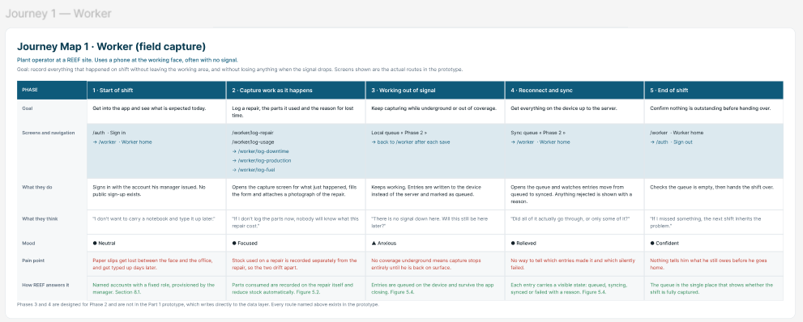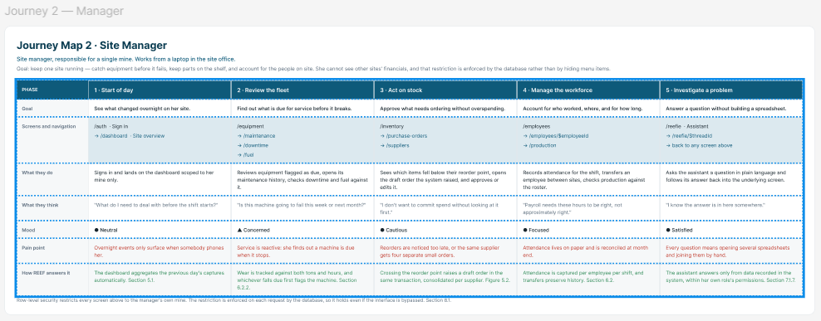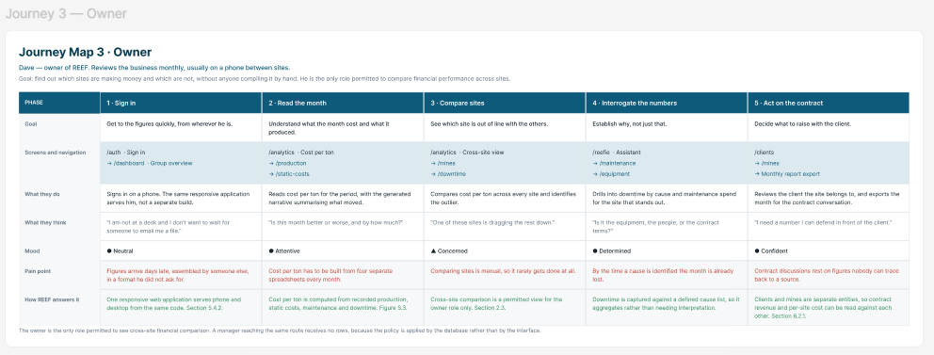

2.5 Work Breakdown Structure
Author: Bradley Rwafa (ST10458380)
The structure set out below decomposes the whole of the project, from the initial engagement with the client through to the handover of a working system and the obtaining of client sign-off, into deliverable-oriented components. That orientation is the one the governing practice standard prescribes, upon the reasoning that a decomposition organised around outcomes is able to be verified upon completion whereas one organised around activity is not (Project Management Institute, 2019). Decomposition has been carried to the level at which a package is able to be assigned to a named individual, reviewed by a named second individual and dated against the calendar, and no further, given that decomposition pursued beyond that point is able to produce administrative burden without improving control (ISO, 2020).
The project is assessed at three points as opposed to one, and the structure is organised around those three points rather than around a single delivery. Every package therefore belongs to a milestone, and the milestone it belongs to governs what it is permitted to depend upon. No package within Milestone A depends upon a working system, for the sufficient reason that on the seventeenth of August no working system exists; the packages that describe the delivered software are accordingly placed within Milestone C, where the system they describe is available to be described.
The dates recorded within the structure were not assigned by hand. Each package carries a duration and a set of predecessors, and the start and finish dates were computed by a forward pass across working days from the sixth of July, so that no date within the table is able to contradict the dependency that produced it. Saturdays and Sundays are excluded and no allowance is made for public holidays, which is stated here because it is a limitation of the method as opposed to a property of the plan.

2.5.1 The three assessed milestones
Three dates are fixed and are not the team's to move: the building document on the seventeenth of August, the code and repository on the twenty-eighth of September, and the final updated system and handover on the fifteenth of October. They are set out below together with the position the computed schedule takes against each, since a milestone recorded without the float remaining against it conveys an obligation but not a risk.
Milestone | What is delivered | Due | Position of the computed schedule against the date
Milestone A | The Part 1 building document: requirements, analysis and design, architecture, security and delivery practice. | Monday 17 August | Computed finish Monday 17 August. Thirty-one working days are used of the thirty-one available, so the float is nil. The date is governed by the delivery practice chain, packages 4.4 to 4.6, which is unable to begin until the cloud architecture at package 3.8 is settled.
Milestone B | The code and the repository: the working system with its pipeline, its tests and its technical documentation. | Monday 28 September | Computed finish Wednesday 23 September. Fifty-eight working days are used of the sixty-one available, so the float is three working days. The date is governed by the mobile client, its offline queue and the device build, packages 5.9, 5.10 and 6.7.
Milestone C | The final updated system and the handover: deployed, accepted by the client, documented against what was actually built, and signed off. | Thursday 15 October | Computed finish Thursday 15 October. Seventy-four working days are used of the seventy-four available, so the float is nil. The date is governed by the acceptance chain, packages 7.3 to 7.5, followed by the assembly of the updated document.

2.5.2 Allocation of work across the team
Packages were allocated against the declared strengths and development interests of the five members as opposed to being distributed evenly by volume, upon the reasoning that a work breakdown structure which ignores capability produces a schedule that is arithmetically balanced and practically unachievable. Two considerations qualified that principle. Firstly, every member owns packages within each of the three milestones as opposed to being confined to one, in order that the individual contribution of each is able to be evidenced across the whole project. Secondly, the pairings vary deliberately from package to package, so that each member reviews and is reviewed by every other member at some point, which distributes knowledge of the system rather than concentrating it.
Member | Declared strength and interest | Principal areas of accountability | Recurring collaborations
Bradley | Adaptable across unfamiliar material; oriented toward project management, cloud engineering and business analysis. | Coordination; questionnaire design and analysis; requirements consolidation; the role model; both class diagrams; cloud architecture; network security; the reporting module; user acceptance testing; handover and sign-off. | Works closely with Tshepo across analysis, the reporting module, running costs and acceptance; reviewed by Leo upon architecture and security.
Leo | Strong across technical work generally, with a stated preference for cybersecurity and for databases. Author of the existing prototype. | Client photographic evidence; questionnaire distribution; functional requirements; the data schema and its implementation; the stock module; security consolidation and verification; environment provisioning and deployment. | Reviews Tlamelo upon DevOps; reviewed by Tshepo upon the schema and security; pairs with Tayler across construction.
Tayler | Programming across the stack, and the strongest implementer on the team. | Sequence and state diagrams; the deployment plan; the API foundation and guard pipeline; the maintenance module; both client applications; interface testing; technical documentation. | Reviewed by Leo upon the diagrams and the mobile client; reviewed by Tlamelo upon the dashboard; reviewed by Tshepo upon software types.
Tshepo | Developing capability in cybersecurity and in analysis work. Holds an updated non-functional requirements section and an earlier security draft. | Non-functional requirements; the object diagram; the downtime module; unit testing; the vulnerabilities and threats section; the general navigation walkthrough; the privacy position. | Works closely with Bradley across analysis, reporting and acceptance; mentored by Leo through security verification.
Tlamelo | Developing capability across documentation, user experience and delivery practice. | DevOps, covering version control, branching and the pipeline; architecture patterns jointly with Tayler; the journey map and the role navigation walkthrough; the user centred design statement; the user guide and training material. | Reviewed by Leo upon all DevOps work; pairs with Tayler upon architecture and the dashboard; reviewed by Bradley upon user-facing documentation.

2.5.3 Governance, cadence and the verification model
The team operates a weekly sprint anchored upon two standing meetings. A Saturday review at fourteen hundred is the primary ceremony, at which each member presents the work completed within the sprint, and an optional follow-up at nineteen hundred on the same day is available to any member who has acted upon review comments and wishes the correction checked before the sprint closes. Attendance at the follow-up is arranged by prior request as opposed to by attendance on the hour. From the second sprint onward a Wednesday checkpoint is added, so that a package which has stalled is identified at the midpoint of the sprint as opposed to at the end of it.
Verification proceeds in three layers, and the layering is the reason the reviewer column exists within the structure. Firstly, the reviewer recorded against each package examines the work between the two members concerned. Secondly, the Saturday review exposes the work to the whole team, at which point a member who holds an idea bearing upon a section that is not their own is expected to raise it, given that a contribution withheld because of ownership is a contribution lost to the mark. Thirdly, the project coordinator reads the consolidated document against the brief and the departmental build standard in order to identify that which is missing as opposed to that which is merely imperfect.
Ceremony | When | Purpose | Output
Saturday review | Every Saturday, 14:00, from 11 July | Each member presents the sprint deliverable; the team reviews jointly and raises cross-section ideas. | Agreed correction list per package
Follow-up review | Same Saturday, 19:00, by prior request | Re-check of corrections made during the day, so that a member is not left uncertain until the following week. | Confirmation that a correction is on the right line
Wednesday checkpoint | Every Wednesday from 15 July | Midpoint progress check and early identification of a stalled package. | Reallocation or support where a package is at risk
In-person consolidation | Weekly from the second sprint, arranged around timetables | Review of the building document and the working system as a whole. | Updated building document and revised plan
Milestone close | 17 August, 23 September and 15 October | Verification of the submission against the task specification before it is handed in, as opposed to after. | Submitted deliverable and a recorded checklist

2.5.4 Standards applied to every package
Three conventions apply irrespective of the package. Firstly, each written section targets a minimum of five hundred words, upon the reasoning that the assessment rewards demonstrated understanding and that a section shorter than that is seldom able to demonstrate it. Secondly, every diagram is produced to the notation of the governing standard as opposed to an approximation of it, and every diagram is accompanied by prose that explains what it shows and why it is drawn as it is. Thirdly, a package is commenced once its predecessor has been reviewed, so that an error is corrected before it has been built upon.

2.5.5 The work breakdown structure
Durations are expressed in working days. The dates column records the computed start and finish of each package. Predecessors are stated by package code, the owner column records the member accountable for the deliverable, and the reviewer column records the member who verifies it before it enters the building document, which is the first of the three layers described above. The three dark bands mark the assessed milestones, and the package immediately above each subsequent band is the one that constitutes the submission.
Packages 5.7, 5.10 and 5.11 realise capability that Section 2.1 records as specified but scheduled beyond the first phase, namely the artificial intelligence adapter, offline capture with background synchronisation, and export of the report. They appear within the delivered increment here because the calendar to the fifteenth of October accommodates them without lengthening the critical path, and Section 2.5.7 records them as the first candidates for deferral should any construction package slip.

Code | Package and deliverable | Description | Dates | Days | Pred. | Owner | Reviewer | Resources
MILESTONE A · Part 1 building document · due Monday 17 August 2026
Phase 1 · Inception, client engagement and the proposal
1.1 | Project initiation | Confirmation of scope against the client brief and the departmental build standard; agreement of the sequential working method, the review layers and the meeting cadence. | 6 to 7 Jul | 2 | None | Bradley | All members | Client brief; build standard; repository
1.2 | Proposal presentation | Preparation and delivery of the proposal presentation to the department, covering the problem, the proposed system, the technology selection and the cost position. Delivered on the twenty-first of July. | 8 to 21 Jul | 10 | 1.1 | Bradley, Leo, Tayler | Tshepo, Tlamelo | Presentation template; client brief
1.3 | Task 1 prototype | Construction of the demonstrable prototype required by Task 1, built without a back-end tier and against the managed data platform directly, as the task permits. | 8 to 21 Jul | 10 | 1.1 | Leo | Tayler | Development environment; data platform
1.4 | Client photographic evidence | Obtain photographs of the business at its site, or any imagery the company is willing to provide, together with a record of the correspondence. The purpose is evidential: it demonstrates that contact occurred and that communication was effective, which a paragraph asserting the same is not able to do. | 8 to 10 Jul | 3 | 1.1 | Leo | Bradley | Client contact; correspondence log
1.5 | Questionnaire design | Construction of the user questionnaire, its questions framed so that the responses are able to support the requirements and the role model that follow. | 8 Jul | 1 | 1.1 | Bradley | Tshepo | Questionnaire instrument
1.6 | Questionnaire distribution | Distribution of the questionnaire to the respondent group and the collection of the returns. | 9 to 10 Jul | 2 | 1.5 | Leo | Bradley | Respondent list; client contact
1.7 | Questionnaire analysis | Analysis of the returned responses, from which the user roles are subsequently derived, so that the roles rest upon evidence as opposed to assumption. | 13 Jul | 1 | 1.6 | Bradley | Tshepo | Questionnaire results
Phase 2 · Requirements
2.1 | Functional requirements | Derivation of the functional requirements from the project brief, expressed in the detail that a contractual mining services operation demands, each carrying an identifier and a business justification. | 8 to 10 Jul | 3 | 1.1 | Leo | Bradley | Project brief; requirements register
2.2 | Non-functional requirements | Identification of the quality requirements, comprising those common to any system of this class and those arising from the mining specialisation, each carrying an identifier and a measurable target. | 8 to 10 Jul | 3 | 1.1 | Tshepo | Bradley | ISO/IEC 25010; existing draft
2.3 | Requirements consolidation | Reconciliation of the functional and non-functional sections into one uniform format, with the questionnaire evidence integrated, so that the requirements read as a single section by a single hand. | 13 to 14 Jul | 2 | 2.1, 2.2 | Bradley | Leo, Tshepo | Requirements register
2.4 | Roles, stories and permissions | Derivation of the role model from the questionnaire analysis, together with the permission matrix and the user stories, each traced to a requirement. | 15 to 17 Jul | 3 | 2.3, 1.7 | Bradley | Tshepo | Requirements register; questionnaire results
2.5 | Requirements sign-off | Presentation of the consolidated requirements to REEF and the obtaining of written acceptance, which the build standard requires as evidence. | 20 to 21 Jul | 2 | 2.4 | Bradley | Leo | Sign-off form; client contact
Phase 3 · Analysis and design
3.1 | Domain model | Analysis of all requirements, construction of the UML domain class diagram, and a description of the purpose of every class within it. | 15 to 17 Jul | 3 | 2.3 | Bradley | Tshepo | UML 2.5.1; modelling tool
3.2 | Design class diagram | Transformation of the domain model into the UML design class diagram, carrying types, keys, operations and access specifiers. | 20 to 22 Jul | 3 | 3.1 | Bradley | Tshepo | UML 2.5.1; language reference
3.3 | Sequence diagrams | UML sequence diagrams for the core business flows and for the authentication flow. Accuracy against the notation governs, hence dual authorship. | 23 to 28 Jul | 4 | 3.2 | Tayler | Leo | UML 2.5.1; modelling tool
3.4 | State diagrams | UML state diagrams for the queued entry, the supplier order and the equipment component. | 29 to 31 Jul | 3 | 3.3 | Tayler | Leo | UML 2.5.1; modelling tool
3.5 | Object diagram | Object diagram illustrating a representative instantiation of the design model at run time. | 23 to 24 Jul | 2 | 3.2 | Tshepo | Bradley | UML 2.5.1; modelling tool
3.6 | Data schema and ERD | Entity relationship diagram, physical schema, constraints and indexes, with an assessment of NoSQL technologies and a justification of the relational choice. Every diagram and schema is described and explained. | 23 to 28 Jul | 4 | 3.2 | Leo | Tshepo | PostgreSQL; dbdiagram.io
3.7 | Architecture patterns | Selection and justification of the architecture patterns, with alternatives considered and the grounds of their rejection. | 23 to 28 Jul | 4 | 3.2 | Tlamelo, Tayler | Bradley, Leo | ISO/IEC/IEEE 42010
3.8 | Cloud architecture | Zone definition, permitted traffic, protocols and technology decisions, with a diagram showing network segregation. | 29 to 31 Jul | 3 | 3.7 | Bradley | Leo | Provider docs; ISO/IEC 17789
3.9 | Deployment plan | Deployment topology, environment strategy, release pipeline, migration strategy, rollback and post-deployment verification. | 3 to 5 Aug | 3 | 3.8 | Tayler | Tlamelo | Provider documentation
3.10 | User experience journey map | Mapping of every screen and the navigation between them, per role. | 20 to 22 Jul | 3 | 2.4 | Tlamelo | Bradley | Prototype; prototyping tool
Phase 4 · Security, delivery practice and assembly of Part 1
4.1 | Security: network security | Trust boundaries, transport hardening, boundary controls and the residual risk register. | 3 to 5 Aug | 3 | 3.8 | Bradley | Leo | ISO/IEC 27033-1; NIST SP 800-207
4.2 | Security: vulnerabilities and threats | Common vulnerabilities and potential threats, with particular attention to cross-site scripting, each member contributing a technique drawn from the PRSE module written in their own hand. | 3 to 6 Aug | 4 | 3.8 | Tshepo | Leo, all members | PRSE material; OWASP Top 10
4.3 | Security consolidation | Integration of the individual contributions into one section, preserving variation in voice while securing a uniform structure. | 7 to 10 Aug | 2 | 4.1, 4.2 | Leo | Bradley | Contributed paragraphs
4.4 | DevOps: version control and branching | The manner in which the team addresses rapid deployment of a high-quality application, covering the repository, the branching strategy and the development flow. | 3 to 5 Aug | 3 | 3.8 | Tlamelo | Leo | GitHub; branching policy
4.5 | DevOps: pipeline and diagram | Description, with a diagram, of the continuous integration pipeline: the branching model, the movement of a change through it, and the point at which automated testing executes. | 6 to 10 Aug | 3 | 4.4 | Tlamelo | Leo | GitHub Actions; diagramming tool
4.6 | DevOps: collective contribution | Each member records their understanding of continuous integration and delivery for an application of this kind; the contributions are combined into fluid prose. | 11 to 12 Aug | 2 | 4.5 | Bradley | All members | Contributed paragraphs
4.7 | Running costs and change management | Cost model against the free tiers, the documented upgrade path, and the change control procedure. | 6 to 10 Aug | 3 | 3.9 | Bradley | Tshepo | Provider pricing; brief
4.8 | Documentation | Assembly of the building document, verification against the departmental build standard, correction of the defects identified, and submission. This package is Milestone A. | 13 to 17 Aug | 3 | 4.3, 4.6, 4.7, 3.4, 3.5, 3.6, 3.10, 2.5 | Bradley | All members | Report template; build standard
MILESTONE B · Code, repository and testing · due Monday 28 September 2026
Phase 5 · Construction of the system
5.1 | Database implementation | Physical schema realised as versioned migrations, with constraints, indexes and seed data sufficient to exercise every dashboard and report. | 18 to 20 Aug | 3 | 4.8 | Leo | Tshepo | PostgreSQL; migration tooling
5.2 | API foundation and guard pipeline | Project structure, the versioned REST contract, authentication, token issue and refresh, role authorisation, input validation, rate limiting and structured logging. | 21 to 27 Aug | 5 | 5.1 | Tayler | Leo | Development environment
5.3 | Module 1: maintenance and repairs | Equipment and component registers, repair capture with parts and labour cost, wear accrual and the service-due rule. | 28 Aug to 3 Sep | 5 | 5.2 | Tayler | Tlamelo | Development environment
5.4 | Module 2: stock and auto-ordering | Live stock levels, consumption against repairs, the reorder point calculation and the automatic raising of a draft purchase order for approval. | 28 Aug to 3 Sep | 5 | 5.2 | Leo | Tayler | Development environment
5.5 | Module 3: financial and analytical reporting | Static and variable cost capture, cost per ton, the magnetite to tonnage ratio and the generated monthly report. | 28 Aug to 1 Sep | 3 | 5.2 | Bradley | Tshepo | Development environment
5.6 | Module 4: performance and downtime | Downtime capture against a controlled cause list, the downtime dashboard, and comparison across sites and teams. | 28 Aug to 1 Sep | 3 | 5.2 | Tshepo | Bradley | Development environment
5.7 | Artificial intelligence adapter | Narrative generation behind an interface, with the deterministic template fallback and the recording of the prediction source. | 2 to 4 Sep | 3 | 5.5 | Bradley | Leo | Gemini free tier; test double
5.8 | Manager web dashboard | The React dashboard, its views, charting, search, filtering, sorting and pagination. | 4 to 11 Sep | 6 | 5.3 | Tayler | Tlamelo | Development environment
5.9 | Site mobile application | The React Native client implementing the two or three functions a site manager most needs while at the plant. | 4 to 11 Sep | 6 | 5.3 | Tayler | Leo | Development environment; test devices
5.10 | Offline queue and synchronisation | The encrypted local queue, deferred replay, duplicate suppression and the display of unsent state. | 14 to 17 Sep | 4 | 5.9 | Leo | Tayler | Development environment
5.11 | Notifications and export | In-application and electronic mail notification upon real events, and export of the report to PDF and spreadsheet. | 2 to 4 Sep | 3 | 5.5 | Tlamelo | Tshepo | Mail relay; export library
Phase 6 · Repository, pipeline and verification
6.1 | Environment provisioning | Provisioning of the development, staging and production environments, with configuration separated and secrets held outside the source. | 28 to 31 Aug | 2 | 5.2 | Leo | Tayler | Hosting accounts
6.2 | Pipeline into production | The build, test and deploy workflow operating against the production environment, including the scheduled keep-alive probe. | 1 to 2 Sep | 2 | 6.1 | Tlamelo | Leo | GitHub Actions
6.3 | Unit testing | Unit tests using a real framework over the business logic, namely the reorder calculation, the cost per ton calculation, wear accrual and downtime aggregation. | 2 to 7 Sep | 4 | 5.6 | Tshepo | Tayler | Test framework
6.4 | Interface testing and API collection | Automated tests over the core endpoints, and a submitted collection usable by a party outside the project. | 14 to 15 Sep | 2 | 5.8, 5.9 | Tayler | Leo | Postman; test framework
6.5 | Authorisation testing | Verification of the permission matrix, each denial being tested in addition to each permission. | 16 to 17 Sep | 2 | 6.4 | Leo | Tshepo | Test framework; permission matrix
6.6 | Security verification | Verification that each control described in the security section operates, with the evidence recorded. | 16 to 18 Sep | 3 | 6.4 | Leo | Tshepo | Scanning tools; evidence log
6.7 | Mobile build and device testing | Production of an installable package and testing upon a physical device, including the offline path. | 18 to 21 Sep | 2 | 5.10 | Tayler | Tlamelo | Build service; test devices
6.8 | Defect log and resolution | A recorded log of what broke and how it was fixed, maintained throughout verification as opposed to reconstructed after it. | 8 to 11 Sep | 4 | 6.3 | All members | Bradley | Issue tracker
6.9 | Repository readiness and technical documentation | README covering setup and the running of all three components, the API documentation, the deployment runbook, the branching evidence and the test plan with its results, all present in the repository. | 16 to 18 Sep | 3 | 6.4 | Tayler | Leo | Repository; test evidence
6.10 | Code and repository submission | Verification that the repository builds from a clean checkout, that the pipeline is green and that every artefact the task requires is present, followed by submission. This package is Milestone B. | 22 to 23 Sep | 2 | 6.5, 6.6, 6.7, 6.8, 6.9, 6.2, 5.4, 5.7, 5.11 | Bradley | All members | Repository; task specification
MILESTONE C · Final updated system and handover to REEF · due Thursday 15 October 2026
Phase 7 · Deployment into service and acceptance
7.1 | Production deployment and smoke test | Deployment of all three components and verification that each responds correctly in the production environment. | 22 Sep | 1 | 6.2, 6.6, 6.7 | Leo | Tayler, Bradley | Hosting accounts; smoke test script
7.2 | Live data load | Loading of the operational data REEF supplies, and reconciliation of the loaded figures against the source. | 23 to 24 Sep | 2 | 7.1 | Leo | Bradley | Client data; migration tooling
7.3 | Pilot operation alongside the existing process | A period during which REEF records a working week through the system while continuing the manual process, after which the two records are reconciled. Acceptance of a system that has not yet carried real operating data is acceptance of an assumption. | 25 Sep to 1 Oct | 5 | 7.2 | Bradley | Tshepo | Client staff; live operating data
7.4 | User acceptance testing with REEF | Structured walkthrough with the client against the agreed requirements, conducted upon the production system carrying real data, with acceptance or defects recorded. | 2 to 6 Oct | 3 | 7.3 | Bradley | Tshepo | Client contact; acceptance script
7.5 | Correction of accepted defects and regression | Correction of the defects raised at acceptance, followed by a regression pass over the tests already written, so that the handover carries the corrections as opposed to a promise of them. | 7 to 9 Oct | 3 | 7.4 | All members | Tayler | Defect log; test suites
Phase 8 · Documentation of the delivered system
8.1 | Software types and their operation | Detailed treatment of the classes of software employed within the system and the manner in which each operates within it. | 16 to 21 Sep | 4 | 6.4 | Tayler | Tshepo | Implementation; vendor documentation
8.2 | Navigation walkthrough, by role | Screenshot, an explanation of what is occurring upon the screen, and the reason the step is taken, beginning from a site manager reporting an operational event. | 23 to 25 Sep | 3 | 7.1 | Tlamelo | Tayler | Working system; questionnaire results
8.3 | Navigation walkthrough, general | The same treatment applied to traversal of the whole application, without reference to a particular role. | 28 to 29 Sep | 2 | 8.2 | Tshepo | Bradley | Working system
8.4 | User centred design statement | A concise statement of the manner in which the system pursued user centred design through consistency, visibility and accessibility. | 28 Sep | 1 | 8.2 | Tlamelo | Tayler | WCAG 2.2; working system
8.5 | User guide and training material | A short user guide written for the site manager and for the owner separately, in the language of the operation as opposed to that of the system. | 23 to 25 Sep | 3 | 7.1 | Bradley | Tshepo | Working system; screenshots
8.6 | Privacy position and terms | The statement of what personal information is held, why it is held and how it is protected, together with a terms of use note. | 21 to 22 Sep | 2 | 6.6 | Tayler | Bradley | POPIA; privacy note template
8.7 | Updated documentation assembly | Revision of the Part 1 document against what was actually built, incorporation of the sections describing the delivered system, and correction of every place at which the design and the implementation diverged. | 12 to 14 Oct | 3 | 8.1, 8.3, 8.4, 8.5, 8.6, 7.5 | Bradley | All members | Document; working system
Phase 9 · Handover to REEF and closure
9.1 | Client training session | A working session with REEF staff covering the site manager capture path and the owner reporting path. | 28 Sep | 1 | 8.5, 7.2 | Bradley | Tshepo | Working system; user guide
9.2 | Client sign-off | Written acceptance from REEF that the deliverable requested has been received, retained separately from the enhanced version submitted to the department. | 12 Oct | 1 | 9.1, 7.5 | Bradley | All members | Sign-off form
9.3 | Final submission and handover | Declarations of authenticity, repository link, transfer of every third-party account to REEF, and submission of the updated building document and the system. This package is Milestone C. | 15 Oct | 1 | 9.2, 8.7 | All Members | All members | Report; declarations; account inventory

2.5.6 Sprint schedule
The packages above fall across fifteen weekly sprints, each closing upon the Saturday review. The three assessed submissions fall within Sprints 7, 12 and 15 respectively. The proposal presentation, delivered on the twenty-first of July by Bradley, Leo and Tayler, and the Task 1 prototype brought to a demonstrable state by Leo over the same period, are recorded within the structure as packages 1.2 and 1.3 rather than as loose antecedents, since both are deliverables that the plan is accountable for.
Sprint | Working week | Review | Milestone to be demonstrated at the review
Sprint 1 | 6 to 10 July | Sat 11 Jul | Scope agreed against the brief; questionnaire designed and issued; functional and non-functional requirements drafted; client imagery requested
Sprint 2 | 13 to 17 July | Sat 18 Jul | Questionnaire analysed; requirements consolidated; role model, user stories and permission matrix complete; domain model complete
Sprint 3 | 20 to 24 July | Sat 25 Jul | Proposal presentation delivered and the Task 1 prototype demonstrated on 21 July; requirements signed off by REEF; design class diagram and journey map complete
Sprint 4 | 27 to 31 July | Sat 1 Aug | Sequence, state and object diagrams complete; entity relationship diagram and architecture patterns complete; cloud architecture documented
Sprint 5 | 3 to 7 August | Sat 8 Aug | Deployment plan complete; network security and the vulnerability section drafted; version control and branching written
Sprint 6 | 10 to 14 August | Sat 15 Aug | Security section consolidated; pipeline documentation and the collective contribution complete; running costs complete; Part 1 in final assembly
Sprint 7 | 17 to 21 August | Sat 22 Aug | MILESTONE A submitted on 17 August; database implementation begun against the design class diagram
Sprint 8 | 24 to 28 August | Sat 29 Aug | API foundation and guard pipeline complete; the four business modules begun; development and production environments provisioned
Sprint 9 | 31 August to 4 September | Sat 5 Sep | All four business modules complete; artificial intelligence adapter and the notification and export facility complete; pipeline into production working; unit testing under way
Sprint 10 | 7 to 11 September | Sat 12 Sep | Manager dashboard and site mobile application complete; defect log maintained against the unit test results
Sprint 11 | 14 to 18 September | Sat 19 Sep | Offline queue and synchronisation complete; interface, authorisation and security testing passed; repository readiness and technical documentation complete
Sprint 12 | 21 to 25 September | Sat 26 Sep | Mobile build and device testing complete; MILESTONE B submitted on 23 September; system deployed to production, live data loaded and the pilot commenced
Sprint 13 | 28 September to 2 October | Sat 3 Oct | Pilot week concluded and reconciled against the manual record; navigation walkthroughs and the user centred design statement complete; client training delivered; acceptance testing begun
Sprint 14 | 5 to 9 October | Sat 10 Oct | Acceptance testing concluded with REEF; defects raised at acceptance corrected and the regression pass complete
Sprint 15 | 12 to 15 October | Closure | Client sign-off obtained; updated documentation assembled against what was built; MILESTONE C submitted and the handover completed on 15 October

2.5.7 Critical path, float and the principal schedule risks
The forward pass identifies a single chain running the length of the project, through packages 1.1, 2.1, 2.3, 3.1, 3.2, 3.7, 3.8, 4.4, 4.5, 4.6, 4.8, 5.1, 5.2, 5.3, 5.9, 5.10, 6.7, 7.1, 7.2, 7.3, 7.4, 7.5, 8.7 and 9.3. The chain amounts to seventy-four working days, and the period from the sixth of July to the fifteenth of October affords seventy-four. The float upon it is therefore nil, and that is the single most important property of the plan: slippage upon any package named above translates directly into a late handover, because there exists no reserve from which the time might be recovered.
The position is not uniform across the three milestones, and stating it as though it were would misrepresent where the risk actually sits. Milestone A carries no float at all and is governed by the delivery practice chain rather than by the analysis, which is a result that is not obvious and which would have been missed had the dates been assigned by judgement. Milestone B carries three working days, which is the only genuine reserve anywhere in the plan and which exists because construction proceeds along four parallel module tracks rather than one. Milestone C returns to nil, because the acceptance sequence is inherently serial: the client cannot accept a system before the pilot has run, the defects raised at acceptance cannot be corrected before they are raised, and the updated document cannot describe a system whose corrections are still outstanding.
One consequence follows and should be stated plainly. The three days of float at Milestone B are the whole of the project's contingency, and they are consumed the moment construction slips. The Wednesday checkpoint exists precisely in order that such slippage is detected at the midpoint of a sprint as opposed to at its close, and the response recorded below is to reduce the delivered increment rather than to move a date that is not the team's to move.
Risk | Why it arises | Mitigation recorded within the plan
Nil float at Milestone A | Thirty-one working days are available between the sixth of July and the seventeenth of August, and the delivery practice chain consumes precisely thirty-one. | The chain is short and its packages are documentation rather than construction, so effort may be added to it at short notice. Packages 4.4 to 4.6 are owned by Tlamelo and reviewed by Leo, and Bradley is able to absorb the collective contribution at 4.6 if the sprint runs late.
Nil float at Milestone C | The acceptance sequence, packages 7.3 to 7.5, is serial by nature and cannot be compressed without removing either the pilot period or the opportunity to correct what acceptance reveals. | The pilot at 7.3 is the only package of the four that is able to be shortened without destroying the purpose of the sequence, and it is shortened from five working days to three in preference to any other response. Both alternatives, namely conducting acceptance upon a system that has carried no real data and handing over defects uncorrected, are worse.
Only three days of contingency exist in the whole plan | The float at Milestone B is the sole reserve, and construction is the phase most likely to consume it. | Should a construction package slip beyond three days, the recommended response is to defer packages 5.7, 5.10 and 5.11, in that order, to a documented roadmap. Only 5.10 sits upon the critical path, and deferring it also releases package 6.7, which is the pair that governs Milestone B.
The documentation of the delivered system sits inside Milestone C | Packages 8.1 to 8.6 describe software that does not exist before Milestone B, so none of them is able to be brought forward into the Part 1 submission. | Those packages are scheduled from the sixteenth of September onward, in parallel with verification rather than after it, so that the assembly at 8.7 receives finished sections rather than commissioning them. Only 8.7 itself falls in the final week.
Package 1.4 depends upon a third party | The client is obliged to supply or permit the imagery, and no internal effort is able to compel it. | The request is issued within the first sprint. The package is deliberately off the critical path, so that a refusal delays evidence but not delivery.
Packages 5.2, 5.8 and 5.9 rest principally upon one member | The API foundation, the dashboard and the mobile client are owned by the strongest implementer, and two of the three sit upon the critical path. | Leo and Tlamelo are named reviewers upon them and are therefore the members best placed to assume the work. Modules 5.4, 5.5 and 5.6 are deliberately owned by three different members in order to spread the construction load away from that member during the same sprints.

3. Non-Functional Requirements
Author: Tshepo Kau (ST10454055)
Functional and Non – Functional Requirements:
To fully understand how this platform will work and fulfil the requirements of REEF, we need to define the terms functional and non-functional requirements. According to GeeksforGeeks (2020), Functional requirements describe the services that a system should perform in order to satisfy business and user needs, compared to a non- functional requirement which basically describes the quality and standards of a system rather than the individual features by explaining factors such a performance, availability and reliability; functional requirements focus on what the system does such as processing data, user logins and reporting and notifications. REEF currently employs 42 active employees cross three active mining sites in Mpumalanga and does not have a central software system; information is currently recorded via paper slips, personal spreadsheets and verbal communication. The employees report site activities to the site managers who compile reports for the owner, this entire process limits the business’ ability to monitor maintenance, stock, production, downtime and costs while operations are taking place. This is where the proposed REEF Operations Platform comes in, by digitising the process using two primary interfaces. The worker interface will allow authorised employees to record equipment and materials used, completed repairs, production quantities and downtime. The manager interface will provide consolidated information about available stock, repairs, production and downtime via a dashboard, that way the management or finance personnel will review financial information and important reports before they are treated as final.
Because the platform will operate at mining sites, its non-functional requirements must consider factors like unreliable connectivity, offline operation, mobile-device use, data accuracy, security, reliability and ease of use. These requirements should be measurable, testable and aligned with both the implemented prototype and REEF’s confirmed operational needs.
The identification of the REEF Connected Platform’s non-functional requirements is guided by ISO/IES 25010:2023. This standard basically presents a product- quality model that consists of nine characteristics and related characteristics which is suitable for this project because the platform will be REEFs first central operations system. The model can be used to determine whether the prototype performs efficiently, protects business information, remains reliable and exchanges information consistently. The standard consists of nine characteristics which are as follows:
- Functional suitability
- Performance efficiency
- Compatibility
- Interaction capability
- Reliability
- Security
- Maintainability
- Flexibility
- Safety
These characteristics make the model more appropriate for modern software products that operate in complex and safety sensitive environments. This is relevant to REEF because it provides recognised quality categories against which the platforms requirements can be organised and checked for the completion of the platform. It can also help the project team by establishing objectives as well as defining the testing criteria and seeing if the platform is up to the standards of the business.
ISO/IES 25010:2023 standards also specify quality in use by assessing the practical outcomes and user experiences when the system operates within the intended context. Which is very crucial for REEF, as its evaluation should reflect real world operating environments used by working staff as well as the managerial staff rather than relying only on controlled testing scenarios. (ISO, 2023b)
Furthermore, the standards from 2008’s ISO/IEC 25012 provides a model for evaluating the structured data quality (ISO, 2008), which is important because the REEF Operations Platform will depend on accurate, complete and consistent information concerning equipment, inventory , production, downtime and finances.

Performance Efficiency
Performance efficiency is concerned with how effective a system performs and how efficiently it uses processing power, storage, memory, data and battery power. The platform will initially support REEF’s 42 employees across three active client mining sites. (ISO25000, n.d.) For REEF, the platform should process user requests within a certain period and remain responsive during normal and busy operating conditions. Screens that are used frequently should operate without unnecessary delays, for example when a worker submits operational information, the interface should respond promptly and confirm whether the information has been saved. Dashboards and reports that contain large amounts of historical information may require additional processing time, but the users should receive visible feedback and indication that its being processed.
REEF currently has 42 active employees operating across 3 client sites but not every employee is expected to us the platform simultaneously, workers will use the worker interface to record activities such as equipment usage, repairs, production, and downtime. While the site managers and other authorised management personnel will use the management interface to view operational information, inventory levels and reports
The system should also use memory, battery power and network data efficiently. Because REEF operates in the more rural areas of Mpumalanga, resource efficiency is important because the workers may use mobile devices for extended periods of time and some areas may not have appropriate amenities like charging facilities and good network coverage. Frequently used activities such as submitting production, repair, equipment usage and downtime records, should complete without unnecessary indicate whether a record has been saved locally, submitted to the server or placed in the offline synchronisation queue. Manager dashboards may process information from several modules and sites, but they should remain responsive while records are being submitted.
The final performance requirements must contain measurable targets which include:
- Maximum acceptable response time for common operations
- The number of users who may use the platform simultaneously
- The appropriate use of mobile data, battery power and device storage
- The amount of operating data that can be processed within a specified period
- The maximum time allowed for producing large reports

Compatibility and Interoperability
Compatibility describes the ability of the platform to operate correctly alongside other system as well as exchange information when required (Lenovo, 2021). Because the REEF Connected Platform has several connected areas such as maintenance , stock control, performance, downtime and finance reports, information exchanged between these modules must be accurate and consistent throughout. Not only the modules, but the system should be able to operate with the devices, browsers and operating systems approved by REEF. The business should identify all the mobile devices used by the workers and the computers/ browsers used by managers. Then compatibility testing should be completed by those environments . IBM defines the term interoperability as a standards-based approach which allows different information systems to exchange data in a way that limits manual convention (IBM, 2025). This is important if REEF later connects the platform to accounting systems , supplier systems or other business software. Any future integration must exchange data in a controlled and consistent manner while maintaining data integrity and security.
Inventory management research identifies integration capability and mobile accessibility as important qualities for systems used across different locations (Goroshkevych, 2023) but this requirement doesn’t mean that every possible external system must be supported immediately; REEF should identify which platforms require current or future compatibility.

Interaction Capability
Interaction capability replaces the term “usability” in ISO/IEC 25010:2023. It concerns whether intended users can understand, learn and operate a product successfully. (ISO, 2023). The REEF worker interface should be understandable to employees with different levels of technical experience which means that frequently performed tasks should require as few steps as reasonably possible. Buttons, labels and instructions should use clear language that is familiar to the intended users. The platform must also provide immediate confirmation after an action has been completed such as error messages should explain the problem and tell users what action they can take instead of displaying only technical codes. Important actions should include protection against avoidable user mistakes, which is one of the most important aspects of interaction design. (Appinio, n.d.).
The interface must also consider accessibility. The Web Content Accessibility Guidelines recommend that digital information should be perceivable, operable, understandable and robust (W3C, 2024). Therefore, the platform should provide:
Readable text and appropriate text sizes.
Sufficient contrast between text and backgrounds.
Consistent screen layouts and navigation.
Clearly labelled buttons and input fields.
Information that is not communicated through colour alone.
Understandable instructions and error messages.
The platform should be tested by actual intended users in realistic working conditions which will help determine whether workers and managers can complete their activities accurately and efficiently. ISO/IEC 25019:2023 supports evaluating software according to its specified context of use, making the working conditions at REEF relevant to the evaluation (ISO, 2023b).

Reliability
Reliability is the ability of a system to operate error free and stay available over a period. This relies on maintaining the correct performance during any software or hardware failures, as well as the system recovering from serious faults (Cannonito, 2025). The REEF Operations platform should operate consistently and preserve existing records when errors occur.
Availability is particularly important because the site managers will depend on the platform to require access to current maintenance, stock, production and downtime information during operating hours. The central platform should be able to be available every day as well as achieve a minimum uptime of 99.9% during each month. The uptime percentage target will allow about 7 hours and eighteen minutes of downtime during a 30-day month. Scheduled maintenance should preferably take place during periods of low activity and users should be informed before any planned interruptions whenever possible (SIOS Technology, 2025).
The responsible people who must receive system alerts. One potential failure in the REEF Operations Platform shouldn’t automatically cause the entire system to become unavailable, for example the failure of the artificial intelligence service shouldn’t stop site managers from recording equipment usage, maintenance, production or downtime. The existing information should remain protected when a failure occurs, meanwhile the serious errors should be recorded and reported to the proper authorities. REEF should implement consistent application logging across its modules because infrastructure logs from devices and databases may not provide enough information about activities that occur in the application. So, application logs can provide additional information for detecting things such as security events, debugging errors while establishing normal operating patterns and monitoring performance and identifying unusual occurrences. This logged information should follow a very consistent format in so the events from the maintenance, stock control and inventory, financial reporting and downtime modules can be compared as well as analysed together to create and maintain the goal of a connected system (OWASP, 2024).
Logging will also help administrators detect and investigate problems, but it should form part of a broader reliability strategy. Microsoft recommends considering reliability throughout the system-development lifecycle rather than only responding to problems after deployment (Microsoft, 2025b), meaning that the REEF Connected Platform should therefore combine application logging with failure isolation, monitoring, recovery procedures and regular reliability testing.

Availability Measurement and Testing
The availability requirements should be shown via measurable targets and evaluated using evidence collected from the operational platform. ISO/IEC 25040:2024 provides the current framework for planning and performing quality evaluations of software products, IT services and data , and it requires the evaluation process to define its purpose, identify the relevant quality requirements, conduct the evaluation, document the results and specify suitable procedures (ISO, 2024). However, the ISO/IEC 25023:2016 remains the current published standard by containing the quantitative measures for evaluating system and software quality so therefore it can continue to support the quantitative measurement of REEF Operations Platform’s reliability and availability (ISO, 2016).
Because the REEF Operations Platform uses cloud hosted services, ISO/IEC TS 250522:2024 may also provide supporting guidance. The technical specification defines quantitative quality measures for software-as-a-service (or SaaS) cloud services and can be used alongside the wider SQuaRE quality models
For the Operations Platform, availability should be measures by comparing the period during which the central service remains operational with the total period during which it is expected to be available. The platform should aim for at east 99% uptime during each calendar month which is usually calculated using this formula:
Availability (%) = (Total agreed service time − Unavailable service time) ÷ Total agreed service time × 100 (Saxena PMP, 2024)
So, for a 30-day month period which contains 720 hours, a 99% uptime target permits about 7 hours and 12 minutes of downtime. According to Microsoft (2024), availability and recovery targets should be defined according to the business requirements and refining them through continual workload monitoring and testing, which means the platform should use said automated monitoring to record:
- Service interruptions and when they start and end
- The total duration of unavailable service
- The module/component affected.
- Whether this interruption was planned or not
- If users could still be able to complete essential activities
- The cause of interruption where known
- The actions taken to restore the service
- And whether any information was lost or corrupted
Availability measurement should relate primarily to the central platform and its controlled services. Failures caused only by an individual user’s phone, laptop or local internet connection should be recorded separately. This distinction is important because the central platform may remain operational while a particular mining site temporarily loses connectivity.
A local connectivity interruption should nevertheless be evaluated because it affects the user’s practical ability to access the platform. During such an interruption, essential activities should remain available through offline functionality. Records entered offline should remain securely stored, display a pending status and synchronise when connectivity returns.
The Google Site Reliability Engineering guidance describes availability as the proportion of time during which a service is usable. It also explains that availability may be evaluated using the proportion of valid service requests that are completed successfully (Jones et al., 2017), so REEF should therefore monitor both central-platform uptime and the success rate of important activities such as:
- User authentication.
- Operational-record submission.
- Dashboard retrieval.
- Report generation.
- Offline-record synchronisation.
- Inventory updates.
- Retrieval of maintenance and downtime information.
Availability should not be evaluated only during normal operating conditions. Controlled failure testing should simulate situations such as:
- Temporary loss of network connectivity.
- Failure of the artificial-intelligence service.
- Interrupted uploads or synchronisation.
- Database connection failures.
- Unavailable reporting functions.
- Application or server restarts.
- Failure of a third-party cloud service.
- Recovery after an unsuccessful deployment.
Each test should define the component being tested, the failure being introduced, the expected platform behaviour and the conditions required for the test to pass. Testing should confirm that:
- Essential records remain protected.
- Accepted information is not lost or corrupted.
- Unaffected platform components remain available where possible.
- Users receive understandable status and error messages.
- Administrators receive alerts for serious failures.
- Offline records remain available for later synchronisation.
- The platform returns to normal operation after the failure is resolved.
- Retried operations do not create duplicate records.
NIST recommends testing contingency and recovery procedures to determine whether information systems can be restored effectively following a disruption (Swanson et al., 2010). The results of each availability and recovery test should therefore be documented. The record should include the test date, test conditions, expected result, actual result, recovery time, identified weaknesses, corrective action and outcome of subsequent retesting.
The combined use of ISO/IEC 25040:2024, ISO/IEC 25023:2016 and ISO/IEC TS 25052-2:2024 provides REEF with a current evaluation framework, established product-quality measures and additional cloud-service measurement guidance. These standards do not automatically establish that 99% is the correct target; the target must still be approved by REEF according to its operational needs.

Offline Availability and Data Synchronisation

Mining is a high-risk industry where equipment breakdowns and safety breaches not only affect worker wellbeing as well as operational continuity for example unstable connectivity, unlimited bandwidth and temporary network interruptions, and REEFs current paper-based processes can’t often meet current regulatory expectations or give managers real time insights to catch problems before they escalate (Alpha Software, n.d). Because mining sites also have poor bandwidth, unreliable connectivity or times where they have no network at all, the platforms core mobile functions need to keep working even with no internet connection. Android Developers (n.d.) describes an offline-first app as one able to carry out all or the essential parts, of its function without relying on a constant network connection by typically by holding data locally and syncing it with the central system once a connection is restored.
For REEF, offline availability is important because the site managers may have to record operational information in real time so requiring the site managers to wait for stable internet connection may lead to delayed submissions, incomplete records or reliance on handwritten notes which may be captured again which just reverts them back to the old and inefficient method used before. So the offline capability should therefore support operational continuity without weakening data integrity or security

Offline Worker Activities

The site manager facing interface must remain functional for core tasks even when the network connection temporarily drops, so offline functionality should cover the following:
- Accessing content that was downloaded in advance and approved for offline viewing.
- Logging which equipment was used during a shift.
- Logging equipment issues, upkeep and repair work.
- Entering data that’s relevant to production.
- Logging any downtime events with the stated reason.
- Jotting down notes so that management can review them later.
- Checking whether the records created on the device are still waiting to sync.
- Editing an unsynced record before it gets sent to the central system.
Features that rely on up-to-date central data are allowed to be unavailable offline, since they aren't essential in the moment and these features include generating company-wide reports, pulling in newly submitted data from other locations, adjusting user access rights, and viewing full financial reports. Whenever a feature can't be used because it needs fresh data from the central system, the app should make that clearly visible to the user.

Local Storage and Device Security
Records created offline must be stored securely on the authorised phone or laptop until synchronisation is completed. Offline information should not be stored indefinitely or in an easily readable file that can be accessed outside the application.
The local storage requirements should include the following:
- Offline records must be associated with the authenticated user and relevant mining site.
- Sensitive, cached information must be protected using security controls supported by the device and selected application framework.
- Passwords, API keys and complete authentication credentials must not be stored as readable text.
- Users must not be able to access another user’s offline records merely by opening the same device.
- The application should limit cached information to what is necessary for approved offline activities.
- Complete financial reports should not be stored offline unless REEF specifically approves this requirement and suitable protection is implemented.
- Offline records must include identifiers and timestamps so that their origin can be traced.
- Cached information should be removed when it is no longer operationally required, subject to synchronisation, retention and audit requirements.
Local caching is not a replacement for central backup. Until a record has successfully synchronised, the device may contain the only available copy. The application must therefore avoid deleting a pending record when it is closed, restarted or temporarily unable to connect.

Synchronisation Behaviour
Android Developers explains that an offline-first application must reconcile local and network information when connectivity returns. This process may use push-based synchronisation to upload local changes and is also useful for providing real life updates , pull-based synchronisation to retrieve central changes from the server or for example when users when custom reports ; or the process can use a combination of both approaches (Murtaza, 2025, Android Developers, 2026).
The REEF application should attempt to synchronise pending operational records as soon as a usable connection returns. The proposed 24-hour period should not cause the system to hold all records until the following day. Instead, 24 hours should represent the maximum acceptable period for which an operational record may remain pending, subject to confirmation by REEF.
If a record has remained pending for close to or longer than the approved period, the application should:
- Display a visible warning to the user.
- Continue retaining the local record.
- Attempt synchronisation again when technically appropriate.
- Allow the user to initiate a manual retry.
- Notify the responsible user or administrator if repeated synchronisation attempts fail.
- Avoid presenting the record to managers as centrally confirmed information.
The 24-hour requirement may not be suitable for critical equipment or safety-related information. REEF should identify whether certain information must be communicated through an alternative approved process when it cannot be synchronised within a shorter period.

Synchronisation Statuses

Every record created offline should display a clear synchronisation status. At minimum, the platform should support the following statuses:
Status | Meaning | Required platform behaviour
Pending | The record is stored locally but has not reached the central platform | Retain it securely and retry when connectivity returns
Synchronising | A transfer is currently in progress | Prevent unnecessary repeated submission
Synchronised | The central platform has confirmed successful receipt | Retain the central copy and apply the local-cache policy
Failed | The latest synchronisation attempt was unsuccessful | Preserve the record, display the reason where possible and permit retry
Review required | A conflict or validation problem requires authorised attention | Preserve both relevant values and prevent silent overwriting
Stale | Displayed information may no longer represent the current central record | Warn users before they rely on it
Statuses should be communicated using text or symbols and must not rely on colour alone. A success message must only be displayed after the platform has established whether the record was stored locally or confirmed by the central server. “Saved offline” and “synchronised successfully” should be presented as different outcomes.

Duplicate Prevention and Safe Retry Handling
Network interruptions can occur after a device sends a record but before it receives confirmation from the central server. If the application automatically resends the same operation, a duplicate may be created. The platform should therefore assign a unique identifier to each locally created record before its first synchronisation attempt.
When the device retries the operation, the central service should recognise the identifier and determine whether the record has already been accepted. Repeating the request should not create another production, downtime, maintenance or inventory entry.
Retry behaviour should:
- Use the same record identifier for repeated attempts.
- Avoid immediate and unlimited retries that consume battery power and network data.
- Increase the interval between repeated failed attempts where appropriate.
- Permit a user-initiated retry.
- Record repeated failures for diagnosis.
- Stop retrying automatically when a record requires correction or authorised review.
- Never remove the local record merely because a retry failed.

Conflict Identification and Resolution

A conflict can occur when a locally cached record and the central record are changed independently. For example, a worker may update an equipment record offline while a manager changes related information through the central platform.
The platform should define conflict rules according to the type and importance of the information. A universal “last change wins” rule may be unsuitable because a later timestamp does not necessarily identify the most accurate value.
Conflict handling should follow these principles:
- New operational events should normally be stored as separate traceable events rather than overwriting previous events.
- Changes to reference information, such as equipment details, should be compared against the latest central version.
- The platform should use record versions, timestamps and identifiers to detect competing changes.
- A conflict affecting important operational, financial or equipment information should be marked as requiring review.
- The original and proposed values should remain available to the authorised reviewer.
- The identity of the person resolving the conflict and the selected outcome should be recorded.
- The platform must not silently discard a worker’s submission.
REEF should determine whether site managers, administrators or another authorised role will resolve each category of conflict.

Stale Information
Information stored on a device may become outdated while the device is offline. The interface must not display cached information as though it has been confirmed recently by the central platform.
Cached records should therefore display:
- The date and time of the last successful synchronisation.
- An offline or stale-information warning.
- Whether the information is read-only or can be updated.
- Whether newer central information may exist.
- The site and user context to which the information belongs.
Stale-information warnings are especially important for equipment availability, maintenance status, inventory quantities and safety-related operational information. Users should be instructed to follow REEF’s approved communication and safety procedures when current information cannot be confirmed.

Lost, Stolen or Reassigned Devices
Offline storage increases the risk that operational or personal information could remain on a lost, stolen or reassigned phone or laptop. REEF should establish a procedure through which a missing device is reported promptly.
The response process should include:
- Disabling or revoking the affected account or session.
- Recording the date and circumstances of the report.
- Determining what information may have been cached.
- Attempting remote session invalidation where the technology permits it.
- Changing credentials where compromise is reasonably suspected.
- Investigating whether unauthorised access occurred.
- Removing REEF information before a device is reassigned, where possible.
- Reporting a personal-information security compromise through the applicable POPIA process where required.
The application should not depend entirely on remote deletion because the missing device may remain offline. Local authentication, limited caching and protected storage are therefore still required.

Cache Removal
After the central service confirms successful synchronisation, temporary local information should be handled according to an approved cache-retention policy. It should not be removed before successful receipt has been confirmed.
Where a local copy is no longer required, the application should securely remove it or retain only the minimum information necessary to show that synchronisation occurred. Audit and operational records required by REEF must remain in the central system according to the approved retention schedule.

Offline Testing
Offline functionality should be tested on the phones and laptops expected to be used by REEF. Testing should simulate realistic connectivity conditions rather than testing only a completely connected and completely disconnected state.
The test scenarios should include:
- Opening the application with no connection.
- Creating several operational records while offline.
- Closing and restarting the application before synchronisation.
- Restoring connectivity and confirming automatic synchronisation.
- Interrupting connectivity while synchronisation is in progress.
- Retrying a record after the server accepted it but before the device received confirmation.
- Creating conflicting changes on the device and central platform.
- Leaving a record pending beyond the approved maximum period.
- Attempting to access cached information using an unauthorised account.
- Confirming that successfully synchronised records are not duplicated.
- Confirming that failed records remain available.
- Checking that stale, pending, failed and synchronised statuses are displayed correctly.
Testing should record the expected result, actual result, device used, connectivity condition, number of records, synchronisation time, errors detected and corrective action taken.

Offline Quality Requirements
The following measurable requirements should be included in the verification catalogue:
ID | Requirement | Target | Verification
NFR-OFF-01 | Essential worker records must remain capturable during temporary connectivity loss | All approved offline activities available | Connectivity-interruption test
NFR-OFF-02 | An accepted offline record must not disappear after the application restarts | Zero lost test records | Restart and persistence test
NFR-OFF-03 | Pending records must synchronise when connectivity returns | All valid test records synchronised | Reconnection test
NFR-OFF-04 | Repeated submission must not create duplicate records | Zero duplicate records | Retry and identifier test
NFR-OFF-05 | Each offline record must display its current synchronisation status | Status displayed for every test record | Interface inspection
NFR-OFF-06 | Conflicting changes must not be silently overwritten | All test conflicts detected or resolved according to policy | Conflict test
NFR-OFF-07 | Records pending beyond the approved period must produce a warning | Warning displayed when threshold is exceeded | Time-threshold test
The 24-hour target, permitted offline activities, conflict owner and cache-retention period remain subject to confirmation by REEF.

Security
Security concerns the protection of the REEF Operations Platform and its information against unauthorised access, disclosure, modification, misuse, disruption or destruction. The platform will process employee, equipment, maintenance, inventory, production, downtime and financial information. A security failure could therefore affect confidentiality, data integrity, operational continuity and management decisions.
ISO/IEC 27001:2022 supports the establishment of information-security controls according to the risks, needs and operating environment of an organisation (ISO, 2022). The NIST Cybersecurity Framework 2.0 also organises cybersecurity outcomes into Govern, Identify, Protect, Detect, Respond and Recover (NIST, 2024). These sources support treating security as an ongoing organisational process rather than only a set of application features.

Authentication
Users must authenticate before accessing protected platform functions. Each user should have an individual account so that activities can be attributed to the person who performed them. Shared accounts should be avoided because they weaken accountability and make it difficult to investigate errors or unauthorised actions.
Authentication requirements should include:
- Each authorised user must have a unique account.
- Authentication must take place through a protected connection.
- Invalid login attempts must not reveal whether a particular account exists.
- Repeated unsuccessful attempts should be restricted or monitored.
- Default or temporary credentials must be changed according to the approved account process.
- Authentication failures and suspicious login activity should be logged.
- More protective authentication should be considered for administrators, owners and users accessing sensitive financial information.
- Password-reset processes must verify that the request belongs to the authorised account holder.
- Disabled accounts must no longer be able to access protected platform services.
OWASP recommends protecting login pages and subsequent authenticated activity using strong transport protection because an unprotected connection can expose credentials and session information (OWASP Foundation, n.d.d).

Password Protection
Passwords must never be stored as readable text. They should be processed using an approved adaptive password-hashing function provided by the selected development framework. Hashing is different from encryption: the platform should verify a submitted password without storing a copy that can simply be decrypted.
The platform should also:
- Permit sufficiently long passwords.
- Avoid silently shortening passwords.
- Prevent the use of known default credentials.
- Protect password-reset links or codes.
- Avoid placing passwords in application logs.
- Require credential changes when compromise is reasonably suspected.
- Restrict access to stored authentication information.
- Apply framework and security updates affecting password handling.
OWASP’s password-storage guidance should be followed when selecting and configuring the hashing method (OWASP Foundation, n.d.c).

Role-Based Access Control and Least Privilege
Authorisation determines what an authenticated user is permitted to see and do. Access should be based on the user’s organisational role and responsibilities. Authentication alone must not allow a worker to access management, administrative or financial functions.
The principle of least privilege holds that a system should only grant users or processes acting on their behalf the minimum level of access needed to carry out their assigned tasks and nothing more. Permissions should be enforced by the server or API and not only by hiding buttons in the interface and a user should not gain access to a restricted function by manually changing a URL, request or record identifier (NIST, 2024)

The proposed permission matrix is:
Activity | Worker | Site manager | Finance | Owner/Administrator
Submit operational records | Yes | Yes | No | Yes
View own submitted records | Yes | Yes | As approved | Yes
Review records for assigned site | Limited | Yes | Limited | Yes
View organisation-wide operational reports | No | As approved | Limited | Yes
Review complete financial information | No | As approved | Yes | Yes
Approve or verify financial output | No | As approved | Yes | Yes
Resolve synchronisation conflicts | No | As approved | No | Yes
Manage user accounts and roles | No | No | No | Yes
View technical security logs | No | No | No | Authorised administrator only
Configure AI integration | No | No | No | Authorised administrator only
This matrix is proposed and must be checked against the prototype and approved workflow. “Owner” and “administrator” should be separated if they are not performed by the same person.
OWASP recommends denying access by default, applying least privilege and validating permission on every request rather than assuming that an earlier interface check is sufficient (OWASP Foundation, n.d.b).

Session Management
After authentication, the platform uses a session or token to recognise the user. Session information must be protected because a stolen session may allow another person to act through the authenticated account.
Session requirements should include:
- Session tokens must be unpredictable and generated using approved framework functionality.
- Tokens must not contain exposed passwords or unnecessary confidential information.
- Sessions must be transmitted only over protected connections.
- The platform must invalidate the session when the user signs out.
- Sessions should expire after an approved period of inactivity.
- Privileged sessions may require shorter expiry periods.
- A user’s active sessions should be revoked when the account is disabled or compromise is suspected.
- Session tokens must not be written into ordinary application logs.
- A new secure session should be established after authentication or a relevant privilege change.
The selected timeout period must balance security with the practical conditions at mining sites. It should be confirmed through stakeholder and user testing rather than selected arbitrarily. OWASP notes that transport protection helps prevent interception of session identifiers but does not replace secure token generation, expiry and invalidation controls (OWASP Foundation, n.d.e).

Encryption in Transit
Information exchanged between phones, laptops, the API, database services and authorised third-party services must be protected while travelling across a network. All production endpoints should use HTTPS with a properly configured version of Transport Layer Security.
This protection should apply to:
- Login credentials.
- Session tokens and JSON Web Tokens.
- Worker submissions.
- Management reports.
- Financial information.
- Synchronisation requests.
- AI-service requests and responses.
- Administrative functions.
- File and image uploads.
OWASP recommends that REST services expose only HTTPS endpoints so that authentication details and transmitted data are protected against interception and unauthorised modification (OWASP Foundation, n.d.f).

Secure Offline Storage
Offline storage should contain only the information necessary for approved offline activities. Sensitive locally cached information must be protected using security features supported by the device and application framework.
The security design should:
- Associate offline data with an authenticated account.
- Prevent one user from opening another user’s pending records.
- Avoid storing complete credentials locally.
- Protect locally stored tokens.
- Limit the period for which sensitive information remains cached.
- Remove temporary data according to the approved cache policy.
- Avoid storing complete financial reports offline unless specifically approved.
- Retain unsynchronised records until central receipt is confirmed.
- Support access revocation and incident investigation after device loss.

Audit Trails
NIST (2023b) defines an audit trail as a succession of events that are captured within a computer system, these events could pertain to user actions, a specific application or an operating system. Auditing is the process of examining and assessing operational, managerial and technical controls.
So, in terms of REEF, the Operating Platform should record where relevant:
- The authenticated user.
- The date and time.
- The relevant site.
- The type of operation.
- The affected record identifier.
- Whether a record was created, changed, approved, rejected or removed.
- Previous and updated values for important, controlled changes.
- Failed authentication or authorisation attempts.
- Synchronisation failures and conflict resolutions.
- Administrative role or permission changes.
- AI processing requests and human review outcomes, without unnecessarily recording confidential prompt content.
Audit records should not be editable by ordinary users and access to these records should be limited to authorised administrators or investigators.

Secure Application Logging
Application logging is the systematic recording of events that occur while an application is operating, these events may include user actions, system changes, processing errors, synchronisation, low storage warnings, unexpected application restarts, database connection failure and repeated failed authentication attempts. These types of logs provide information that may not appear in any ordinary device, server or database logs. They can help administrators monitor the platform, investigate faults, identify unusual behaviour and understand any circumstances that surround an incident (SolarWinds, 2026) . For the REEF Operating Platform, logging should cover the maintenance, inventory, production, downtime, finance reports and the AI related components in a consistent way
Logs should not include:
- Readable passwords.
- Complete authentication tokens.
- API keys.
- Encryption keys.
- Unnecessary personal information.
- Complete financial reports.
- Full AI prompts or responses containing confidential information unless specifically justified and protected.
The reason being that logs can create a security and privacy risk if they contain confidential information, so where a user or record must be identified, the platform must record an internal identifier rather than duplicating the full personal/operational record. Any error messages must also provide enough information for investigations without revealing credentials, confidential data or any technical details that attackers could use for a cyber-attack.
Logs should use consistent timestamps, log levels, severity levels, component names, and event and user identifiers. Serious events should trigger alerts to the appropriate administrator.
Not only does logging support troubleshooting and performance monitoring, but it is crucial for security auditing because recorded events may expose possible unauthorised access, misuse of an account or repeated tries to access the access controls. OWASP provides specific guidance for constructing application logging mechanisms and using logs to detect and investigate security events (OWASP Foundation, n.d.a).

Secrets and API-Key Management
Database credentials, signing keys, AI-service keys and other technical secrets must not be embedded directly in publicly available source code, mobile application packages or browser code.
Secrets should be:
- Stored in protected server-side configuration or an approved secrets-management service.
- Accessible only to the components that require them.
- Excluded from source-code repositories.
- Rotated when compromise is suspected.
- Revoked when no longer required.
- Prevented from appearing in logs and error messages.
- Transmitted only through protected channels.
The mobile and web applications should send authorised requests to the REEF backend. The backend should then communicate with protected third-party services where appropriate. OWASP advises that secrets should not be transmitted in plaintext and should be managed throughout their creation, storage, use, rotation and removal (OWASP Foundation, n.d.g).

Account Removal and Access Revocation
Access revocation means pulling back permissions, credentials or system access that was previously assigned to a user, this includes things such as network resources, shared credentials and live session tokens. This process is not as simple as it sounds, as access exists in multiple layers and not just one place. Turning off someone's main account stops new logins, but an active session can remain valid until it naturally expires, OAuth tokens and API keys keep functioning until someone manually revokes them, and any app a user connected outside of SSO has its own separate credentials entirely. So true and complete revocation means addressing every one of these layers otherwise a "disabled" account can still leave a backdoor open which can lead to issues such as data theft or audit failures (siit, 2026).
The revocation process should identify:
- Who may request account removal.
- Who approves permission changes.
- How quickly access must be removed.
- How active sessions are invalidated.
- Whether the user possesses a device containing offline data.
- Whether records created by the user must remain for audit purposes.
- How the change is documented and verified.
Historical business records should not lose their attribution merely because the user account becomes inactive.

Lost or Stolen Devices
A lost device may contain cached operational data or an active session. Users should report missing devices immediately through an approved communication process.
The response should include:
- Recording the incident.
- Disabling or restricting the affected account where appropriate.
- Revoking active sessions and tokens.
- Determining what data may have been cached.
- Changing credentials or secrets where compromise is suspected.
- Assessing whether a POPIA security compromise may have occurred.
- Notifying authorised management and information-security personnel.
- Preserving relevant evidence and audit records.
- Correcting the weakness that contributed to the incident.
Remote deletion may be useful where supported but must not be the only protection because the device may remain disconnected.

Security Testing
Security controls should be tested before release and after significant changes. Testing should include:
- Valid and invalid authentication.
- Repeated failed login attempts.
- Password-reset procedures.
- Session expiry and logout.
- Access attempts by each role.
- Direct API requests to restricted functions.
- Attempts to access another site’s records.
- Lost or expired tokens.
- Offline-data access by an unauthorised account.
- File and input validation.
- Confirmation that logs do not contain prohibited information.
- Confirmation that the client does not expose API keys.
- Dependency and configuration review.
- Audit-trail creation and protection.
Testing must be performed only against authorised systems and environments. Results should record the control tested, expected result, actual result, risk severity, corrective action and retest outcome.

Security Incident Response
A security incident may include unauthorised access, exposed credentials, suspicious activity, lost devices, altered information or disclosure of personal information. REEF should establish a response process aligned with the NIST Cybersecurity Framework functions of Detect, Respond and Recover (NIST, 2024).
The process should include:
- Identifying and recording the event.
- Determining its severity and affected information.
- Containing the incident.
- Revoking compromised access.
- Preserving logs and evidence.
- Correcting affected records where authorised.
- Restoring secure service.
- Assessing legal and POPIA notification duties.
- Informing appropriate stakeholders.
- Reviewing the cause.
- Implementing corrective controls.
- Testing the corrections.

Security Requirements Catalogue
ID | Requirement | Target | Verification
NFR-SEC-01 | Protected functions require authentication | No unauthenticated access in testing | Authentication test
NFR-SEC-02 | Server-side permissions must enforce approved roles | No unauthorised role access | Authorisation and API test
NFR-SEC-03 | Passwords must not be stored as readable text | Zero readable passwords | Configuration and storage inspection
NFR-SEC-04 | Production data must be protected in transit | HTTPS used for all production endpoints | Transport configuration test
NFR-SEC-05 | Logout and account revocation must invalidate access | Revoked sessions rejected | Session test
NFR-SEC-06 | Client applications must not expose service API keys | Zero exposed secrets | Build and source inspection
NFR-SEC-07 | Important actions must be traceable | Audit record created for every selected test action | Audit test
NFR-SEC-08 | Logs must exclude prohibited confidential values | Zero prohibited values in test logs | Log inspection
NFR-SEC-09 | Lost-device incidents must follow an approved response process | Every simulated incident documented and handled | Incident exercise

Data Integrity and Accuracy
The information stored in the REEF platform must remain accurate, complete and consistent. Incorrect information in one area could affect several connected processes. For example, an incorrect stock record could affect current stock levels, ordering decisions, operational planning and financial reporting.
The platform should validate information before accepting it. Validation should prevent:
- Missing compulsory values.
- Invalid or impossible dates.
- Duplicate records.
- Incorrect data formats.
- Negative values where they are not permitted.
- Records that do not relate to a recognised site or piece of equipment.
Records should use unique identifiers and reliable timestamps so that activities can be traced. Relationships between sites, equipment, maintenance information, stock items, production records and users should remain consistent.
If an operation cannot be completed successfully, the system should not leave a partially updated record that could mislead users. These controls support the data-quality model presented by ISO/IEC 25012 (ISO, 2008).

AI Governance and Compliance

The owner has approved the inclusion of an artificial intelligence component called the REEF Insights Assistant which will use the Google Gemini API to convert the operational data into understandable reports as well as answer authorised questions about REEF’s own data
AI Governance touches on the policies, responsibilities and controls that are used to make sure that the artificial intelligence systems are used safely, ethically and transparently (Mucci and Stryker, 2024). Even though the use of Gemini has been approved, its operation must still act in accordance with REEFs data quality, security and human review requirements. REEF should document what Gemini is approved to be used for, what kinds of data can be shared and who is allowed to use the features. Details of the approval process which includes when it was granted, who signed off on it and any agreed upon limits should be kept on file as a part of the entire project’s records.
ISO/IEC 42001:2023 lays out a framework for managing AI systems responsibly and the NIST AI Risk Management Framework recommends governing, mapping, measuring, and managing AI risk at every stage of a system's life (ISO, 2023c; NIST, 2023)

Gemini’s Use
Geminis use is limited strictly to functions that REEF has signed off on such as:
- Summarising maintenance, production or downtime data.
- Spotting trends in approved operational records.
- Helping managers make sense of reports.
- Drafting any explanations of operational trends.
- Supporting financial analysis where management or finance has approved it.
- Ensuring that the information is easy to read and understand

REEF AI Rollout Phases

The REEF proposal breaks down the platforms AI and analytics work into stages:
- Phase One: the groundwork stage where the core data model, worker logging, photo storage, basic downtime tracking and the owners dashboard are built and this stage must come first because the AI cannot produce anything useful without a solid foundation or operational data to work from.
- Phase Two: automated stock reordering which is based on production rates and cost breakdowns along with downtime cause analytics.
- Phase Three: the predictive maintenance stage, by using patterns between component wear and past maintenance events to predict issues and this phase could also bring automated monthly reports and comparisons across teams or sites.
However, predictive maintenance shouldn't be marketed as something that's ready to go unless it's genuinely built into the working prototype. It needs a solid history of maintenance and wear data for each component before its predictions mean anything so that means until there's enough data and the method's been properly tested, the existing maintenance rules and human judgement should still take priority.

Keeping the Gemini Integration Secure
Access to Gemini should go through a secure, server-side connection. Under no circumstances should the Gemini API key or other credentials be built into the mobile app or dashboard, placed in client-side code, pushed to a public repository, or shown to users. Credentials need to live in a secured configuration or secrets manager, accessible only to the authorised backend component.
All communication between REEF and Gemini must be encrypted. Requests should be authenticated, tracked, and restricted to authorised users performing approved functions. It's fine for logs to note that an AI request was made, but they shouldn't unnecessarily capture the actual confidential prompts, responses, credentials, or personal data involved.

Making Sure Output Is Accurate and Reviewed
A rising phenomenon is AI “hallucinations” , which is when a system generates something that sounds convincing but is actually wrong or not backed up by actual data, and studies show that AI generated content can go wrong in various ways so outputs need to be double checked before they inform anything important. (Sun et al., 2024).
Any AI-generated summary or recommendation that could affect financial, maintenance, production, or safety decisions must be checked by someone with the proper authority and should be clearly flagged as AI generated. Gemini itself must never be allowed to approve spending, change verified records, sign off on maintenance work, make employment-related calls, or determine whether an activity is safe.

Protecting Data Integrity
Content generated by Gemini must never automatically overwrite verified operational or financial data. The original information entered by workers and authorised users needs to always stay accessible and traceable. If something Gemini produces contradicts the original data, the system should hold onto the original record and flag the AI-generated version for review instead.
Whenever an authorised person accepts an AI-assisted change, that action needs to go into the audit trail and that includes who reviewed it, when, what data was affected, and the fact that AI was involved in producing it.

Accountability and Reporting
Even when Gemini assists with a decision, responsibility ultimately rests with REEF and its authorised staff the AI itself can't be held accountable for business, financial, or safety outcomes so REEF needs to define:
- Who signs off on Gemini's functions within the platform
- Who's permitted to send data to Gemini for processing
- Who reviews financial or management-related outputs
- Who investigates inaccurate or inappropriate AI responses
- Who can modify Gemini's configuration
- Who has the authority to pause or disable an AI function
Users should have a way to flag outputs that seem wrong, unsafe, biased, or irrelevant and any issues reported should be logged, investigated, and used to refine prompts, validation checks, user guidance, or access controls.

Handling Downtime and Failures
Gemini needs to operate independently of the platform's core record keeping functions. If Gemini goes down, is delayed, or is otherwise unavailable, that should never stop operational records from being created, viewed, stored, or synced. If Gemini isn't available, the system should hold onto the original request where relevant, let the user know AI assistance is temporarily down, and keep letting them carry on with non-AI tasks. The platform also shouldn't keep resubmitting the same request in a way that duplicates processing or racks up unnecessary costs.

AI Governance Requirements
Gemini's use must meet the following conditions:
- Only approved purposes are allowed
- Only necessary data can be submitted
- Credentials must be kept secure on the server side
- Access must be limited to authorised users
- AI-generated content must be clearly labelled
- Significant outputs must go through human review
- AI output can't automatically override verified records
- AI activity must remain traceable
- Users must have a way to report bad outputs
- Gemini can't make autonomous calls on safety, employment, or finance
- Core platform functions must keep running if Gemini fails
- The integration must be reassessed if the provider, model, setup, or data terms change
These safeguards align with recognised approaches to managing AI risk across a system's lifecycle, including ISO/IEC 42001:2023 and the NIST AI Risk Management Framework (ISO, 2023c; NIST, 2023). Research also points to clear accountability, human oversight, transparency, and controls over both the technology and the data it handles as essential for effective AI governance within organisations (Batool, Zowghi and Bano, 2025).

Maintainability
Maintainability concerns how easily the software can be analysed, corrected, tested and improved. The platform should be organised so that future changes can be completed without unnecessarily disrupting unrelated areas.
The source code should follow consistent coding standards and be supported by appropriate technical documentation. Changes should be tested before they are released. System logs should provide developers with useful diagnostic information while avoiding the unnecessary exposure of confidential information.
The platform’s components should be sufficiently separated so that a correction or update in one area does not automatically damage another area. Maintainability is important because the requirements of the mining company may change as new sites, processes or technologies are introduced.
GeeksforGeeks (2025) notes that identifying maintainability requirements can reduce future testing, debugging and maintenance effort. REEF should establish who will maintain the platform and how faults and change requests will be reported.

Flexibility and Scalability
ISO/IEC 25010:2023 replaces the earlier portability characteristic with flexibility. Flexibility considers whether a product can respond to changes in its environment, capacity or use. For REEF, this includes adaptability, scalability and the ability to operate in approved technical environments.
The platform should accommodate growth in the number of:
- Users and user roles.
- Mining sites.
- Equipment and component records.
- Stock items and suppliers.
- Production and downtime records.
- Financial and analytical reports.
The addition of a new site should not require the complete system to be redesigned. Similarly, an increase in users or records should not cause unacceptable performance degradation.
Inventory-management research identifies scalability as important because a system must remain stable while inventory volumes, locations and business processes grow (Goroshkevych, 2023). REEF should provide estimates of its current and expected future operations so that realistic capacity targets can be established.

Safety
Safety was added as a separate product-quality characteristic in ISO/IEC 25010:2023. This is particularly relevant to the mining environment because incorrect, delayed or misleading operational information could contribute to unsafe decisions. The platform should not present uncertain, incomplete or outdated information as if it were confirmed and current. Where information has not synchronised, the interface should display its status clearly. The system should also warn authorised users when an important process has failed or when critical information cannot be retrieved.
The platform must not replace the company’s formal safety procedures, qualified personnel or legally required inspections. It should instead provide reliable supporting information and clearly indicate its operational limitations.
The Mine Health and Safety Act 29 of 1996 aims to protect the health and safety of employees and other people at mines and to promote a culture of health and safety (South African Government, 1996). Therefore, any REEF information used to support equipment, or operational decisions should be accurate, traceable and accessible to authorised personnel.

Backup and Recoverability
The REEF Operations Platform needs safeguards against information loss that’s caused by cyber-attacks, equipment damages, accidental deletion and technical failures; so secure backups should therefore be created according to an agreed schedule and stored separately from the main operational database. Contingency planning involves establishing procedures and technical measures that will allow important information systems to continue operating or recover any disturbances (Swanson et al., 2010). So, the backup process should consequently all kinds of information that are required to restore the platform which includes operational records, database concepts, system configurations, source code where appropriate and supporting the technical documentation.

Responsibilities Before and After the Team Hands Over the System

While the platform is still being developed and supported initially, the REEF project team will take care of regular backups and checking that the backed-up data can be successfully restored and they’ll need to write up the backup procedure clearly and hand REEF proper recovery instructions once the platform is officially delivered.
Once that formal handover takes place, backup and recovery responsibility moves fully over to REEF and from there, REEF will need to provide and maintain the necessary infrastructure via potentially a secure server room, dedicated backup servers, and approved backup hard drives as well and put as putting someone in charge of managing the process, whether that's an internal employee or an outside service provider (IBM, 2021).
It's also important that backups don't all sit in the same physical or technical environment as the live server and if they do, a single event such as equipment failure, theft, fire, malware, or any other site specific disruption could take out both the operational system and its backups at once. The Cybersecurity and Infrastructure Security Agency recommend keeping offline, encrypted backups of critical data and testing their integrity and availability on a regular basis (CISA, n.d.). With that in mind, REEF should keep at least one encrypted backup somewhere separate so either a different approved physical site or a secure cloud environment.
REEF must establish:
- How frequently backups should be created.
- How long backups should be retained.
- Where backups should be stored.
- Who may access them.
- How much recent information the company could afford to lose.
- How quickly the platform must be restored.
- Who is responsible for initiating and verifying recovery.
A backup is only useful if it can be successfully restored. Recovery testing should therefore form part of the platform’s quality-assurance process.

Recovery Testing

A backup is only useful if it can be restored successfully, recovery testing should therefore form part of the platform’s quality assurance process. Recovery testing is a form of software testing focused on assessing how well an application bounces back after a crash, failure, or other unexpected disruptions by deliberately triggering faults in the system to see whether it can restore normal function quickly and reliably. The goal of this is to confirm that the software can handle unforeseen problems without losing data or breaking down functionally (GeeksforGeeks, 2020c). NIST contingency planning guidance includes testing, training and exercises as part of maintaining an effective contingency plan (Swanson et al., 2010).
The REEF Project team should conduct and document at least one recovery test before handing the platform over to REEF and this test should confirm that the selected operational records, database contents and system configurations can be restored without unacceptable corruption or loss. Following handover REEF will be responsible for conducting recovery tests according to an approved schedule.
ISO 22301:2019 provides a framework for preparing for, responding to and recovering from disruptive incidents (ISO, 2019). Applying these principles will help ensure that backup and recovery responsibilities continue after the student team’s involvement has ended.

Privacy and Legal Compliance

The REEF Connected platform must comply with South Africa’s Protection of Personal Information Act otherwise known as the POPIA act when processing employee or other personal information. Section 19 of POPIA requires responsible parties to establish reasonable technical and organisational measures that protect the integrity and confidentiality of personal information. These measures must help prevent loss, damage, unauthorised destruction and unlawful access or processing (Information Regulator South Africa, n.d.).
REEF should therefore know:
- What personal information the platform needs to collect.
- Why the information is required.
- Who may access it.
- How long it will be retained.
- How inaccurate information can be corrected.
- How expired information will be securely deleted.
- How suspected security incidents will be reported.

Verification and Measurement
The nonfunctional requirements need to be specific, measurable, and testable each requirement should specify the quality attribute in question, the conditions under which it applies, a measurable target, the testing method and the stakeholder responsible for approving it. Different qualities call for different testing methods such as performance via response-time and load testing and security via authentication and authorisation checks and audit logs. Reliability and availability can be tested through uptime monitoring, which uses automated health checks from various testing regions to confirm a system is reachable and alerts the development team as soon as an outage is detected (Pinghome, 2022), alongside controlled failure testing using mocking APIs that stimulate external services and inject faults such as latency spikes, server errors and/or deformed data. This will allow the team to safely validate how the system deals with unexpected disruptions on the platform without putting a live production environment at risk (Ambassador Team, 2025).
While useability can be tested by observing the workers interact with the system, and offline capability by cutting connectivity and confirming data remains available as well as syncs correctly once reconnected. The actual numeric targets shouldn't be invented by the project team but approved by REEF, and requirements should be reviewed carefully since quality attributes can conflict with one another for example, more frequent syncing improves data currency but drains battery and network usage, while stricter security controls improve protection at the cost of usability therefore such trade-offs need to be worked through with stakeholders rather than settled independently.

4. Analysis Artifacts
Author: Bradley Rwafa (ST10458380)
This section records the manner in which the requirements were analysed in order to arrive at a model of the business, and the manner in which that model was subsequently transformed, in order to permit construction, into a specification capable of being implemented. Two models are presented, and the distinction between them is maintained without exception. The domain model is conceptual, and it accordingly carries no data types, no keys, no operations and no assumption whatsoever concerning the technology by which it might be realised. The design model is the implementation view, and it introduces precisely those elements, together with the technical classes that possess no counterpart within the business but without which the departmental build standard is not able to be satisfied. Both are expressed in the notation of the Unified Modeling Language (Object Management Group, 2017).

4.1 Domain Modelling
The domain model was derived by means of a decomposition of the noun and verb phrases appearing within the client brief and the requirements, each noun being classified as a candidate class, as an attribute of another class, or as a synonym to be discarded. Each requirement was thereafter traced forward to the classes upon which its satisfaction depends, and any requirement that proved incapable of being satisfied by the candidate set disclosed, in the manner in which a failed trace properly does, a concept that was presently missing. It is this tracing that produced the additions recorded in Section 4.1.2, and it is worth stating that those additions were not embellishments but corrections without which requirements stated elsewhere within the report would have been unimplementable.

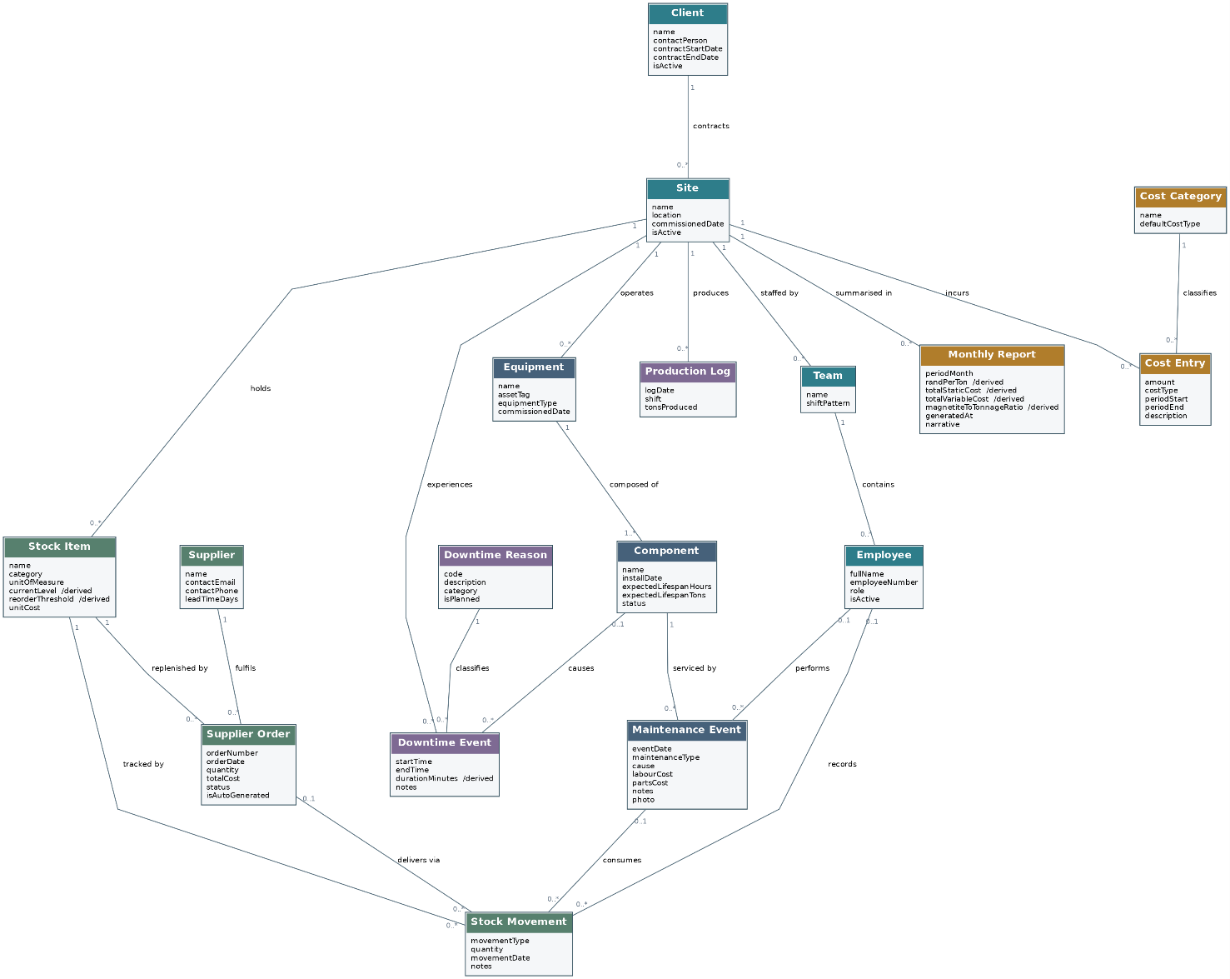
Figure 4.1: The domain class diagram, presenting the concepts of the REEF operation, their attributes and the multiplicity of the associations between them. Attributes annotated as derived are computed at the time of enquiry and are not stored.

4.1.1 Purpose of each domain class
Class | Purpose within the business domain
Client | A mining company that contracts REEF to conduct operations at one or more of its mines. The class permits profitability to be reported per contract and permits the history of a concluded contract to be retained.
Site | A single client mine at which REEF operates. The site is the principal unit of analysis, given that cost, stock, production and downtime are each reported against it.
Team | A crew assigned to a site upon a shift pattern. It is modelled as a class as opposed to an attribute because the comparison of one team against another is a stated requirement.
Employee | A member of REEF staff who records activity. The class is necessary in order that a maintenance event, a stock consumption or a production figure may be attributed to a person.
Equipment | A machine situated at a site, of which a dense medium separation module is the characteristic example.
Component | A wearing part belonging to an item of equipment and carrying its own install date and expected life. It is separated from Equipment because wear accrues, and is predicted, per component.
Maintenance Event | The record of a repair or a service, capturing what failed, what the remedy cost, who performed it and when. It is the basis upon which cost per repair and frequency of failure are computed.
Stock Item | A consumable or a spare held at a site. Its quantity on hand and its reorder point are derived quantities as opposed to fixed properties.
Stock Movement | A single change in stock, being either a consumption by a worker or a delivery against a supplier order. It is the authoritative record from which the quantity on hand is derived.
Supplier | A vendor from whom stock is replenished. The class is required in order that an automatically raised order may possess an addressee and a lead time.
Supplier Order | A purchase order raised against a stock item, whether by a person or by the reorder rule, and subject to approval before transmission.
Production Log | The tonnage produced at a site upon a given date and shift. It drives cost per ton, the rate of reorder and the accrual of wear.
Downtime Event | A period during which production ceased, together with its cause. Its duration is derived from the start and end times.
Downtime Reason | A controlled vocabulary of causes. It is modelled as a class in order that downtime may be aggregated by cause, which free text would not permit.
Cost Entry | A cost incurred by a site, classified as static or variable and bounded by a period so that it may be apportioned to a reporting month.
Cost Category | The classification applied to a cost entry, among which are wages, leases, magnetite and overtime.
Monthly Report | The generated per-site summary. It is modelled as a persisted concept so that a report is retained, reproducible and capable of being placed before a client.

4.1.2 Concepts absent from the supplied model, and the requirements they defeat
The brief proposed a model of nine entities. Requirement tracing established that the model, as supplied, is not able to satisfy a number of requirements stated within the very documents that accompany it. The corrections are recorded below, each against the requirement that it rescues, on the principle that an analytical decision unaccompanied by its justification is indistinguishable from an arbitrary one.
Concept absent | Requirement thereby defeated | Correction adopted
No employee or user concept, notwithstanding that both Maintenance Event and Stock Movement refer to a worker | Requirements FR-27 to FR-30 and the departmental requirement for an audit trail and for role-based access control | Employee is introduced within the domain model and ApplicationUser, Role and UserRole within the design model. In the absence of an identity no action is attributable and no permission is checkable.
Equipment and Component treated as a single concept | The tracking of failure frequency and the correlation of wear with tonnage | The two are separated, one item of equipment holding at least one component. A single machine carries several wearing parts of differing lives, which one combined class is not able to express.
A supplier is referred to by Supplier Order but is nowhere defined | The automatic raising of a purchase order | Supplier is introduced and carries a lead time, without which the reorder point is not able to be computed.
No client concept, the site standing at the head of the hierarchy | The reporting of three active clients and four within the past year, and profitability per contract | Client is introduced, a site belonging to a client. The history of a concluded contract is thereby preserved.
The reason for downtime held as free text | The reporting of downtime by cause | Downtime Reason is introduced as a controlled vocabulary. Free text is not able to be aggregated with confidence, with the consequence that the requirement would have failed.
The active team held as an attribute of the site | The comparison of one team against another | Team is promoted to a class. A comparison presupposes that the things compared are identifiable entities.
Cost Entry carrying an amount and a single date | The computation of cost per ton, which is a monthly figure | A period is introduced together with an apportionment operation. A quarterly lease attributed in its entirety to one month distorts the figure for that month and for the two that follow.
The quantity on hand held as a stored attribute alone | Data integrity, and the accuracy of the reorder rule | The quantity is retained as a cached value but is made derivable from the stock movements. A stored figure that cannot be reconstructed cannot be audited.
No concept for the generated report | The automatic monthly report and the retention of it | Monthly Report is introduced and is uniquely keyed by site and month, so that a report placed before a client remains reproducible.

4.2 Design Artifacts
The design model transforms the domain model into classes capable of being implemented, and it introduces four elements that the domain model deliberately excluded, namely data types, primary and foreign keys, operations, and access specifiers. It introduces, in addition, the technical classes that carry no business meaning but upon which authentication, auditing, notification and the artificial intelligence feature depend. The model is presented across three figures in order that each may remain legible at the scale of a page, and the three are to be read as one model.
The notation is that of the Unified Modeling Language (Object Management Group, 2017). A plus sign denotes public visibility, a minus sign private visibility and a hash protected visibility. The stereotypes «PK», «FK», «UK» and «IX» denote respectively a primary key, a foreign key, a unique key and an indexed column. A solid line denotes an association, a hollow triangle generalisation, a broken line terminating in a hollow triangle the realisation of an interface, and a broken line terminating in an open arrowhead a dependency.

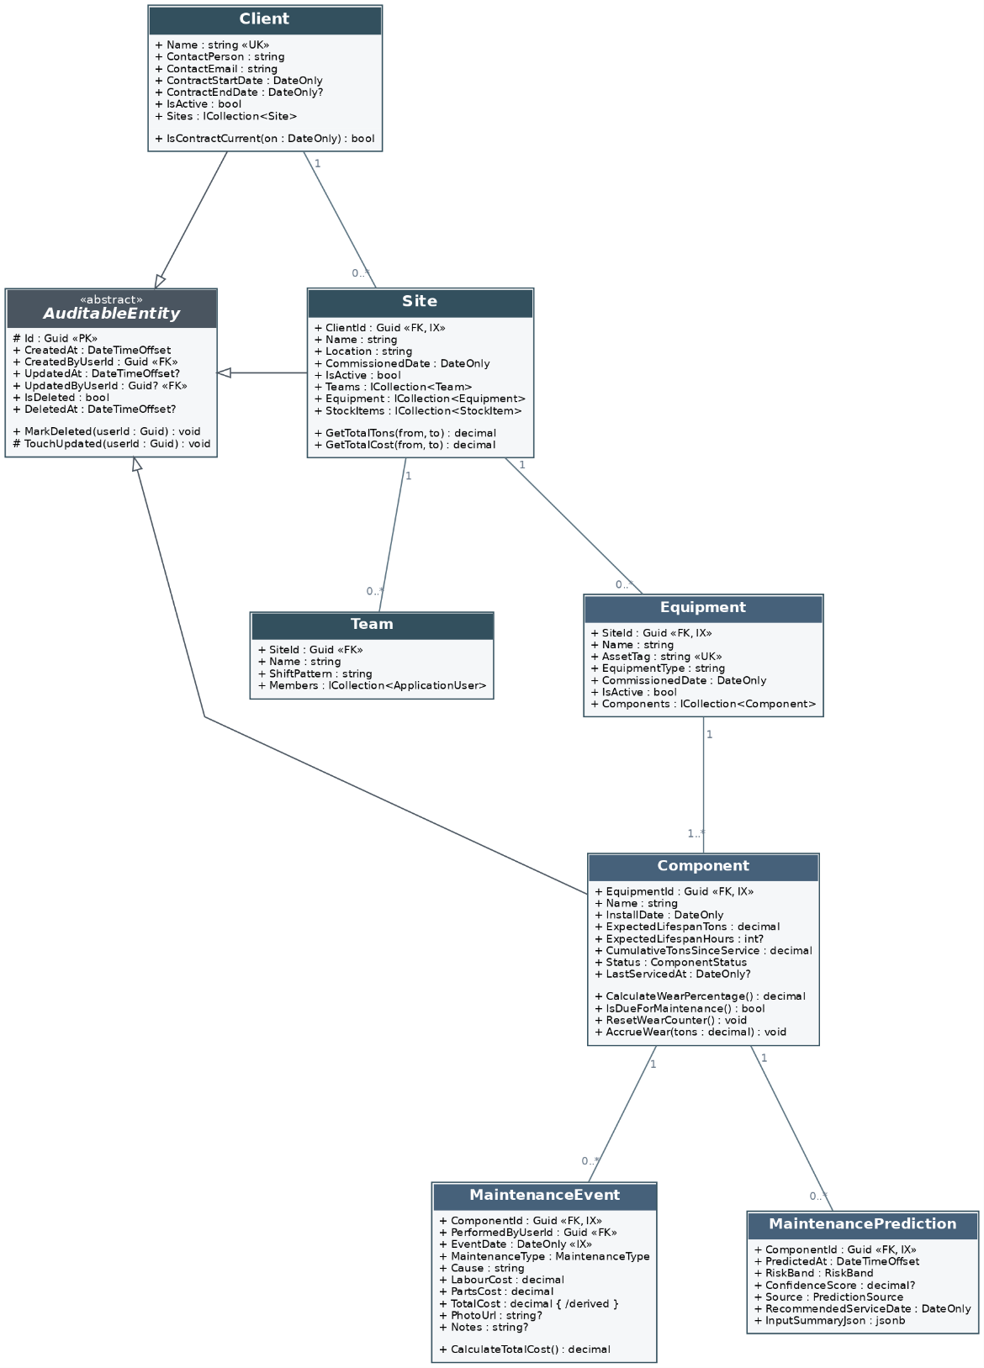
Figure 4.2: Design classes for the organisation, the assets and the maintenance record, together with the abstract base from which every auditable entity inherits.
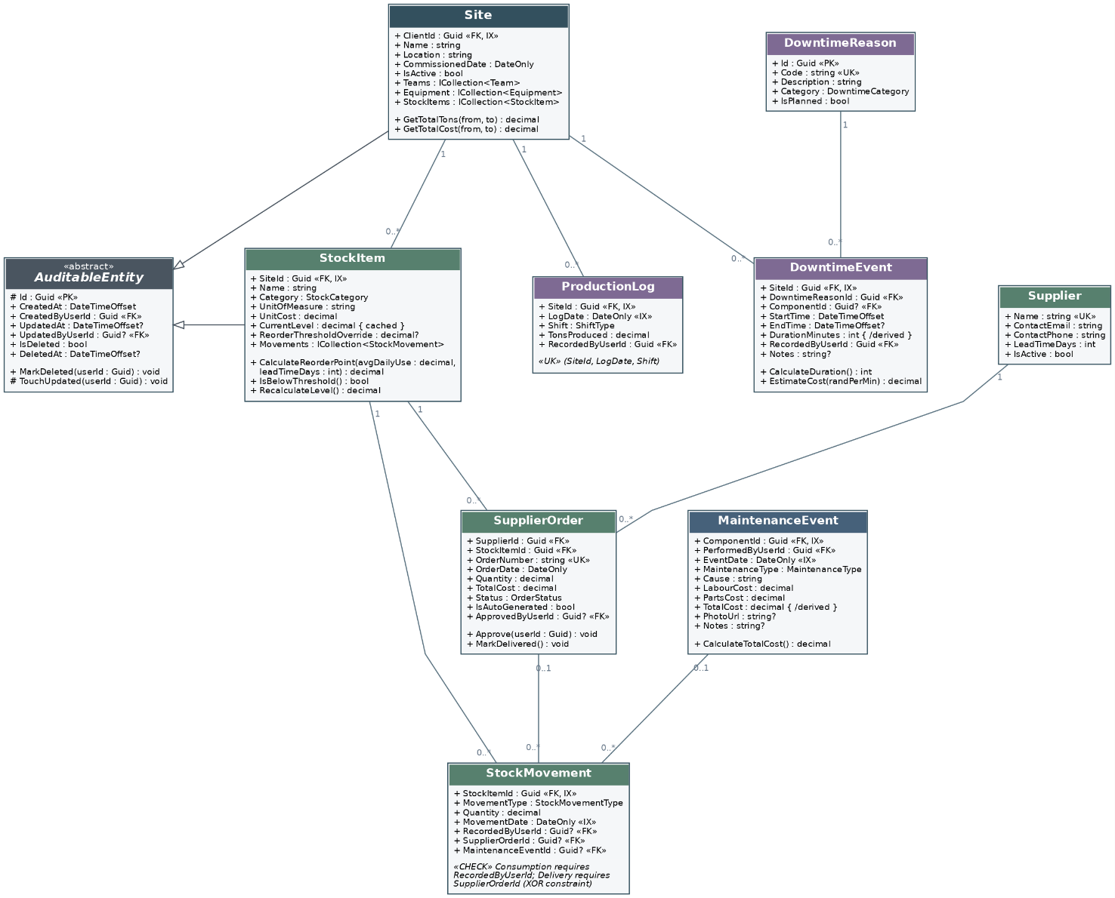
Figure 4.3: Design classes for stock control, supplier ordering, production and downtime, including the constraint that governs which foreign key a stock movement is obliged to carry.
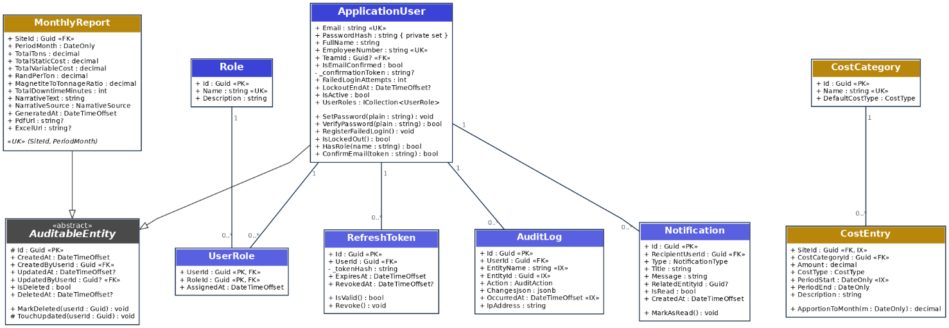
Figure 4.4: Design classes for identity and access, auditing, notification, cost and reporting.

4.2.1 Design decisions and the reasoning that supports them
Decision | Reasoning
An abstract auditable base class | Every business entity inherits an identifier, creation and amendment stamps carrying the identity of the actor, and the flags by which a soft deletion is expressed. The departmental requirements for an audit trail and for archiving in place of destruction are thereby satisfied once, in one place, as opposed to being restated upon every class and forgotten upon one.
Globally unique identifiers as surrogate keys | The mobile client is required to create records while disconnected. A sequential integer allocated by the database is not able to be assigned before the record reaches the database, whereas a globally unique identifier is able to be generated upon the device without coordination and without collision.
Identity separated from the employee concept | Password material, lockout state, confirmation of an address and refresh tokens are technical concerns and not business ones. The domain model accordingly holds Employee and the design model holds ApplicationUser, the latter carrying the security state.
The password hash carrying a private setter | The field is not assignable from outside the class and is set only through an operation that applies the hashing function, with the consequence that the storage of a plaintext password by inadvertence is made structurally impossible as opposed to merely discouraged.
An exclusive constraint upon the stock movement | A consumption is obliged to record the worker and a delivery the supplier order. Both foreign keys are nullable, and a database check constraint therefore enforces that exactly the appropriate one is populated for the type of movement recorded.
The quantity on hand marked as cached | The quantity is logically the sum of the movements. It is cached upon the stock item for the sake of the dashboard, and an operation is provided by which it is rebuilt from the movements, so that the cached figure remains verifiable as opposed to authoritative.
The source of a prediction recorded upon the prediction | Recording whether a prediction proceeded from the model or from the static wear rule renders the claimed fallback demonstrable. A claim of graceful degradation that leaves no trace is not able to be evidenced under examination.
A unique key upon site, date and shift | The constraint prevents the same shift being logged twice, which would inflate tonnage, depress cost per ton and do so silently.
Indexes upon foreign keys and upon date columns | The dashboard and the report filter by site and by period. Indexing the columns upon which those filters operate satisfies the departmental requirement for indexes upon frequently interrogated fields.

4.2.2 Alignment with the data schema in Section 6
One divergence between this section and Section 6 has to be recorded rather than left implicit. The analysis above separates Equipment from Component and argues that separation at 4.1.2, on the ground that a single machine carries several wearing parts of differing lives and that a combined class is not able to express the correlation of wear with tonnage per part. The entity relationship diagram in Section 6.2.2 does not presently carry that separation: it holds the wear counters upon equipment itself. The two are therefore not yet aligned, and the misalignment is one of implementation lagging the analysis rather than of disagreement about the business. Either the schema gains a components table, in which case the maintenance event references the component and the counters move with it, or the analysis is amended to record wear at the level of the machine and the requirement to correlate failure with a particular wearing part is withdrawn. The first is preferred, because the requirement it serves is stated in the client brief, and it is scheduled at package 5.1 of the work breakdown structure. Until that package completes, a reader comparing Figure 4.2 against Figure 6.1 should expect the difference and should read Section 4 as the specification and Section 6 as the present state.

5. Implementation
Author: Tayler Usmar (ST10445063)
This section documents the dynamic behaviour of the REEF Operations Platform. Where the architecture and data model describe what the system is, the diagrams in this section describe what it does: the order in which components exchange messages to satisfy a user goal, and the lifecycles through which the system's longerlived objects pass.
Two diagram types are used, because they answer different questions. Sequence diagrams show interaction across components over time, and are used here for the flows that cross module or tier boundaries. State diagrams show the permitted lifecycle of a single object, and are used for the entities whose behaviour depends on their current state rather than only on the request being made. All diagrams follow the notation defined in the Unified Modeling Language specification (Object Management Group, 2017).
The flows documented here were not chosen arbitrarily. A flow qualifies as critical for the purposes of this section if it meets at least one of three tests: it crosses a module boundary and therefore evidences the claim that this is one connected system rather than four separate applications; it is the only path by which a core business value is produced; or its failure mode is non-obvious and therefore needs to be documented before it is implemented.
One point of scope is worth making before the diagrams. Two things described in this section are designed rather than delivered. The offline capture path in Sections 5.1.1 and 5.2.1 is one: the Task 1 prototype, which under the project brief required no back-end functionality, writes directly to the data layer and has no local queue. The dedicated React Native mobile client is the other. Both are scheduled for Phase 2, and the requirements they satisfy are set out in Section 3. The prototype meets the responsive design requirement through a single web application that adapts between phone and desktop rather than through a separate mobile build. The diagrams below describe the system as designed, and where the current prototype differs this is stated.

Notation conventions applied throughout
- A solid line with a filled arrowhead is a synchronous call; an open arrowhead is asynchronous; a dashed line is a return message.
- Every call has an explicit return, including void returns, so that the reader can see where control resumes.
- Activation bars mark the period during which a lifeline is actively processing.
- Combined fragments (alt, opt, loop, par) are used for conditional, optional, repeated and concurrent behaviour rather than drawing a separate diagram per branch.
- State diagrams carry an initial pseudostate and at least one final state, and transitions are labelled in the form trigger [guard] / effect.
- No client lifeline sends a message directly to the database. This is the layered architecture constraint described in Section 7.2, expressed in the dynamic view.

5.1 Sequence Diagrams

5.1.1 SD-1 — Worker logs a maintenance event offline, then syncs on reconnect
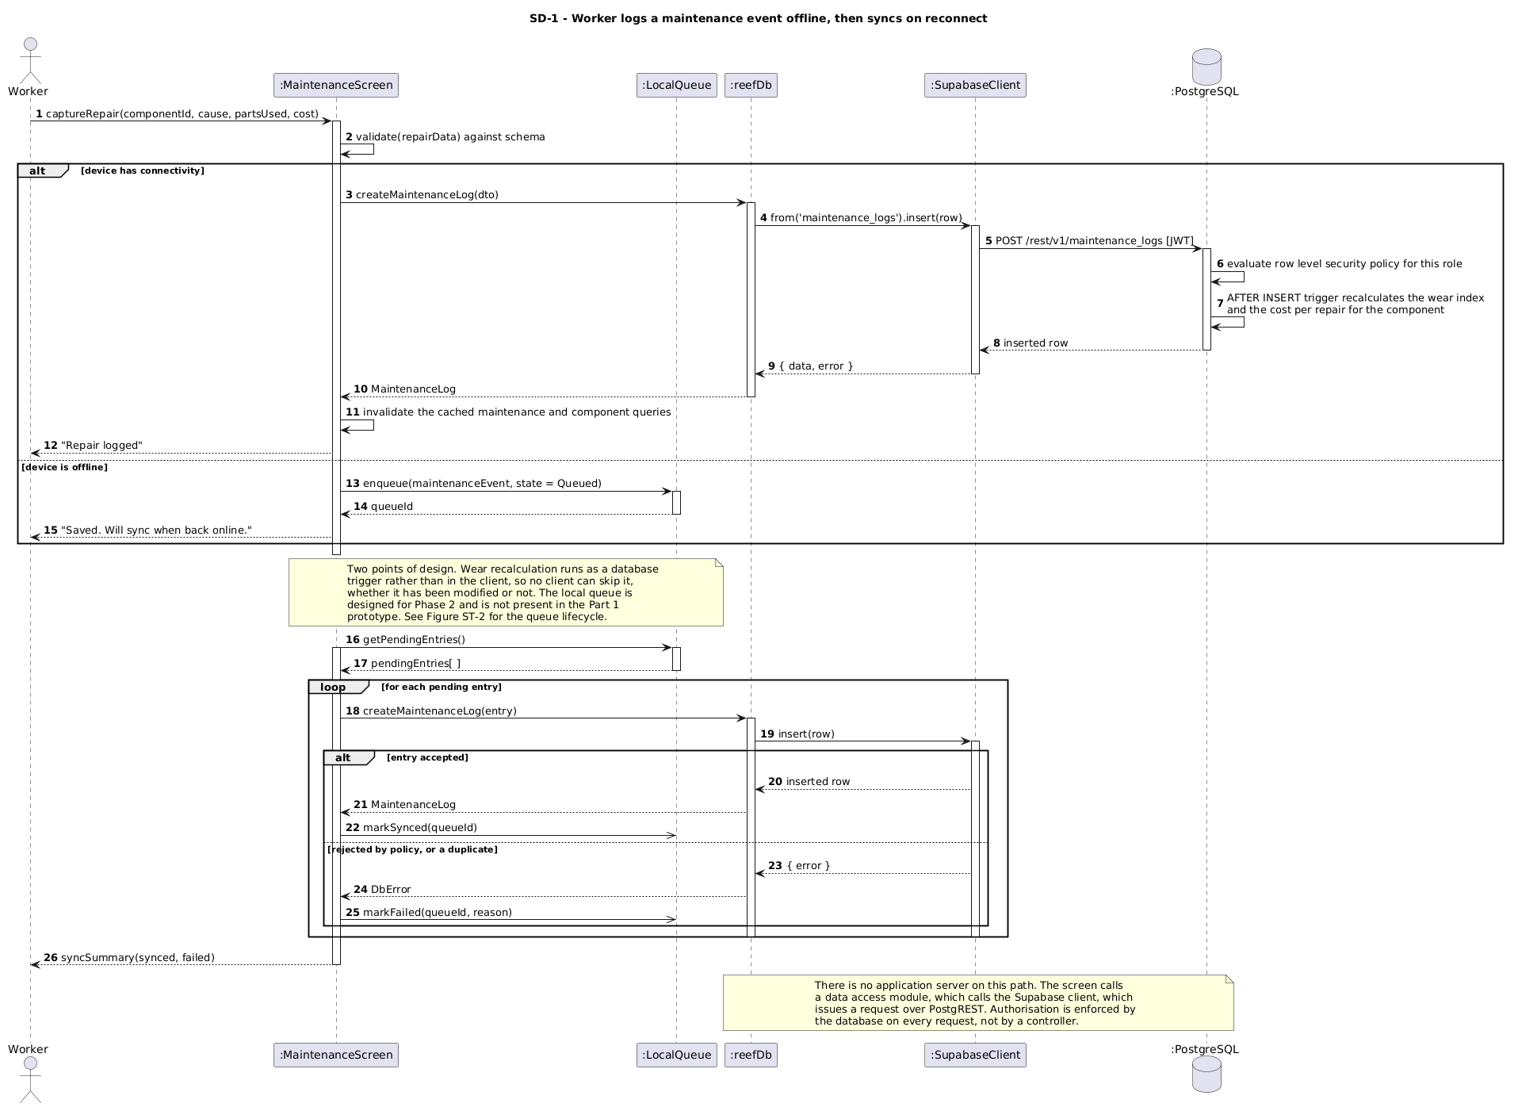
Figure 5.1 — SD-1: Worker logs a maintenance event offline, then syncs on reconnect
Figure 5.1 traces the platform's most operationally significant path: a worker recording a repair at a client mine site where connectivity is unreliable. The alt fragment shows that the decision between an immediate API call and local persistence is made entirely on the device, so the worker's interaction is identical either way. This is a deliberate design choice, since a worker underground should never have to know whether a log was transmitted.
On the online branch, the maintenance service performs two distinct pieces of work after persisting the event. It recalculates the cost per repair, and it updates the component's wear profile. The second of these is the link between the Maintenance module and the Performance and Downtime module, and it is executed on the server precisely so that an offline client cannot skip it. Were wear recalculation performed on the device, a worker who never regained signal would leave the maintenance predictions permanently stale.
The deferred synchronisation below the note is triggered by the mobile application's connectivity listener, not by the worker. The inner alt fragment shows that a rejected entry is marked as failed rather than silently discarded, which is what makes the queue auditable: the worker can be told which logs did not synchronise and why. Note that no client lifeline messages the database at any point; every data access is mediated by the Web API.

5.1.2 SD-2 — Stock usage crosses the reorder threshold and raises a supplier order
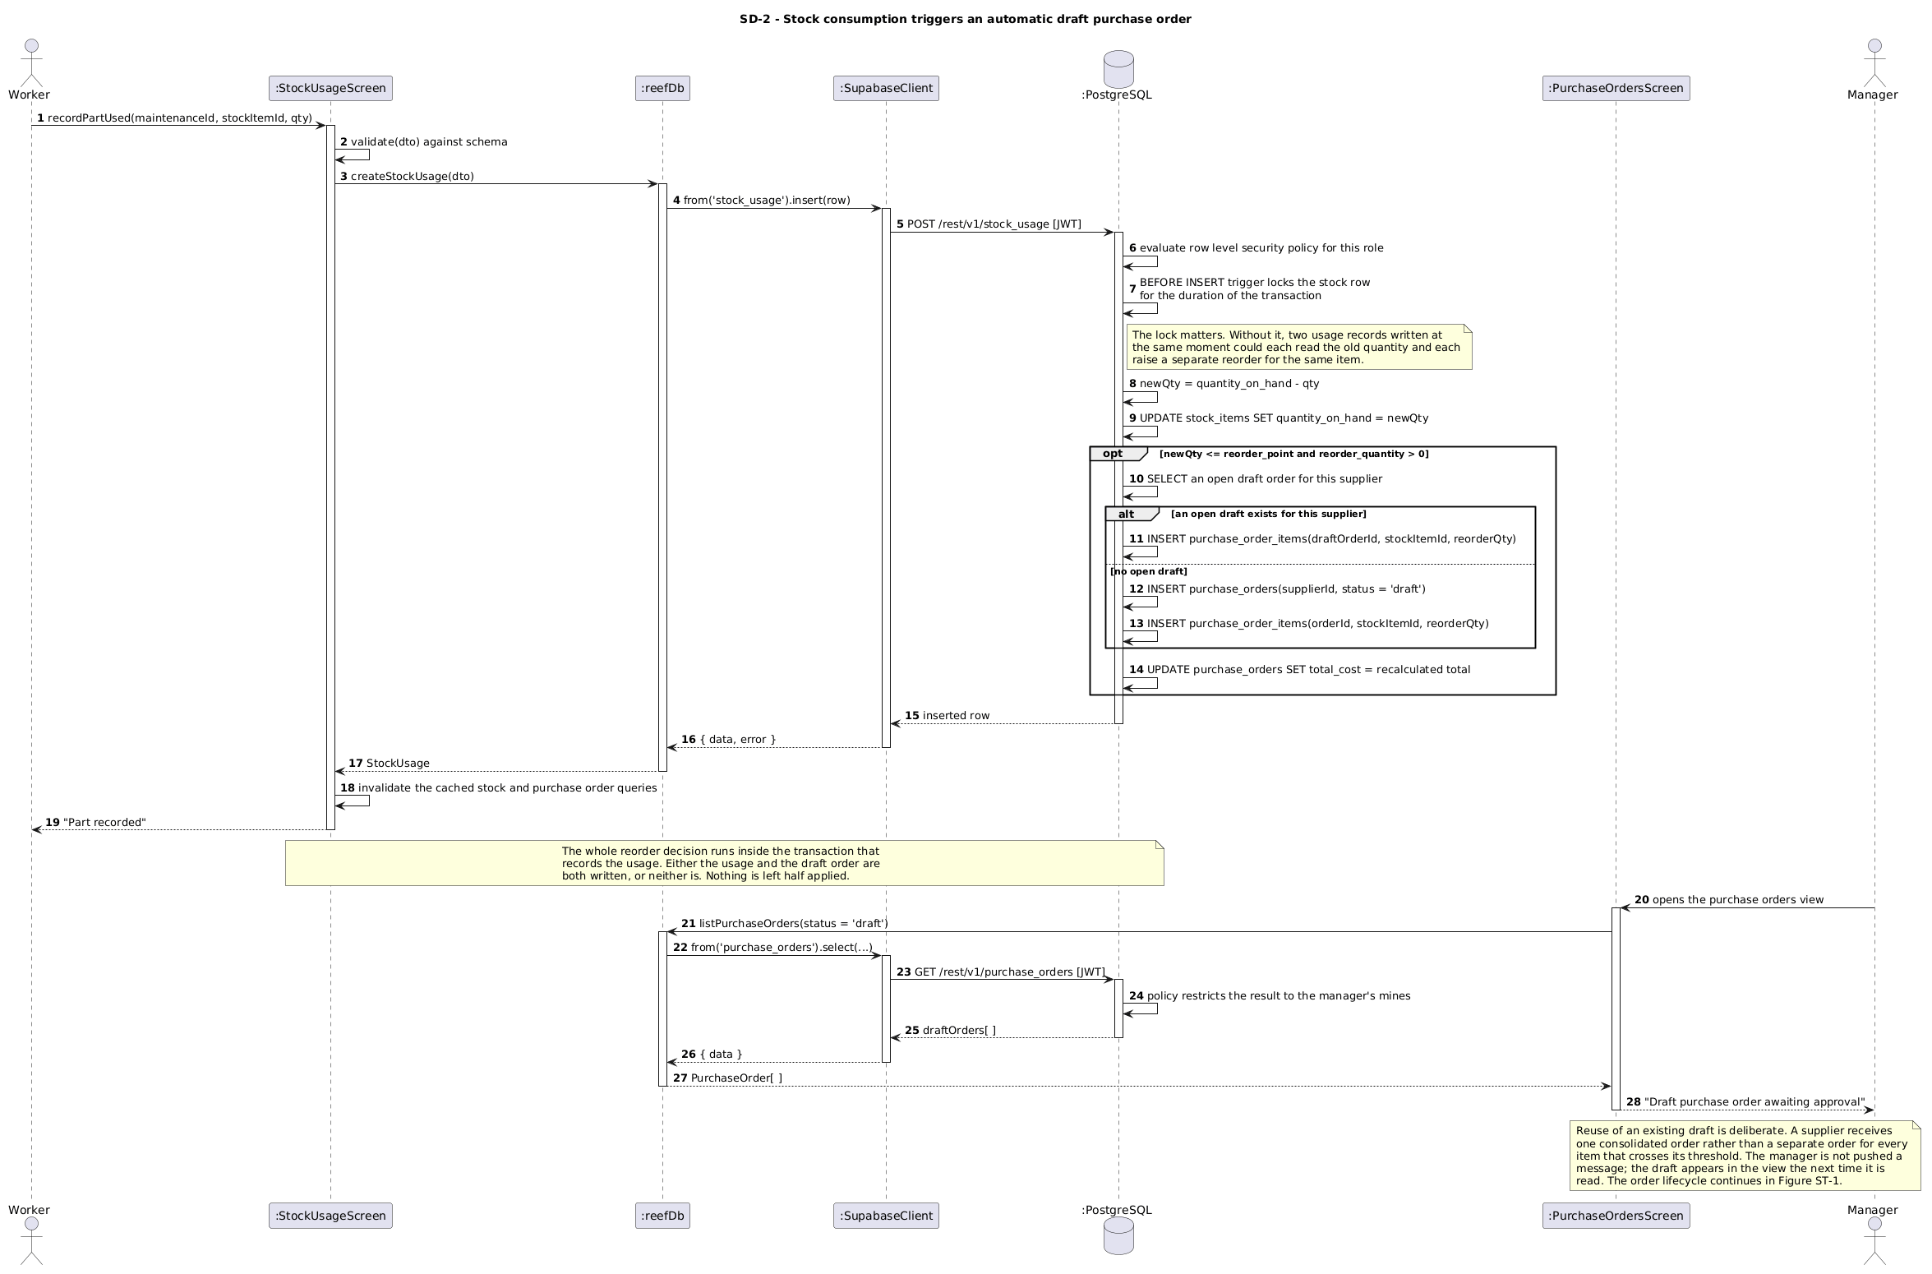
Figure 5.2 — SD-2: Stock Usage crosses the reorder threshold and raises a supplier order
Figure 5.2 documents the flow that most directly evidences the platform's central claim. A worker logs consumption of magnetite or a spare part, which is an act of the Stock Control module. Persisting that movement causes the stock service to recalculate the item's current level and compare it against a reorder threshold that is itself derived from the site's recent production rate, a value owned by the Production module. An opt fragment then shows that, only when the threshold is breached, a supplier order is generated and a notification is dispatched to the manager.
The diagram is included because it demonstrates three modules interacting within a single request without any of them holding a reference to another module's data store. It is also the clearest illustration of why a busier site reorders sooner: the threshold is not a fixed number but a function of throughput. The order is created in the Draft state only, so automatic reordering proposes a purchase rather than committing REEF to spend without a human decision. That lifecycle is documented in Section 5.2.2.

5.1.3 SD-4 — Owner requests the automatically generated monthly report
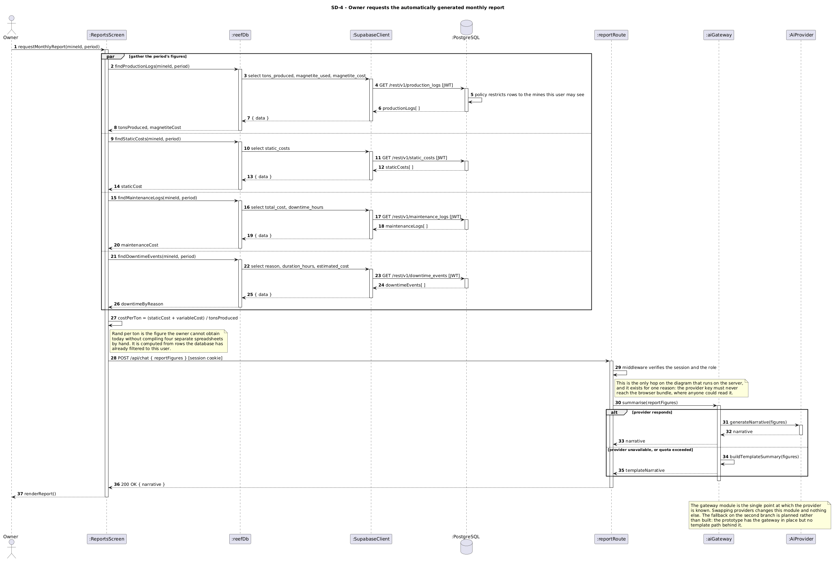Figure 5.3 — SD-4: Owner Requests automatically generated monthly report
Figure 5.3 shows the reporting path and the artificial intelligence integration. The reporting service aggregates cost entries, production logs and downtime events for the selected site and period, computes rand per ton, and passes the resulting figures to the adapter for narration. A par fragment shows that the three aggregate queries are independent of one another and may be executed concurrently.
The diagram's principal purpose is the alt fragment on the adapter's response. If the artificial intelligence service returns successfully, the narrative is attached to the report. If it is unavailable or has exceeded its request limit, the adapter produces a deterministic summary built from a template using the same figures. The report is therefore always produced. This is the dynamic-view evidence for the graceful degradation pattern described in Section 7.2, and it documents a failure mode which would otherwise only be discovered at the least convenient moment.

5.2 State Diagrams

5.2.1 ST-2 — Queued log entry lifecycle
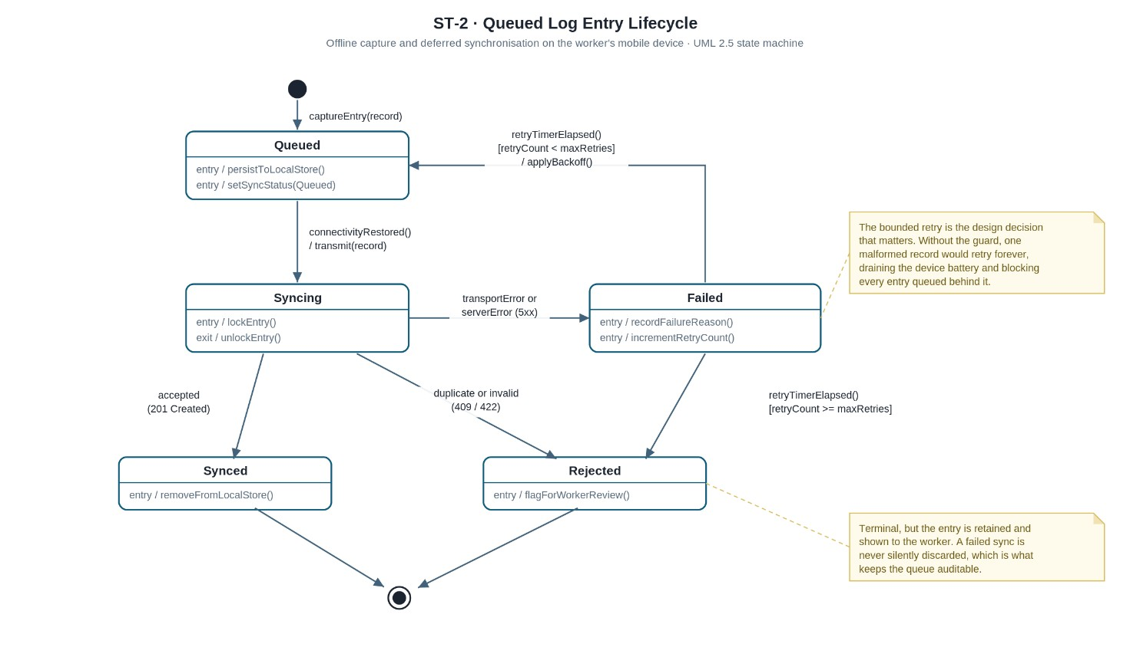
Figure 5.4 — ST-2: Queued Log Entity Lifecycle, from automatic draft through approval to receipt
An entry captured offline moves from Queued to Syncing to Synced, with Synced as a final state. A failed transmission moves the entry to Failed, from which a guarded transition returns it to Queued while the retry count remains below the configured limit, and the complementary guard moves it to the terminal Rejected state once that limit is reached.
This is the most important of the state diagrams. The bounded retry is a genuine design decision rather than decoration: without the retry limit, a single malformed or permanently rejected entry would cycle indefinitely, consuming battery and bandwidth on the worker's device and blocking the entries queued behind it. Entries that fail are marked rather than discarded, so the queue remains auditable. This diagram is the behavioural specification of the offline-first store-and-forward pattern described in Section 7.2.

5.2.2 ST-1 — Supplier order lifecycle
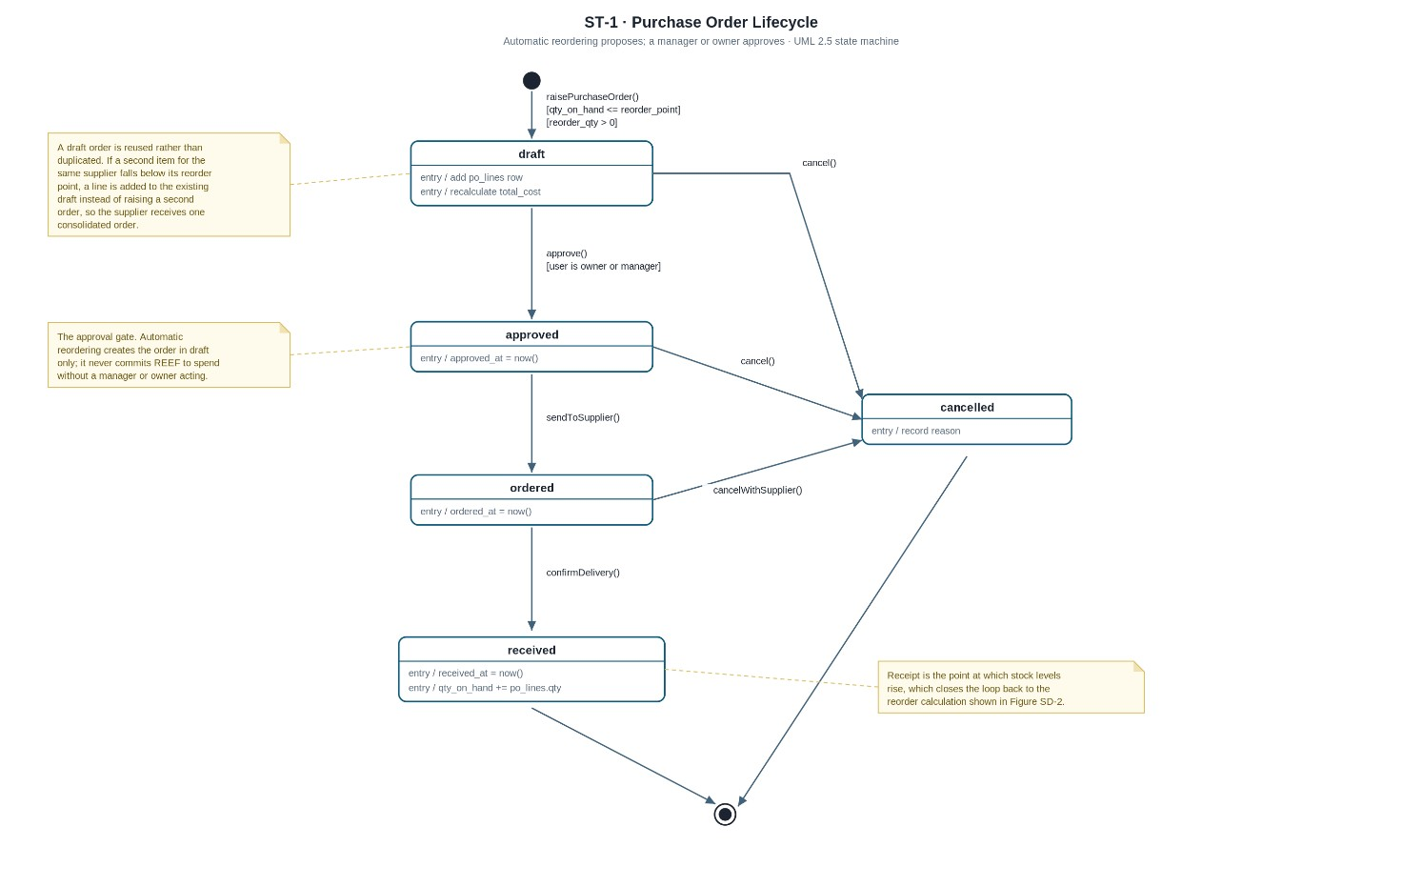
Figure 5.5 — ST-1: Purchase order lifecycle, from automatic draft through approval to receipt
A supplier order progresses from Draft through Pending Approval, Ordered, In Transit and Received to Closed, with Cancelled available as an alternate final state from any state prior to receipt. The transition from Draft to Pending Approval may be triggered automatically by the reorder logic documented in Section 5.1.2, or manually by a manager, and the guard on the transition from Pending Approval to Ordered is managerial approval.
Modelling this lifecycle explicitly matters because it establishes that automatic reordering proposes a purchase rather than committing REEF to expenditure without a human decision, which is a point a client would reasonably want confirmed before adopting the system. Receiving a delivery is also the point at which stock levels rise, which closes the loop back to the reorder calculation.

5.2.3 ST-3 — Equipment component lifecycle
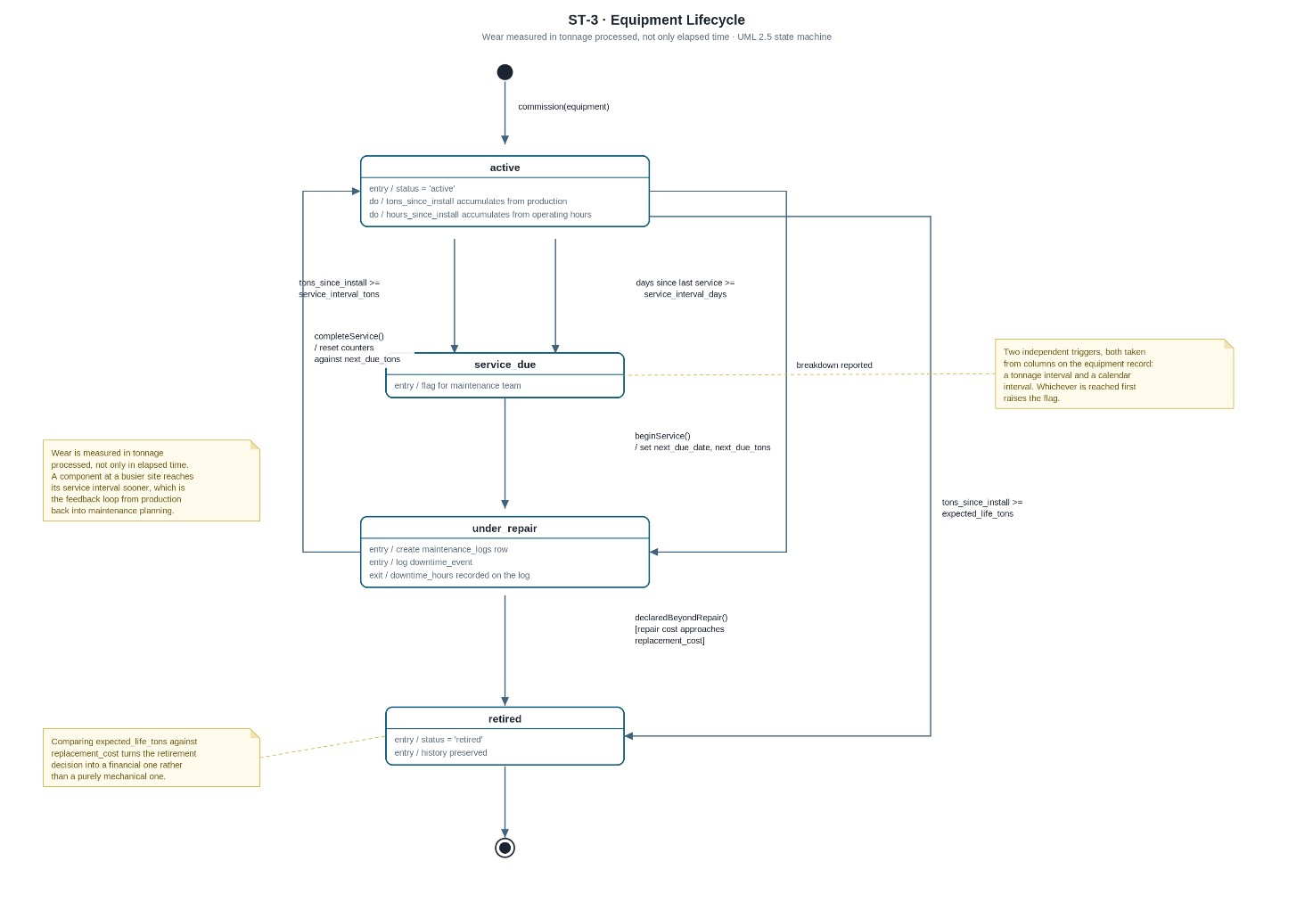
Figure 5.6 — ST-3: Equipment lifecycle, with service triggered by tonnage or elapsed time
A component moves from Operational to Maintenance Due to Under Repair and back to Operational, with Decommissioned as a final state. The transition into Maintenance Due has two independent triggers: the elapsing of a scheduled service interval, and a wear index that has risen past its threshold as a consequence of tonnage processed at the site.
That second trigger is the predictive element of the platform, and it is the feedback loop from the Performance and Downtime module back into the Maintenance module. The cycle back to Operational on completion of a repair is what causes maintenance history to accumulate against a single component rather than appearing as a series of unrelated events. Downtime is recorded on entry to and exit from the Under Repair state, so a repair automatically produces the duration used by the downtime cost analysis.

5.3 Traceability of Documented Flows
The following table records which modules each diagram exercises and which requirement it evidences.
Figure | Modules exercised | Requirement evidenced
SD-1 | 1 Maintenance, 4 Performance | Offline capture; server-side wear feedback loop
SD-2 | 2 Stock, 3 Financial, 4 Performance | Production-rate-driven automatic reordering
SD-4 | 3 Financial, AI component | Automatic monthly report; graceful degradation
ST-2 | Mobile client | Bounded retry; auditable failed synchronisations
ST-1 | 2 Stock | Automatic order proposes, a human approves
ST-3 | 1 Maintenance, 4 Performance | Predictive maintenance trigger from wear

5.4 Deployment Plan

5.4.1 Purpose and Scope
This section describes how the REEF Operations Platform is built, released, hosted and recovered. It covers the Phase 1 scope defined in the project roadmap: the Web API, the React web dashboard, the React Native mobile application, and the Supabase data layer. The plan is written against a constraint imposed by the project, namely that the entire platform must run at zero recurring cost. That constraint is not treated here as a limitation to be apologised for, but as a design input with consequences that must be identified, mitigated and documented. A deployment plan that lists free hosting providers without acknowledging what free costs in latency and availability is incomplete.

5.4.2 Deployment Topology

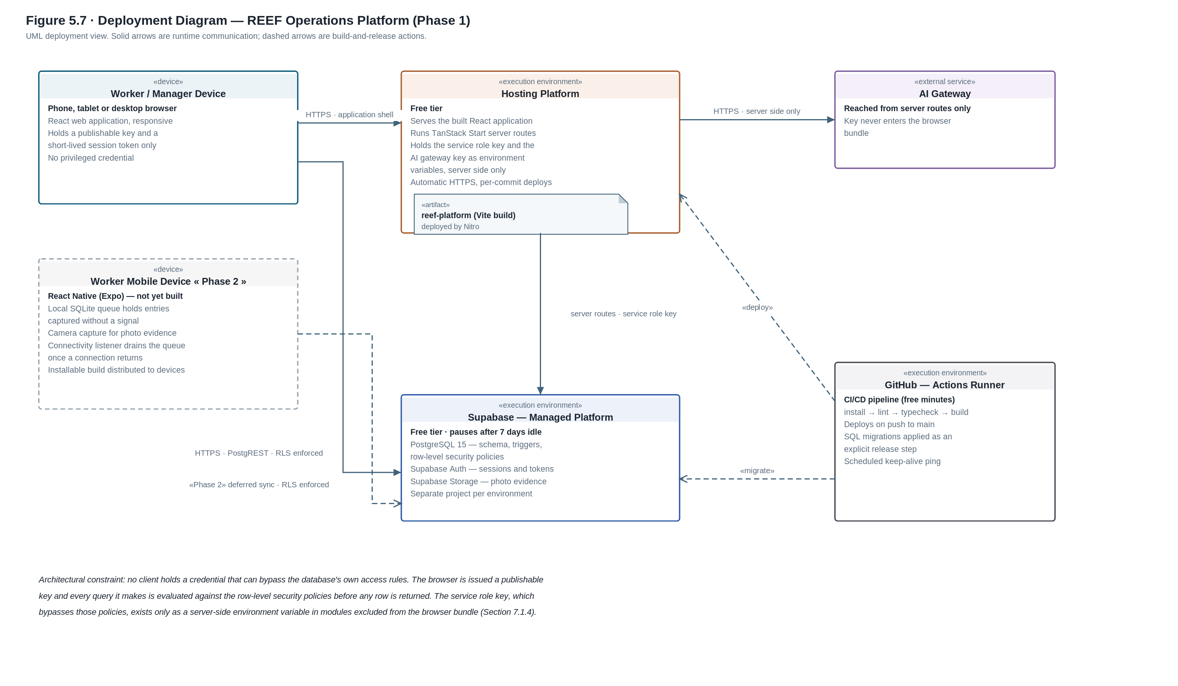
Figure 5.7 — Deployment diagram, REEF Operations Platform (Phase 1)
Figure 5.7 presents the deployment view of the system, four categories of nodes are shown: the client device, the hosting platform that serves the application and runs its server routes, the managed data platform and the external services supporting the build pipeline and the artificial intelligence feature.
The topology enforces one rule above all others. In the designed architecture no client node holds a database credential: the dashboard is delivered to the browser as a compiled bundle, the mobile client is installed upon the worker's device as a built package, and neither artefact contains a connection string. All persistence is mediated by the Web API, which is the sole holder of that credential and the single point at which a request is authenticated, authorised, validated, rate limited and logged. This is the arrangement the departmental build standard requires, which states that the front end and the mobile application must both consume the same back end and that there is to be no direct database access from client applications. It is also what makes the layering described in Section 7.2 enforceable rather than advisory, because the absence of a credential renders a layer violation impossible as opposed to merely discouraged.
The Task 1 prototype, which that task permitted to be built without a back-end tier, reaches the data platform differently. The browser holds a publishable key, and every query made with it is evaluated against the row-level security policies at the database before any row is returned, while a second key of higher privilege is confined to modules excluded from the browser bundle, as Section 7.1.4 explains. That arrangement enforces access control at a layer no modified client is able to bypass, and Section 7.1 documents it as built rather than as intended. It is not, however, the delivered architecture. The direct path is removed at package 5.2 of the work breakdown structure; Section 7.3.4 records the transition and Section 8.7 records the residual risk that stands until it completes. Figure 5.7 above draws the prototype topology, which is why the client node within it is annotated as carrying a publishable key and a short-lived session token; Figure 7.7 draws the delivered topology, in which the client node carries neither and every persistence call crosses the application tier.
The dedicated mobile client is drawn with a broken outline because it is designed but not yet built. It is shown in full so that the deployment view records the intended shape of the system rather than only its current state. In Phase 2 it is a React Native application built with Expo and installed on the worker's own Android or iOS device. It carries a local SQLite queue, so that a capture made underground or out of signal is written to the device and held there rather than lost, and a connectivity listener drains that queue to Supabase once a connection returns. It also takes photographic evidence directly from the device camera. The broken arrow to the managed platform is the deferred synchronisation path, and it is governed by the same row-level security policies as every other client, because the mobile application would hold a publishable key exactly as the browser does.
The artificial intelligence gateway is reachable only from the server routes. Its key is held as a server-side environment variable and never appears in a client bundle, where it would be readable by anyone who opened the browser's developer tools, this is designed to protect the application.

5.4.3 Environment Strategy
Three environments are maintained across the lifecycle of the platform.
Environment | Purpose | Hosting
Local development | Individual developer work | Local runtime, development server, developer's own database project
Staging | Integration testing and demonstration rehearsal | Preview deployments with a dedicated database project
Production | The submitted, demonstrable system | Production hosting with a dedicated database project

The important decision here is the use of a separate database project per environment rather than a shared database with separate schemas. Database migrations are the highest-risk operation in the release process, because they are the only step capable of destroying data irreversibly. If staging and production share a database, there is no safe way to rehearse a destructive migration. Provisioning a second free-tier project costs nothing and removes that risk entirely.

5.4.4 Build and Release Pipeline
Continuous integration runs on GitHub Actions, on the principle that every change should be built and tested automatically so that the software is always in a releasable state (Humble and Farley, 2010). On every push to a feature branch, and on every pull request raised against main, the pipeline installs the project's dependencies, runs the linter, runs the TypeScript type checker, and produces a production build with Vite. A failure at any one of those stages blocks the merge. The point of ordering it this way is that the cheapest checks run first, so a formatting error is reported in seconds rather than after a full build has completed.
Main is protected, which means changes reach it through a pull request rather than through a direct push. On a successful build of main the hosting provider pulls the new commit and deploys it automatically, so a merge and a deployment are the same event and there is no separate manual release step that somebody can forget to perform. Every deployment is tied to a specific commit, which is what makes the rollback described in Section 5.4.8 possible at all.
No credential is held in the repository. The values the pipeline needs are injected at run time from the encrypted secret store belonging to the repository and to the hosting account, and they are scoped so that a build running against a feature branch cannot reach the production project. Section 5.4.6 sets out how those values are separated by environment. Database changes are deliberately excluded from this pipeline and are applied as an explicit release step instead, which Section 5.4.5 describes, so that a schema change is always a decision somebody makes rather than something that happens quietly alongside an application deployment.

5.4.5 Database Migration Strategy
The schema changes are managed as SQL migration files kept in the repository. Each one is committed to source control and reviewed like any other code. Editing the hosted database manually or by hand is not allowed due to the fact that it makes the deployed schema drift away from the migration history without anyone noticing.
Migrations are applied as an explicit release step rather than automatically when the application starts. Applying them at start-up means a restart under load can try to migrate a database that is already in use. Every migration should also have a working reverse, since that is what makes the rollback strategy below possible at all.
The nine migration files that are in the repository are a complete record of how the schema and its access policies were built up. That record includes the point at which the early permissive policies were dropped and replaced with role-scoped ones, which is discussed later in Section 8.

5.4.6 Configuration and Secrets Management
There are two credentials with different privilege levels that exist and they are handled differently. The publishable key goes to the browser by design; it identifies the project rather than granting access to it and the row-level security policies decide what the signed-in user can actually see. The service role key bypasses those policies completely and is read from a server-side environment variable only which is in modules that never reach the browser bundle. The key for the artificial intelligence gateway works the same way as the service role key.
Keeping configuration in the environment rather than in files committed next to the code follows the twelvefactor approach (Wiggins, 2017). Local development uses an environment file that is excluded from source control, and a committed example file records which variables are required without disclosing their values.
One qualification that should be recorded honestly. The environment file is currently committed to the repository and is not listed in the ignore file. It holds only the publishable key and the project identifiers, so nothing privileged has been exposed, but it should be ignored before any further secret is added to it. This is recorded here rather than omitted because it is exactly the kind of oversight the configuration strategy exists to prevent.

5.4.7 Constraints of the Zero-Cost Tier and Their Mitigations
The free hosting tier imposes four measurable constraints. Each is stated below with the mitigation adopted for it. Documenting these constraints is deliberate: a marker or client evaluating the system will encounter the cold start within the first minute of use, and a plan that anticipates it demonstrates that the hosting choice was made with open eyes rather than by accident.

Constraint | Impact | Mitigation
he API container sleeps after a period of inactivity | A delay of roughly 30 to 60 seconds on the first request after idling | A scheduled workflow pings the API periodically, and the client displays an explicit loading state so that a cold start reads as slow rather than broken
The database project pauses after a period with no activity | The database becomes unreachable until manually resumed | The same scheduled workflow issues a lightweight query against the database
The free tier caps database and file storage capacity | Photographic evidence will exhaust storage before the database itself fills | Images are compressed on the client before upload, and a documented retention policy archives photographs older than the current reporting period T
The artificial intelligence service caps daily requests | Narrative generation fails under burst load | The adapter falls back to a template-built summary rather than returning an error, so the report is always produced

5.4.8 Rollback Strategy
Rollback is defined by its triggers as well as by its mechanism. A release is rolled back if any of the following is observed after deployment: authentication failures affecting all users, a server-error rate above a nominal threshold on any core endpoint, or data being written in an incorrect shape.
The mechanism has two parts, and the order in which they are performed matters. First the application is reverted, since the hosting providers retain previous successful deployments and support reverting to the last known-good build. Second, if the failed release included a schema change, the corresponding reverse migration is applied to restore the previous schema. Reverting the application without reverting the schema leaves the old code running against a new database shape, which is frequently worse than the original fault.

5.4.9 Post-Deployment Verification
Each release is confirmed by a short smoke test executed against the deployed environment: authenticate as each of the three roles, retrieve a site dashboard, submit a maintenance event, and confirm that the record appears in the database. The hosting providers expose deployment logs, and the API writes structured application logs for failed requests. Formal uptime monitoring is out of scope for Phase 1 and is recorded here as a Phase 2 item rather than silently omitted.

6. Data Schema

6.1 Choice of Technology
Author: Tayler Usmar (ST10445063)
The platform stores its data in PostgreSQL, hosted through Supabase, with Supabase Storage handling files such as photographs attached to repairs and downtime events. This section explains why that was chosen, what else was considered, and how the choice holds up as REEF grows.

6.1.1 Why Relational

The main reason is that REEF's data is relational, and heavily so. A client has mines, a mine has equipment, equipment has maintenance records, and those records consume stock items which are replenished by purchase orders raised against suppliers. There are 21 tables and 29 foreign keys between them. That is not incidental complexity the team introduced, it is the shape of the business.
The figure the owner actually wants, cost per ton, makes this concrete. Obtaining it means combining production logs, static costs, maintenance costs and downtime costs for one mine over one month. In a relational database that is a query. In a document store the data would either be duplicated across documents so that each one is self-contained, or four collections would be fetched and joined in application code. The first creates a consistency problem every time a cost changes, and the second means writing the join by hand in every place it is needed.
The second reason is transactional integrity. Some of the platform's business rules run inside the database. When a worker records that a repair consumed parts, the database locks the stock item row, reduces the quantity, checks whether that took it below the reorder point, and if so either adds a line to an existing draft purchase order or creates a new one. That is a read, an update and a conditional insert across three tables, and it either all happens or none of it does. Relational databases provide that guarantee directly. Document stores generally offer weaker guarantees across collections, and building the same safety in application code means handling partial failure manually.
The third reason is that access control is enforced at the database. Row-level security policies check a user's role before any query returns anything, which is what makes the permission model real rather than cosmetic (PostgreSQL Global Development Group, 2026). That depends on a database engine with row-level policies, and PostgreSQL has them.

6.1.2 Why Supabase

Supabase provides managed PostgreSQL rather than a different kind of database, so nothing described above is given up. It also bundles authentication, file storage and an automatically generated REST interface, which for a five-person team on a fixed deadline removes a meaningful amount of work (Supabase, 2026). Credentials are handled by a service built for that purpose rather than by the team, which is generally the correct decision for authentication. It is also free at the scale REEF operates at, which matters because the project carries a zero-cost constraint.

6.1.3 Alternatives Considered
A document store such as MongoDB was the main alternative and was rejected for the reasons above. It suits data that is naturally hierarchical and read as whole documents. REEF's data is neither. It is worth noting that the project brief only asks for JSON schemas if a document store is used, so choosing relational removes that requirement rather than avoiding it.
A self-hosted SQL database such as MySQL or SQL Server would give the same relational benefits but adds server administration, backups, patching and a hosting bill. For a team of this size that is effort spent on operations rather than on the system itself.
Firebase was considered because of its free tier and built-in authentication, but its data model is documentbased, which reintroduces the same join problem, and its query capabilities are limited in ways that would become a constraint as the reporting requirements grow.
SQLite was ruled out quickly. It is a single-file database with limited concurrent writing, and REEF has multiple sites capturing data at the same time.

6.1.4 Scalability

The free tier allows 500 MB of database storage and 1 GB of file storage. The operational tables are small, since a row occupies a few hundred bytes and even years of daily production and maintenance logs across a handful of sites will not approach 500 MB. Photographs are the constraint rather than records, which is why they are held in Storage rather than in the database and compressed on the device before upload.
Beyond the free tier, PostgreSQL scales vertically a considerable distance before anything structural has to change, and read replicas are available if reporting queries begin competing with data capture. Indexes already exist on the foreign key columns, which is what keeps the joins fast as row counts grow. If REEF expanded to significantly more sites, the schema would not need redesigning; the hosting tier would need upgrading, which is a billing decision rather than an engineering one.

6.2 Entity Relationship Diagram
Author: Tayler Usmar (ST10445063)
The REEF Operations Platform stores its data in a relational PostgreSQL database made up of 21 tables. The diagrams below use entity relationship modelling, an approach first set out by Chen (1976) and still the standard way of describing the structure of a relational schema. Because the schema is fairly large, it is presented here as 3 figures. Figure 6.1 covers the operational and procurement side of the business, and Figure 6.2 covers workforce, identity and the assistant. They are the same database, just split so that each one stays readable.
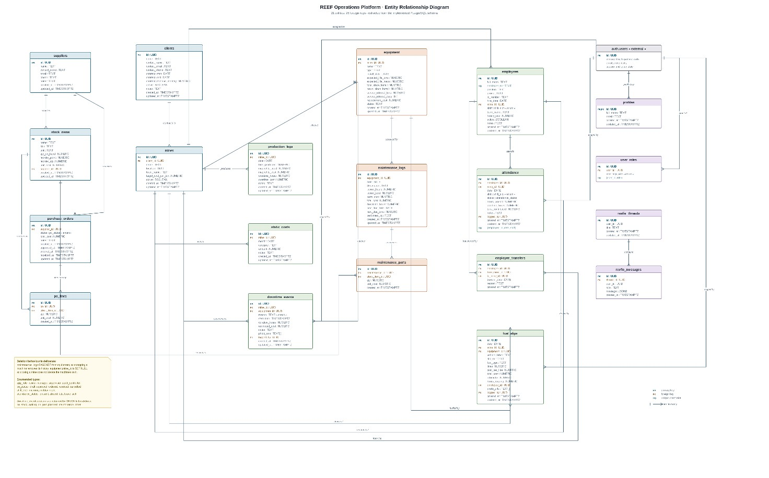
Figure 6 - Entity relationship diagram: Combined
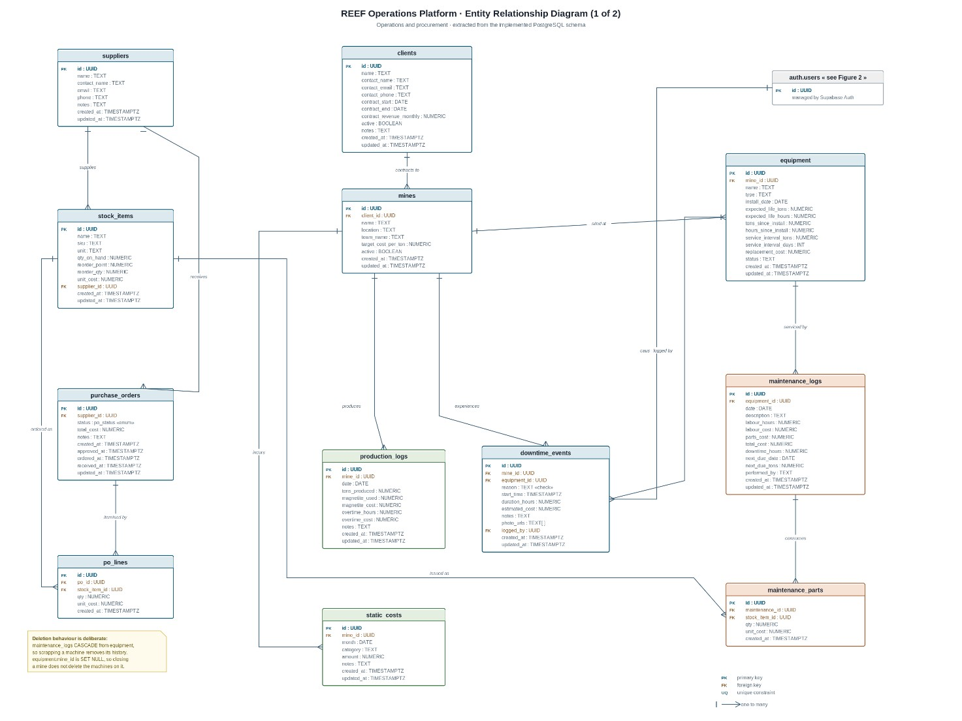
Figure 6.1 - Entity relationship diagram: operations and procurement
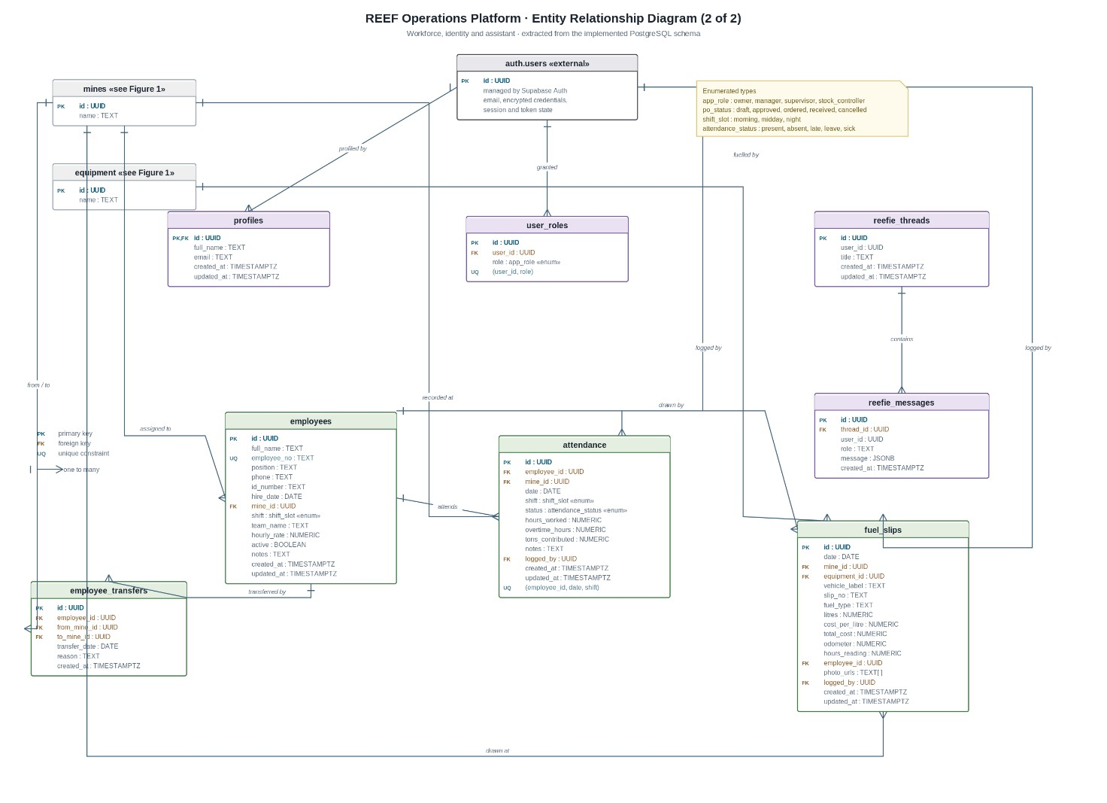
Figure 6.2 - Entity relationship diagram: workforce, identity and assistant

6.2.1 Clients and Mines
The first thing worth explaining is why clients and mines are separate tables. REEF is a contract mining services company, so it does not own the mines it works at. It contracts to client companies, and each client can have more than one site. Splitting these means contract revenue sits on the client record while cost per ton is worked out per mine, which is what lets the owner see that one site is losing money even though the client relationship overall is profitable. If a single site table had been used, that distinction would have been lost, and answering which site is actually making money is the whole point of the platform.
A client has many mines. The foreign key on mines is set to null on delete, so removing a client from the system does not wipe out the production history of the sites REEF worked at.

6.2.2 Equipment and Maintenance
Equipment belongs to a mine, and each piece carries the values the platform needs for wear tracking: tons since install, hours since install, expected life in both tons and hours, and service intervals in both tons and days. Two service intervals rather than one is deliberate. Some components wear by throughput and some by calendar time, and whichever comes first should trigger the service.
Maintenance logs belong to equipment, and this relationship cascades on delete. That is a different decision to the one above, and it is worth saying why: a maintenance record has no meaning without the machine it describes, so if the equipment is scrapped its history goes with it. The link from equipment to a mine is set to null instead, because closing a site does not destroy the machines that were on it. Those machines get moved.
Below maintenance logs sits the maintenance parts table, which records which stock items were consumed on a repair and in what quantity. That table is small but it does a great deal of work, and it is returned to below.

6.2.3 Stock and Procurement
Suppliers supply stock items and receive purchase orders. A purchase order is itemised by order lines, and each line points at the stock item being ordered. Order lines cascade from the purchase order because a line cannot exist without its order, but the link to the stock item is set to null so that removing a discontinued item does not destroy the record of what REEF has historically bought.
The interesting part is that the stock items table has two junction tables hanging off it, and together they form the entire stock loop. Maintenance parts records stock going out, consumed on repairs. Order lines records stock coming back in, ordered from suppliers. Every movement of every item runs through one of those two tables, which is why the platform can hold an accurate quantity on hand without anyone counting shelves.
Stock items also carry a reorder point and a reorder quantity, and these are the values that drive the automatic ordering described in Section 5.1.2.

6.2.4 Production, Cost and Downtime
Production logs belong to a mine and record tons produced, magnetite used and its cost, and overtime hours and cost. Static costs also belong to a mine but are recorded monthly by category. Keeping static and variable costs in separate tables lines up with how REEF actually thinks about money: wages and leases do not change with output, whereas magnetite and overtime do. Cost per ton needs both, which is why the reporting described in Section 5.1.3 draws from the two tables together.
Downtime events link to both a mine and a piece of equipment, and the equipment link is nullable because not all downtime is caused by a machine. The reason column is constrained by a check to breakdown, no stock, waiting on part, planned maintenance, or other, which stops anyone entering free text and making the downtime analysis useless.

6.2.5 Workforce and Identity
Figure 6.2 covers employees, attendance, transfers and fuel slips. Attendance carries a unique constraint on employee, date and shift, so the same person cannot be marked present twice for the same shift. Transfers record movement between mines with a from and a to, which preserves the history rather than simply overwriting an employee's current site.
The users table is managed by Supabase Auth rather than by the team, which is why it is marked as external. Profiles extend it one to one, and the user roles table gives a user one or more roles drawn from an enumerated type. Holding roles in their own table rather than as a column on the user means that a person can hold more than one, and it is also the table that the database access policies check against.

6.2.6 Constraints and Enumerated Types
Four enumerated types constrain values at the database rather than in the application: application role, purchase order status, shift slot and attendance status. That matters because it means an invalid value cannot be written by any client, including one that nobody on the team wrote. A check performed in the application only protects the paths the application controls.
The same thinking applies to the foreign keys. There are 29 of them, and each one either cascades or sets null on delete. Nothing is left undefined, so the database cannot end up holding a maintenance record that points at equipment which no longer exists.

7. Architecture Artifacts

7.1 Design Patterns
Author: Tayler Usmar (ST10445063), Bradley Rwafa (ST10458380)

7.1.1 Introduction
A design pattern is a reusable solution to a problem that keeps appearing in the internal structure of software. It differs from an architecture pattern, which Section 7.2 covers, and the difference is scope rather than kind. An architecture pattern decides how a system splits into major parts. A design pattern decides how the classes and objects inside one of those parts work together.
That distinction matters here because the same component appears in both sections. The adapter around the artificial intelligence service is described in this section in terms of which objects communicate at runtime, and in Section 7.2.9 in terms of the system boundary it protects. Neither description is complete on its own.
The patterns below are described as they appear in the prototype built for Task 1, not as intentions for a later phase. Where the prototype implements only part of a pattern, this is stated rather than glossed over.

7.1.2 Repository
Source: src/lib/reef-db.ts
None of the page components query the database directly. Three functions do all of it, and each one is generic over the table being addressed, with the table name constrained by a union type covering all sixteen operational tables. The equipment screen and the stock screen call the same function with a different argument.

export type TableName =
| "clients" | "mines" | "equipment" | "suppliers"
| "stock_items" | "purchase_orders" | "po_lines"
| "maintenance_logs" | "maintenance_parts"
| "production_logs" | "static_costs" | "downtime_events"
| "employees" | "attendance" | "employee_transfers" | "fuel_slips";

export function useList<T = any>(table: TableName, orderBy = "created_at", asc = false) { return useQuery({
queryKey: [table, "list", orderBy, asc], queryFn: async () => {
const { data, error } = await supabase
.from(table as any)
.select("*")
.order(orderBy, { ascending: asc }); if (error) throw error; return (data ?? []) as T[];
},
}); }
Listing 7.1 — One generic read function serving sixteen tables (src/lib/reef-db.ts)
This is the Repository pattern, which Fowler (2002) describes as mediating between the domain and the data source so that business code works against a collection-like interface rather than against the database directly. What this solves is duplication. Without it every screen would carry its own query and changing how data is fetched would mean editing every screen. Routing everything through one module means components depend on a small interface rather than on the query API of the database library.
Two things about this implementation go past the textbook version of the pattern. The hooks are built on a query-caching library, so the update and delete functions invalidate the cached results for their table when they succeed. A list on one screen refreshes because another screen modified a record, without either screen knowing about the other. The second thing is that success and failure messages are raised inside the mutation hooks rather than at each call site, so every save in the application reports itself in the same way.
One limitation is worth being honest about. In the prototype this repository runs in the browser rather than behind a server tier. The pattern is applied correctly; it is simply sitting on the client side of the network boundary. Section 7.2.6 describes where this layer belongs in the full system, and that difference comes from Task 1 not requiring a back end rather than from any disagreement about the design.
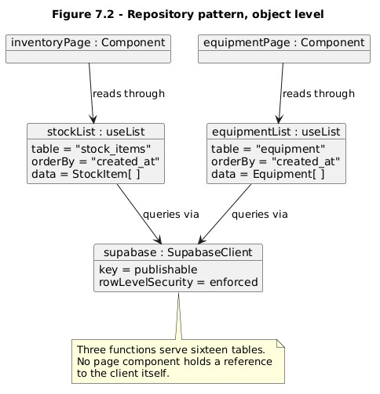
Figure 7.1 - Repository pattern at object level

7.1.3 Adapter
Source: src/lib/ai-gateway.server.ts, used by src/routes/api/chat.ts
The artificial intelligence capability is reached through a factory that returns a configured provider. It is seven lines long, and it takes a client built for one provider's interface and points it at a different gateway. The chat route imports the factory and never touches the underlying provider itself.

import { createOpenAI } from "@ai-sdk/openai";

export function createGeminiAiGatewayProvider(apiKey: string) { return createOpenAI({ name: "gemini",
apiKey,
baseURL: "https://ai.gateway.gemini.ai/v1", }); }
Listing 7.2 — The adapter in full: seven lines confine all provider knowledge to one module (src/lib/ai-gateway.server.ts)
The Adapter pattern converts the interface of a class into another interface that clients expect, allowing classes to work together that otherwise could not because of incompatible interfaces (Gamma et al., 1994). The problem this solves is being tied to an external interface the team does not control. Providers change their APIs, change their pricing, and are replaced. Keeping all provider-specific knowledge in one module means that swapping provider affects one file. The adapter being this small is the point; there is nothing in it except the translation.
One thing is not yet built. Section 7.2.9 describes the adapter falling back to a template-generated summary when the provider is unavailable or over its request quota. That fallback is designed but not implemented, and the current file contains no failure path. Having the adapter in place is what makes the fallback cheap to add later, because it goes in one location and every caller receives it without changing.
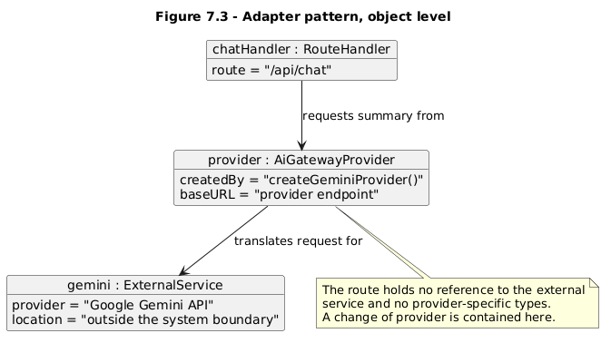
Figure 7.2 - Adapter pattern at object level

7.1.4 Singleton, Lazy Initialisation and Proxy
Source: src/integrations/supabase/client.ts and client.server.ts
Both database clients are exported in the same way, and there are three patterns working together in about eight lines of code.
Singleton, Proxy and Lazy Initialisation are all described by Gamma et al. (1994); a Singleton ensures a class has only one instance and provides a global point of access to it, while a Proxy provides a surrogate for another object in order to control access to it. The exported value here is a Singleton, so every module that imports it receives the same instance, and therefore the same connection pool and the same authentication session. A client created per component would fragment that session, and a user signed in through one instance would not be recognised by another. The instance is built by Lazy Initialisation, on first property access rather than at import time. And the value actually exported is a Proxy: an empty object that intercepts every property access and forwards it to the real client once that client exists.
The laziness is not decoration. The factory throws if its environment variables are missing, and the error names which ones. If the client were built eagerly at import, that error would fire while the module graph was still loading, which makes it difficult to trace. Deferring it means the failure appears where the client is actually used, with a message a developer can act on.
let _supabase: ReturnType<typeof createSupabaseClient> | undefined;

export const supabase = new Proxy({} as ReturnType<typeof createSupabaseClient>, { get(_, prop, receiver) { if (!_supabase) _supabase = createSupabaseClient(); return Reflect.get(_supabase, prop, receiver); },
});
Listing 7.3 — Singleton, lazy initialisation and proxy in eight lines (src/integrations/supabase/client.ts)
There is a security dimension to this as well. Two clients exist and they do not carry the same privileges. The browser client uses the publishable key and operates under row-level security, so the database limits what the signed-in user can read or write. The server client uses the service role key and bypasses row-level security entirely.
What keeps them apart is a file-naming convention. Modules ending in .server.ts are excluded from the browser bundle, and the comments in the file point out that route files and function files do ship to the client, so the administrative client must be imported dynamically inside a server handler rather than at the top of a route. If that convention is broken, a credential that ignores every access rule in the database is delivered to every user's browser. That is a real failure mode, and it is worth naming rather than describing the pattern in the abstract. Section 8 examines it further.
A second short listing evidences the privilege split described in this subsection.

// client.server.ts - service role key, bypasses row-level security const SUPABASE_SERVICE_ROLE_KEY = process.env.SUPABASE_SERVICE_ROLE_KEY;

// SECURITY: Only use this for trusted server-side operations, // never expose to client code. Load inside server handlers:
// const { supabaseAdmin } = await import("@/integrations/supabase/client.server"); // Top-level import is safe only in other .server.ts modules - route files // and *.functions.ts ship to the client bundle.
Listing 7.4 — The convention that keeps the administrative client out of the browser bundle (src/integrations/supabase/client.server.ts)

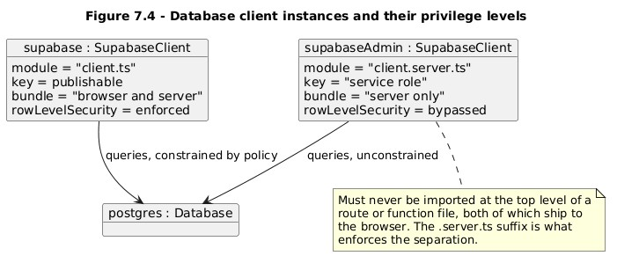
Figure 7.3 - Database client instances and their privilege levels

7.1.5 Guard
Source: src/hooks/useRole.ts, with is_manager() and has_role() in the database
Permission checking happens in two places and they perform different jobs. On the client, a hook reads the signed-in user's rows from the user roles table and reduces them to a single value by precedence, with owner taking priority over manager and manager over worker. A helper answers the common question of whether someone holds either of the elevated roles. Components use these to decide what to display.
These two listings belong together. The first decides what is displayed; the second decides what is permitted.
export function useMyRole() {
return useQuery({
queryKey: ["me", "role"],
queryFn: async (): Promise<Role | null> => {
const { data: userRes } = await supabase.auth.getUser();
if (!userRes.user) return null;
const { data } = await supabase
.from("user_roles")
.select("role")
.eq("user_id", userRes.user.id);
const roles = (data ?? []).map((r: any) => r.role as Role);
if (roles.includes("owner")) return "owner";
if (roles.includes("manager")) return "manager";
if (roles.includes("worker")) return "worker";
return null;
},
});
}

Listing 7.5 — The client-side hook, which shapes the interface (src/hooks/useRole.ts)
In the database, two security-definer functions are consulted by the row-level security policies whenever a query runs. The honest way to describe this arrangement is that the client hook is a convenience and the database policies are the actual control. Someone running a modified client, or querying the database directly with their own credentials, bypasses the hook entirely. They do not bypass the policies, because the database evaluates those on every query regardless of which client sent it.
CREATE POLICY "Managers manage stock" ON public.stock_items FOR ALL TO authenticated USING (EXISTS (SELECT 1 FROM public.user_roles ur
WHERE ur.user_id = auth.uid() AND ur.role IN ('owner','manager')));
Listing 7.6 — The database policy, which enforces the rule (supabase/migrations/)
That is worth stating plainly. A permission check that exists only in the interface is not a security control; it is a usability feature that stops people attempting actions which would fail anyway. Both are worth having and confusing them is how an application ends up with a hidden button protecting nothing. The pattern is a Guard, a condition checked before an operation which decides whether it proceeds, and what makes this version defensible is that the guard sits at the layer that can actually refuse.

7.1.6 Trigger-Based Hooks
Source: supabase/migrations/
Four database functions are attached to tables as triggers rather than being called by application code. One maintains the updated timestamp before update on twelve tables. One creates a profile and role record after a new user is inserted. One consumes stock after a maintenance part is inserted. And one handles the status transitions of a purchase order before update.
This is a hook-based pattern in the Template Method family. The database defines a fixed sequence around each write and these functions supply behaviour at set points inside it. The application performs an ordinary insert or update, and the additional behaviour occurs as part of the same operation.
The advantage is that it cannot be skipped. The stock consumption function reduces stock when a repair uses parts, and raises a draft purchase order if the remaining quantity reaches the reorder point. If that logic lived in the application, any code path that recorded maintenance without calling it would leave stock levels wrong. In the database, every write is subject to it, including writes from a client the team did not write.
The hardening on these deserves its own sentence. They run as security definer, which means they execute with their owner's privileges rather than the caller's, and that is what allows them to modify tables the calling user may not have rights on. Left there it would be a privilege escalation route. The migrations close it by revoking execute permission from public, anonymous and authenticated users, so the functions retain their elevated privilege but no client can invoke them directly. They run only as part of the trigger. That is the difference between security definer being a control and being a vulnerability.

CREATE TRIGGER trg_consume_stock
AFTER INSERT ON public.maintenance_parts
FOR EACH ROW EXECUTE FUNCTION public.consume_stock_on_maintenance();

REVOKE ALL ON FUNCTION public.consume_stock_on_maintenance()
FROM PUBLIC, anon, authenticated;
REVOKE ALL ON FUNCTION public.receive_po()
FROM PUBLIC, anon, authenticated;
Listing 7.7 — The function runs only as part of the trigger; no client can invoke it directly (supabase/migrations/)
There is a cost, and it should be recorded. The behaviour is invisible in the application source. A developer reading the code that inserts a maintenance part sees nothing indicating that stock levels change and a purchase order may be created. That is a genuine maintainability trade-off rather than a pure benefit.

7.1.7 Facade
Source: src/routes/api/chat.ts
The assistant does not receive access to the database. It receives three bounded operations, each with a declared input schema, each running a fixed set of queries and returning a summarised result. The inventory operation returns the item count, total inventory value, the items at or below their reorder point, and recent purchase orders. That is all it returns. The assistant cannot request anything else, cannot compose its own query, and cannot reach a table for which no operation exists.
const tools = {
inventory_status: tool({ description: "Stock levels, items at or below reorder point, " + "total inventory value, and open purchase orders.", inputSchema: z.object({}), execute: async () => {
const [{ data: items }, { data: pos }] = await Promise.all([ supabase.from("stock_items")
.select("name, sku, unit, qty_on_hand, reorder_point, reorder_qty, unit_cost"), supabase.from("purchase_orders")
.select("id, status, total_cost, created_at")
.order("created_at", { ascending: false }).limit(25),
]);
const list = items ?? []; return {
total_items: list.length,
inventory_value: list.reduce((s, i) => s + num(i.qty_on_hand) * num(i.unit_cost), 0), low_stock: list.filter((i) => num(i.qty_on_hand) <= num(i.reorder_point)), purchase_orders: pos ?? [],
};
}, }),
// maintenance_status and production_and_costs follow the same shape };
Listing 7.8 — One of three bounded operations available to the assistant; it cannot compose queries of its own (src/routes/api/chat.ts)
That is a Facade, which Gamma et al. (1994) define as a unified interface to a set of interfaces in a subsystem, making that subsystem easier to use. Here it exposes only what one particular client needs. Here it is partly convenience and mostly containment. A language model with unrestricted query access could read anything the connection permits. With three operations, its reach is exactly what those three return.
Two further decisions complete the picture. The route builds its database client from the requesting user's own token rather than the administrative client, so the assistant reads through the same row-level security as the person asking, and a worker's question cannot return data a worker could not otherwise see. And the system prompt instructs the model to call a data operation before quoting any figure and never to invent numbers, which addresses accuracy rather than access.
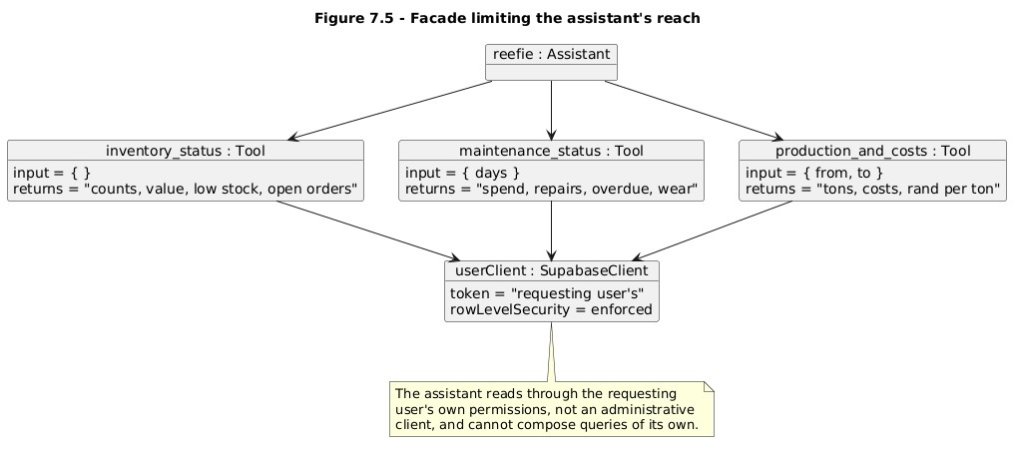
Figure 7.4 - Facade over the data layer

7.1.8 Conclusion
What these patterns have in common is that each one isolates something. The repository isolates changes to data access, the adapter isolates changes to an external provider, the singleton isolates the creation of a shared resource, the guard isolates permission decisions, the trigger hooks isolate rules that must apply to every write, and the facade isolates how far an untrusted consumer can reach. In each case a change that would otherwise spread across many files lands in one.
Three of them do more than structure. The split between the two database clients, the placement of permission enforcement in the database rather than the interface, and the revocation of direct execute rights on the trigger functions all determine what a modified or compromised client is able to do. Section 8 takes these up.

7.2 Architecture Patterns
Authors: Tayler Usmar (ST10445063) and Tlamelo Mothupi (ST10460421)

7.2.1 Introduction
The requirements for the REEF Operations Platform demand an architecture capable of integrating four distinct areas of the business, namely maintenance and repairs, stock control, financial reporting, and performance and downtime monitoring, into a single connected system. Each of these areas must be able to exchange information with the others, while still maintaining a clear separation between the responsibilities belonging to each. An architecture pattern is a reusable, named solution to a recurring problem of system structure: how a system is divided into major parts, what those parts are permitted to know about one another, and how they communicate. This distinguishes an architecture pattern from a design pattern, which addresses the internal structure of code within a single component.
This section identifies the architecture patterns that will be used within the platform, provides a justification for each of them in relation to the requirements of the project, and describes the manner in which those patterns will operate together. The patterns that will be used are a three-tier architecture, a client-server architecture, RESTful APIs, dependency injection together with service-based business logic, the repository pattern, an offline-first store-and-forward approach, role-based access control, and an adapter with graceful degradation for the artificial intelligence component of the system.
Three constraints of the project informed the selection of these patterns, and each of the choices described below is justified in relation to them. Firstly, connectivity at the client mine sites is unreliable, and the system therefore cannot assume that a network connection will be available at the time at which information is captured. Secondly, the platform is intended to operate as one connected system rather than as four separate applications, and the architecture must therefore make this the case structurally rather than merely stating that it is so. Thirdly, the platform will be developed by a team of five members using free hosting services, and any pattern that would impose an operational burden disproportionate to that capacity would be unsuitable regardless of its technical merits.
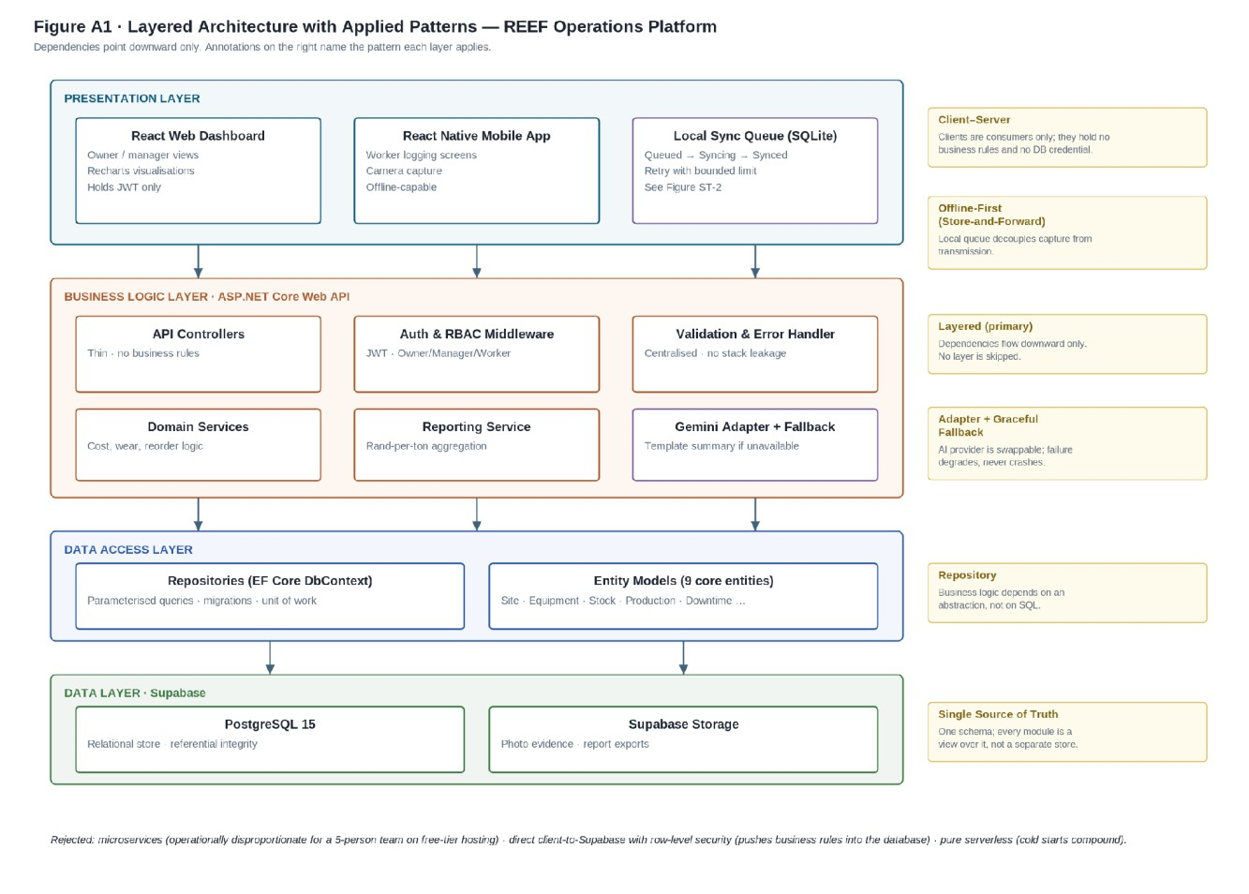
Figure 7.5 — Layered architecture with applied patterns. Dependencies point downward only; annotations name the pattern applied at each layer.

7.2.2 Three-Tier Architecture
The primary architecture pattern that will be used in the REEF Operations Platform is a three-tier architecture. This model divides an application into three principal tiers: a presentation tier, an application or business logic tier, and a data tier (IBM, 2025). Each tier will carry its own defined responsibility. This will allow the components of the system to be developed and maintained independently of one another.
The presentation tier is responsible for interaction with the users of the system. It is a React web application which adapts to the device it is opened on, so that managers working at a desk and workers capturing information on a phone at a mine site use the same application rather than two separate ones. The management views provide stock levels, production performance, maintenance information and generated reports. The worker views provide a means of capturing information from mining operations, including equipment maintenance, stock usage, production tonnage, downtime and fuel. A dedicated React Native mobile client is planned for a later phase, together with the offline capability described in Section 7.2.7.
The business logic tier holds the rules that govern how information is processed. In the delivered architecture that tier is the Web API: validation, orchestration and every business rule execute there, so that a rule is written once and applies identically to the dashboard and to the mobile client, which is what the requirement for a single documented back end consumed by both clients amounts to in practice. In the Task 1 prototype the tier is distributed rather than consolidated, with validation and orchestration running in the TanStack Start server routes and in the application's own TypeScript modules; consolidating them behind the documented interface is package 5.2. Independently of either arrangement, the rules that have to hold for every write, no matter which client makes it, are written as PostgreSQL functions and attached to their tables as triggers. Putting a rule such as stock consumption in the database rather than in the interface means it cannot be skipped by a client that forgets to call it, which is a stronger guarantee than keeping it in application code alone, and it remains true once the direct client path is withdrawn.
The data tier is responsible for storing the information of the system. PostgreSQL is used through Supabase, together with Supabase Storage for files. The database holds information relating to the mining sites, the equipment at each site, the maintenance history of that equipment, stock levels and movements, production output, and recorded downtime.
A three-tier architecture is used for the system because of the different users it serves and because the same information is reached from different views. The separation of the tiers also improves the maintainability of the system.
In the current Task 1 prototype, by contrast, the separation between the tiers is enforced by what each credential is allowed to do, rather than by putting a server in between. The browser gets a publishable key, and every query it makes is checked against the row-level security policies before any row comes back. A second key with higher privilege exists for serverside work and is kept in modules that never reach the browser bundle, which Section 7.1.4 covers in detail. So the clients do reach the data layer directly, but only inside the boundary the database itself enforces. The trade-off is that authorisation lives in the database rather than in one application tier, and that is discussed in Section 7.2.11.

7.2.3 Client-Server Architecture

The platform also applies a client-server architecture. The clients, being the web and mobile applications, issue requests to a server, in this case the Web API. When a user performs an action such as recording a maintenance event, the request travels from the client application to the server, which processes it and communicates with the database as required to fulfil the task.
The use of a client-server architecture allows for the user interface to be separated from the backend of the system. Furthermore, the use of such an architecture also provides security to the system, as the client applications will not have direct access to the database of the system.
In the current Task 1 prototype, by contrast, the client applications act only as consumers of the data layer. They display information and capture input from the users, but they contain no privileged credentials and cannot read or write anything outside the boundary the database enforces for the signed-in user. This distinction matters for the security of the system. If the interface alone decides which records a worker may view, a modified version of the application can be used to view records that workers should not have access to. Because every request is checked against the row-level security policies before a single row is returned, a modified client cannot obtain information the user was not already permitted to access in the first place.

7.2.4 RESTful API
Communication between the clients and the backend will be implemented as a RESTful API. RESTful web APIs apply REST principles to provide an interface between client applications and web services (Microsoft, 2025a). For the REEF Operations Platform, these APIs will allow the web and mobile applications to communicate with the backend. This section describes the delivered architecture reached via package 5.2 of the work breakdown structure; the Task 1 prototype, documented with source in Section 7.1, does not yet expose this interface and instead queries Supabase directly under row-level security, as Section 7.3.4 explains.
The API will expose endpoints for user authentication, maintenance events, stock levels and movements, production output, and downtime events. Requests will be made through the standard HTTP methods, with GET used to retrieve information and POST used to create new records. Responses will follow a consistent JSON format and the API will be versioned from the outset, so that a future change to the format of a response does not affect an installed mobile application that has not yet been updated.
The use of a RESTful interface will mean that the clients do not require any knowledge of the internal processing of the backend. This separation of concerns provides loose coupling between the frontend and backend of the system (Microsoft, 2025a), and it will allow two different client technologies, namely a React web application and a React Native mobile application, to make use of the same business logic without duplication.

7.2.5 Module Composition and Separation of Concerns

The platform does not use a dependency injection container. TypeScript modules are composed through explicit imports rather than resolved at runtime by a container, which gets to the same separation of concerns a different way. A component that needs data imports the data-access module; it does not build a database client of its own and it does not know how the query is made.
What service classes would have done is handled in two places. Behaviour that belongs to one screen lives in that screen's module. Behaviour that has to apply to every write, whichever client makes it, is written as a PostgreSQL function and attached to its table as a trigger. Stock consumption on maintenance and the status changes on a purchase order both work this way, and Section 7.1.6 describes them at object level.
The benefit is the same one a container gives you: a change to how something works which happens in one module instead of at every call site. The cost is that the composition is fixed when the module is imported rather than configurable at runtime. For a system this size that is a reasonable trade, and it saves maintaining a layer of indirection we do not need to implement at the size the system currently is.

7.2.6 Repository Pattern
Data access goes through a single module that exposes three generic functions, covering listing, saving and removing records. Each is generic over the table being addressed, so those three functions serve every operational table in the schema. Components depend on that small interface instead of on the query API of the database library. Section 7.1.2 documents the implementation with the source. One point of placement should be stated, since it is the whole of the difference between the prototype and the delivered system. In the prototype this module executes in the browser. In the delivered system the same abstraction sits behind the Web API, so that the collection-like interface upon which the callers depend is unchanged while the query itself executes upon the server. The pattern is identical in both; only the side of the network boundary upon which it runs moves, and that move is package 5.2.
There are three reasons for routing access through this module. Firstly, query construction sits in one place, so a change to how data is fetched is made once instead of in every screen. Secondly, caching and invalidation are defined centrally, which means a save in one part of the interface refreshes the lists that depend on it without either component knowing about the other. Thirdly, the storage technology becomes easier to replace, this is because a change would be contained in this module rather than affecting every component that reads data.

7.2.7 Offline-First (Store-and-Forward)
A further pattern that will be used within the mobile application is an offline-first, or store-and-forward, approach. This pattern addresses the first of the constraints described in the introduction, and is the pattern most specific to the operating conditions of the mining sites at which REEF works.
The capture of information will be separated from the transmission of that information. When a worker records a repair, a stock movement or a downtime event, the entry will be written to a local database on the device and confirmed to the worker immediately. A connectivity listener within the mobile application will then transmit the queued entries to the backend once a network connection becomes available. The actions performed by the worker will be the same whether or not a network connection is present at the time of capture. This is intended, as a worker at a processing plant should not be required to determine whether an entry has been transmitted before continuing with their work.
Two decisions have been made regarding the operation of this queue. Firstly, the number of retries will be limited. An entry that repeatedly fails to transmit will be moved to a rejected state rather than being retried indefinitely, which will prevent a single incorrect record from consuming battery and network resources and from delaying the entries behind it in the queue. Secondly, entries that fail to transmit will be marked as failed rather than being discarded, so that a record of them is retained and the worker can be informed of which entries did not synchronise and for what reason. The behaviour of this queue is documented in Section
5.2.1.

7.2.8 Role-Based Access Control
The security of the system will be supported by role-based access control. Role-based authorisation allows an application to restrict user access to different parts of the application according to the roles held by those users (Microsoft, 2025b). Three roles will be defined within the system: an admin or owner role, a manager role, and a worker role.
A worker should not hold the same level of access as a manager or an owner. A worker will have access to the features concerned with recording maintenance, production output and downtime at their site. A manager will have access to the dashboards that report on those aspects. An admin or owner will have access to all features of the system, including the comparison of financial performance across sites. These permissions will be enforced by the backend rather than by the frontend applications, since a permission enforced only in the user interface is not a security control at all.
Role-based access control is included as an architectural pattern rather than as a feature of the system because it determines where the authorisation decision is made, and not only what that decision is. Authorisation will be implemented as middleware placed in front of each of the controllers of the backend, which will provide a single point through which all protected requests must pass. As a result, the addition of a new endpoint to the system will not depend on a developer remembering to add an authorisation check to that endpoint, as the check will already be applied. If authorisation were instead implemented separately within each controller, an endpoint for which the check was omitted would appear to function correctly, and the omission would not become apparent until it was exploited.

7.2.9 Adapter with Graceful Degradation
The artificial intelligence feature of the platform will be integrated through an adapter class, which will present a single, limited interface to the remainder of the system for the purpose of summarising a set of report figures. Two benefits will result from this approach.
Firstly, the provider of the artificial intelligence service will be able to be replaced more easily. None of the services within the backend will refer to types specific to a particular provider, and a change of provider would therefore be contained within the adapter class. Secondly, and more importantly, the adapter is designed to reduce its functionality rather than fail entirely. This fallback is planned rather than implemented in the Task 1 prototype, which contains the adapter but not yet the failure path. If the artificial intelligence service is unavailable, has exceeded its request limit or returns an error, the adapter will instead produce a summary constructed from a predefined template using the same figures. The monthly report will therefore always be produced. This approach addresses a known constraint of the system, as the free tier of the service permits only a limited number of requests each day, and it ensures that an external service which the team does not control cannot prevent a core function of the system from operating.

7.2.10 How the Patterns Operate Together
The patterns described above will not operate independently of one another. Each of them addresses a different aspect of the structure of the system, and the manner in which they operate together is of importance to the design.
The three-tier architecture will determine where each part of the logic of the system may be located. The client-server architecture will apply that separation across a network boundary, and the RESTful API will provide that boundary with a documented and versioned interface. Dependency injection and the separation of controllers from services will determine how the components within the business logic tier depend upon one another, while the repository pattern will apply at the boundary between the business logic tier and the data tier, so that the details of database access are not required by the services of the backend.
The offline-first pattern will operate outside of this structure, within the mobile application. It represents the only point at which the system will hold a temporary second copy of information, and the store-and-forward approach is the means by which that copy will be returned to the central database without permitting the mobile application to write to that database directly. Role-based access control and the adapter for the artificial intelligence service will then apply at the two boundaries at which the system is most exposed, namely the point at which requests are received from clients and the point at which an external service is called.
Considered together, these patterns will produce a system in which the offline capability required by REEF does not compromise the accuracy of the information on which the reporting functions of the system depend.

7.2.11 Alternatives Considered and Rejected
A number of alternative architectures were considered for the platform before the architecture described above was selected. Each of these alternatives, and the reason for which it was not selected, is set out below.

Alternative considered | Reason for rejection
Microservices architecture | Operationally disproportionate for a five-person team on free hosting. Independent deployment, service discovery and distributed tracing are costs paid for a scaling benefit this system does not require at three client sites.
A dedicated application server sitting between the clients and the database | Considered and rejected for this phase. Putting a server tier in the middle would centralise authorisation in application code, but it duplicates rules the database can already enforce, adds a hop to every read, and introduces another component that has to be hosted, deployed and kept running. Row-level security gives us enforcement a modified client cannot get around, which a server tier only matches if it is the only route to the data.
Pure serverless function architecture | Cold-start latency would compound on top of the free tier's existing delay, and per-function deployment fragments the shared domain logic on which the platform depends.
Monolithic client with an embedded local database | Cannot satisfy the consolidated multi-site reporting requirement, which is the core business problem the platform exists to solve.

7.2.12 Suitability of the Architecture for REEF
The architecture that will be implemented for the REEF Operations Platform is suitable for the system and its requirements. Each of the components of the three-tier architecture will be able to be developed and managed independently of the other components of the system, which is of benefit to a team working on separate parts of the system at the same time. The client-server architecture, together with the RESTful API, will allow the two frontend applications of the system to make use of a single implementation of the business rules, so that a change made to a calculation such as the reorder point will apply to both applications at the same time.
The architecture will also allow for the future development of the system. Because the components of the system will be independent of one another, further additions may be made to each of them without restructuring the system as a whole. Such additions may include additional dashboards for the management team members, additional functionality within the mobile application, further reporting functions for the mining operations, or the predictive maintenance and artificial intelligence features that are planned for later phases of the project.
Of most significance to REEF specifically, the offline-first approach will allow the platform to remain usable at sites at which connectivity is intermittent. As the majority of the information captured by the system will be entered under these conditions, an architecture that assumed a reliable network connection would be unsuitable for the environment in which the system is intended to be used.

7.2.13 Conclusion
The architecture for the REEF Operations Platform will make use of a number of architectural patterns in order to provide a secure, maintainable and scalable system. The three-tier architecture will separate the components of the system according to their responsibilities. The client-server architecture will allow the mobile and web applications to communicate with the backend, and the RESTful API will provide a standard interface through which that communication will take place. Dependency injection and the separation of services from controllers will reduce the coupling between the components of the backend, while the repository pattern will separate those components from the details of database access. The offline-first approach will allow workers to capture information at sites at which connectivity is unreliable. Role-based access control will limit the access of each user to those features of the system that are appropriate to their role, and the adapter for the artificial intelligence service will allow the reporting functions of the system to continue to operate if that service is unavailable.
Each of these patterns has been selected in response to a specific requirement or constraint of the project rather than adopted by default, and it is the manner in which they operate together, rather than any single pattern among them, that will allow the platform to maintain a single source of truth while operating under the conditions present at a working mine site.

7.2.14 Summary of the patterns applied, and the alternatives cross-checked
Author: Bradley Rwafa (ST10458380)
The subsections above establish each pattern in turn and justify it against the constraints of the project. What they do not provide, and what a reader verifying the architecture against the implementation needs, is a single statement of which pattern governs which element and which constraint each answers. Figure 7.6 and the table beneath it supply that statement. The figure is drawn at the level of the tier rather than the component, so that the one rule the architecture depends upon is visible without reading the surrounding prose: dependencies point downward only, and the versioned contract is the single seam across which the presentation tier is permitted to reach the business tier.
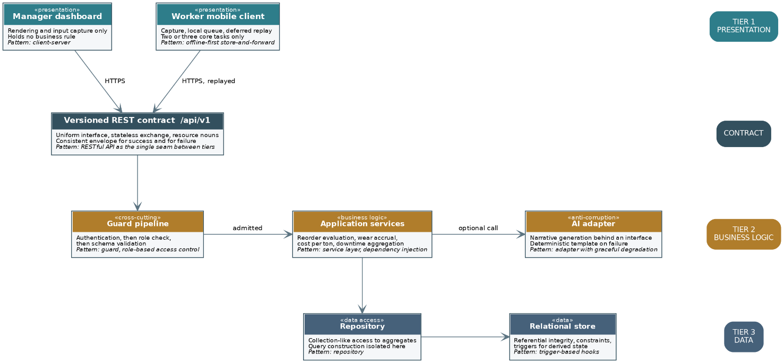
Figure 7.6 — The layered arrangement of the platform, annotated with the pattern that governs each element. The versioned contract constitutes the single seam across which the presentation tier is permitted to reach the business tier.
Pattern | Where it is applied | The constraint it answers
Three-tier layering | Presentation, business logic and data are separated, and a layer is permitted to address only the layer immediately beneath it. | The departmental requirement for a demonstrable separation of concerns. The separation is made enforceable by the deployment topology, in that no client artefact holds a database credential, and is therefore structural as opposed to advisory.
Client-server | The dashboard and the mobile client hold no business rule and issue requests to a server that holds all of them. | Two client applications are obliged to behave identically upon the same data. A rule duplicated across two clients diverges; a rule held once upon the server is not able to.
RESTful interface | A versioned contract at /api/v1 exposing resource nouns, stateless exchanges and a consistent envelope for success and for failure. | The requirement that the dashboard and the mobile client consume the same interface. Statelessness additionally permits the application tier to be restarted, which the free hosting tier does without notice (Fielding, 2000).
Offline-first store and forward | The mobile client writes to an encrypted local queue and replays each entry once connectivity returns. | Intermittent connectivity at the mine sites. The pattern treats the network as an unreliable resource as opposed to an assumed one, and it is the only arrangement under which a shift without signal does not cost REEF the record of that shift.
Repository | Data access is confined to classes that present a collection-like interface over the aggregates. | The isolation of query construction, which permits the business services to be tested without a database and prevents persistence concerns from diffusing through the business tier (Fowler, 2003).
Dependency injection with a service layer | Business operations are held in services that receive their collaborators by construction as opposed to constructing them. | Testability, and the substitution of the artificial intelligence client by a deterministic double during verification (Richards and Ford, 2020).
Guard pipeline | Authentication, then the role check, then schema validation, applied in that order before a request reaches a service. | The requirement that access restrictions be enforced by the system as opposed to being concealed within the interface. Ordering the checks places the cheapest rejection first and prevents an unauthenticated request from consuming validation effort.
Role-based access control | Permissions are attached to roles and roles to users, and the check is performed upon the server for every restricted operation. | The three levels of access that the requirements establish, and the confidentiality obligation that arises from REEF operating at mines belonging to competing clients (OWASP, 2025).
Adapter with graceful degradation | The artificial intelligence client sits behind an interface and returns a null result upon failure, whereupon the caller applies a deterministic fallback. | The dependency upon a free external service subject to rate limiting. The pattern confines the failure of that service to a reduction in the quality of the narrative as opposed to a failure of the report.
The alternatives cross-checked below repeat, in condensed form, the rejections argued in Section 7.2.11, and are retained because a reader auditing the architecture against the constraints needs the rejected options and the accepted ones in the same field of view.
Alternative | Grounds of rejection
Microservices | The system serves a bounded and known population across three active sites, and its modules share one transactional data model. Decomposition into independently deployed services would introduce network calls, eventual consistency and operational overhead in exchange for a scalability that REEF does not require and a cost that the zero-expenditure constraint does not permit.
Direct database access from the clients, secured by row-level policies alone | The arrangement is attractive under a free tier and is in fact what the Task 1 prototype does. It is rejected for the delivered system because it places the enforcement of every rule within the database, distributes the credential to every client, and is expressly precluded by the departmental requirement that clients consume the interface as opposed to the store.
A monolithic server-rendered application | It would satisfy the manager but not the worker, given that server-rendered pages presuppose connectivity at the moment of use, which is precisely the condition that the mine sites do not reliably supply.
Event-driven architecture with a message broker | The reorder rule and the wear accrual are genuinely event-shaped, and the pattern was considered for that reason. It was rejected because a durable broker is not available within the free tier and because the additional indirection would obscure a set of flows that a receiving team must be able to follow.
An offline capability achieved by browser caching alone | Caching serves retrieval and not capture. The requirement is that a worker be able to create a record without connectivity, which presupposes a durable local queue and a replay mechanism as opposed to a cached response.
Taken together, the patterns produce an arrangement in which one rule is enforced in one place, in which the client applications are thin by design, and in which the two dependencies most likely to fail, namely the network and the external artificial intelligence service, each degrade into a defined lesser behaviour as opposed to an outage. It is this property, as opposed to any individual pattern, that renders the architecture suitable for the manner in which REEF presently operates.
Read against Figure 7.5, which draws the same architecture at the level of the component and names the technologies selected for each layer, the two figures answer different questions and are deliberately retained together. Figure 7.5 answers what each layer is built from. Figure 7.6 answers what each layer is permitted to do and which pattern makes that restriction hold. A reviewer checking the implementation against the design needs both, because a layer built from the right technology and permitted the wrong reach is a layer that satisfies one figure and violates the other.

7.3 Cloud Architecture
Author: Bradley Rwafa (ST10458380)
The platform is deployed upon managed cloud services under a service model that is, in the terms of the recognised definition, principally platform as a service, in that REEF neither provisions nor administers the underlying compute, storage or network but does retain control of the deployed application and of its configuration (Mell and Grance, 2011). The consequence of that model, and it is a consequence that is stated here because it governs everything that follows, is that responsibility for security is divided: the provider secures the substrate and REEF secures that which it deploys upon it and the manner in which the components are permitted to address one another (ISO, 2015b). The division is not able to be renegotiated by REEF, with the consequence that the controls set out in Section 8 are confined to that portion which REEF is presently able to govern.
The topology is expressed as five zones. A zone, for the purposes of this document, is a grouping of components that share a level of trust and between which traffic is unrestricted, such that every control of consequence is applied at the boundary between one zone and another as opposed to within either. This is the segregation upon which the network security discussion in Section 8 is constructed, and the two sections are intended to be read together.
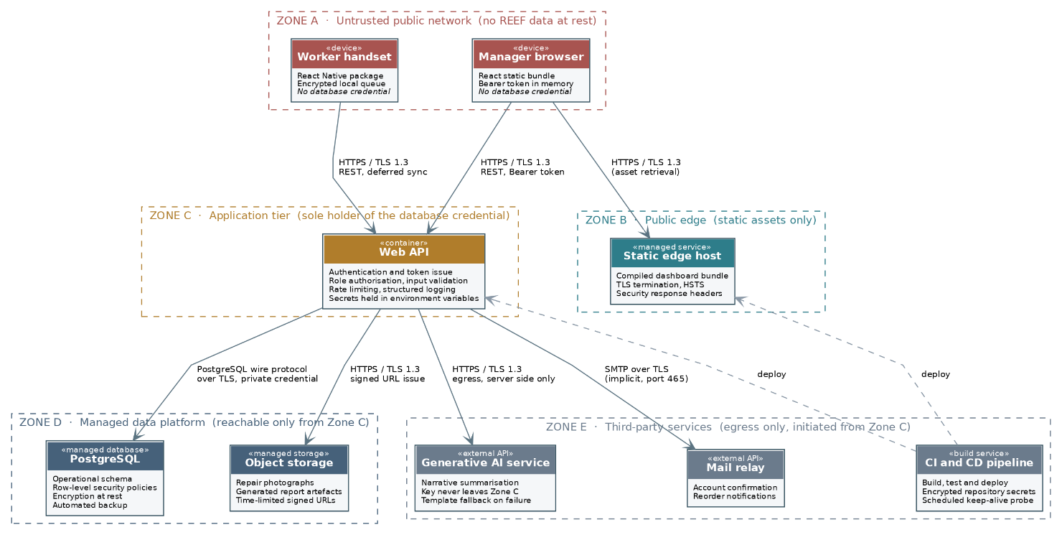
Figure 7.7: The cloud topology of the platform, showing the five zones, the services deployed within each and the protocol by which every permitted flow travels. No path exists by which a component in Zone A is able to address a component in Zone D.
Figure 7.8 presents the same topology in pictorial form. The two figures are deliberately redundant, given that they serve different readers: the schematic above is exhaustive and is the version against which the configuration is to be checked, whereas the pictorial version below is able to be read at a glance and is the version by which the shape of the network is most readily conveyed. Where a device possesses no conventional symbol, the closest available representation is used and the label resolves the ambiguity, so that a hosted server is drawn as a server carrying a cloud badge and is named as the cloud service that it is.
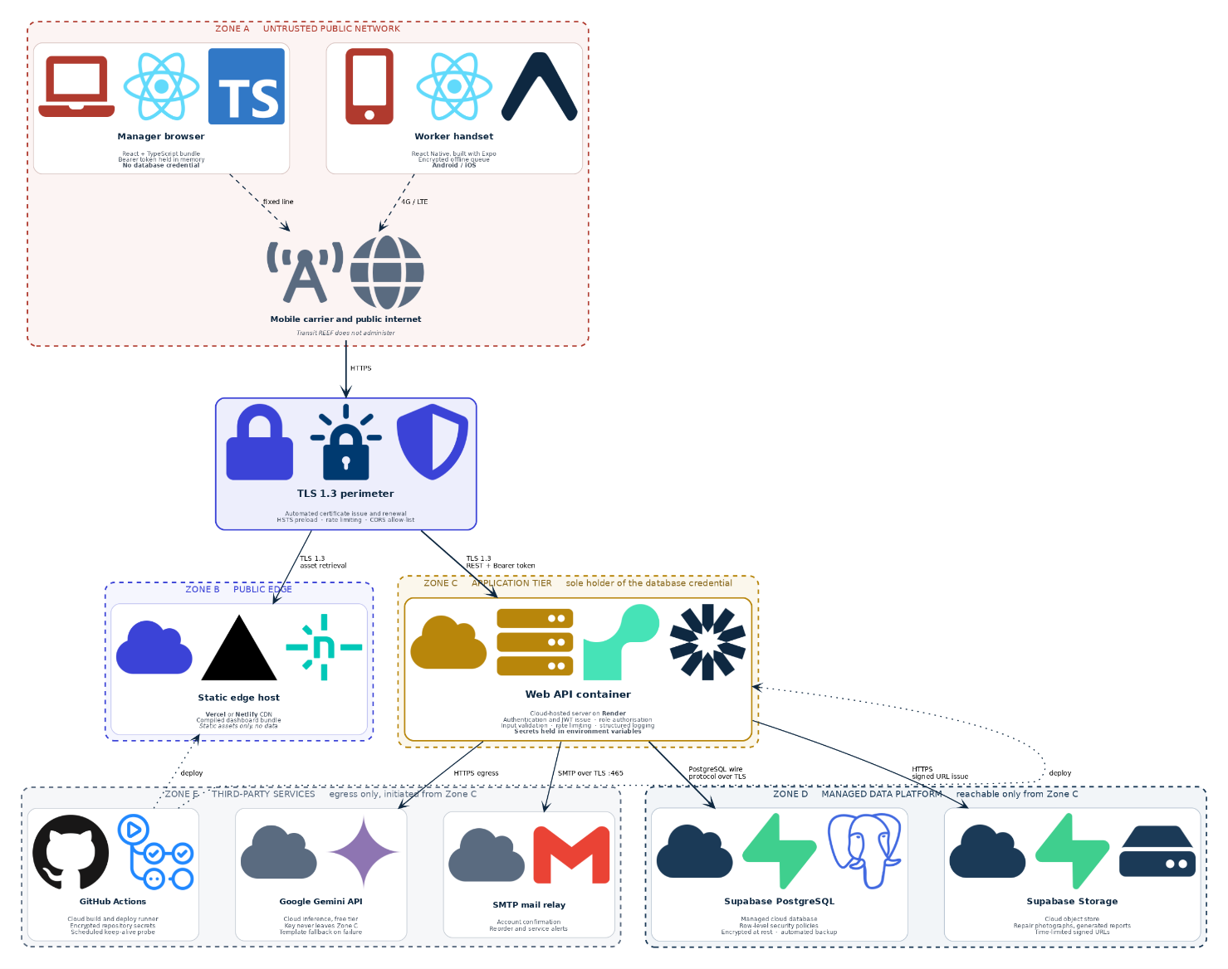
Figure 7.8: The cloud topology drawn pictorially. Each managed service is represented by the device symbol closest to its function, carrying a cloud badge to denote that it is hosted as opposed to being operated by REEF, and every link is annotated with the protocol by which it travels.

7.3.1 The zones and the services deployed within them
Zone | Services | Trust position and the reasoning for it
A. Untrusted public network | The worker handset carrying the mobile client, and the manager browser carrying the dashboard bundle. | Treated as hostile without qualification. The devices are not administered by REEF, they traverse mobile carrier networks and office links that REEF does not control, and neither artefact holds a database credential. Any material held upon a device is held encrypted and is retained only until it has been transmitted.
B. Public edge | The static host that serves the compiled dashboard bundle. | Publicly reachable by design, given that it serves assets to anonymous browsers. It carries no operational data of any kind, with the consequence that its compromise would disclose the application but not the business.
C. Application tier | The Web API container, which authenticates, authorises, validates, rate limits and logs. | The sole point at which trust is granted, and the sole holder of the database credential. Every request that reaches the data platform has passed through this zone, which is what permits the security controls to be reasoned about at one place as opposed to many.
D. Managed data platform | The PostgreSQL instance and the object store holding photographs and generated reports. | Reachable only from Zone C. Encryption at rest and automated backup are supplied by the provider. Row-level policies operate as a second line of defence and not as the primary control, the primary control being that no route exists from Zone A.
E. Third-party services | The generative artificial intelligence service, the mail relay and the build pipeline. | Trusted only to the extent of the specific call made to each, and addressed by egress from Zone C alone. No inbound connection from Zone E is accepted, and no credential belonging to Zone E is ever present within a client artefact.

7.3.2 Protocols governing the permitted flows
Flow | Protocol | Purpose and the control applied
Zone A to Zone B | HTTPS, TLS 1.3 | Retrieval of the compiled dashboard bundle. The edge terminates the connection, asserts strict transport security and returns the restrictive response headers.
Zone A to Zone C | HTTPS, TLS 1.3, REST with a bearer token | Every operational request, whether submitted at the time of the work or replayed from the local queue of the mobile client. The token is presented upon each request, the exchange holding no server-side session.
Zone C to Zone D, database | PostgreSQL wire protocol over TLS | Persistence. The credential resides within the environment of Zone C alone, and the connection verifies the certificate of the server in order that a substituted endpoint is refused.
Zone C to Zone D, object store | HTTPS, TLS 1.3 | Storage of photographs and of generated reports. Retrieval by a client is effected by a signed reference of limited life as opposed to by a durable public address.
Zone C to Zone E, artificial intelligence | HTTPS, TLS 1.3, egress only | Generation of the narrative. The key resides within the environment of Zone C, the payload carries no personal identifier, and the call is bounded by a timeout beyond which the deterministic fallback is applied.
Zone C to Zone E, mail | SMTP over TLS | Confirmation of an account and notification of a reorder. Credentials reside within the environment of Zone C.
Zone E to Zone B and Zone C | HTTPS, authenticated deployment | Release of a new version by the pipeline. The deployment credential is held as an encrypted repository secret and is never present within the source.

7.3.3 Technology decisions and their consequences
Three decisions warrant statement because each carries a consequence that is not self-evident. Firstly, a managed database was preferred to a self-administered instance because the constraint of zero expenditure would otherwise have obliged the team to operate a database upon a general-purpose host, which would have transferred responsibility for patching, backup and encryption at rest from a provider that discharges it competently to a student team that would discharge it intermittently. Secondly, the static bundle is served from an edge host separate from the application tier, which means that a compromise of the asset host does not of itself yield access to the data. Thirdly, and least comfortably, the free tiers upon which the platform depends suspend an idle service and pause a database that receives no request across a period of days, with the consequence that a scheduled probe is required merely to keep the system reachable, and that the first request following a period of idleness is served slowly. That behaviour is a genuine limitation of the arrangement as opposed to an implementation defect, and it is recorded as such in order that the receiving team is able to anticipate the behaviour as opposed to diagnosing it afresh.

7.3.4 The direct client path in the Task 1 prototype, and its withdrawal

One difference between this section and Section 5.4.2 has to be addressed rather than left for a reader to discover. The zone model above places the database credential wholly within Zone C and states that no path exists by which a component in Zone A is able to address a component in Zone D. The Task 1 prototype, documented in Section 7.1 with its source, does contain such a path: the browser holds a publishable key and queries the data platform directly, with row-level security evaluating each query at the database. Both statements are accurate about different things, and the difference is one of phase.
The question of which is correct is not open, and it is worth saying why rather than merely asserting it. The departmental build standard states the requirement twice: the front end and the mobile application must both consume the same back end, with no direct database access from client applications, and the interface connecting the clients to the database is to be a documented RESTful API. A second and independent reason is that the prototype arrangement yields two enforcement points rather than one. Access control is genuinely enforced at the database, and enforced at a layer no modified client can bypass, which is why Section 7.1.5 is able to argue that the policy and not the interface hook is the control. But the remaining protections of a boundary, namely request validation, per-identity rate limiting, abuse lockout and structured logging of refusals, exist only in the application tier, and a query that never passes through that tier receives none of them. A control added to one path does not apply to the other, and a boundary with two doors is only as strong as the weaker one.
The resolution is therefore that Figure 7.7 describes the delivered architecture and the arrangement in Section 5.4.2 describes the prototype that precedes it. The transition is package 5.2 of the work breakdown structure, which consolidates validation, authorisation and persistence behind the versioned contract at /api/v1 and withdraws the publishable key from the client bundle. Row-level security is retained after the transition, not as the primary control but as the second line of defence described in Section 8.5, so that a defect in the application tier does not by itself expose a row. Until package 5.2 completes, the deployment carries the residual difference recorded in Section 8.7, and a reader comparing this section against Section 7.1 should expect the prototype to show two paths where the design shows one.

8. Security

8.1 Least Privilege and Row Level Security
Author: Leo
A security principles I examined for PRSE was the least privilege principle, which was implemented using Supabase’s Row Level Security policies a.k.a (RLS) . The reasoning behind this choice is specific to how the REEF system is structured: every user is a named, internally provisioned account with a fixed role (site manager, finance, or owner), rather than an anonymous public user. That means access control isn't about keeping strangers out; it's about making sure each internal role can only see and change the data relevant to their job.
Rather than relying on the frontend to hide UI elements a user shouldn't see, RLS enforces access control at the database layer itself. Every query against a table is filtered according to the authenticated user's role before any row is returned, so a site manager's account is structurally incapable of reading finance records or the owner's dashboard data, even if that user attempted to call the Supabase API directly and bypass the web interface entirely. This matters because a common and well-documented failure mode in web applications is access control that exists only in client-side code, such as a button that's simply hidden or a page that's just not linked to. That looks secure in normal use but offers no real protection against a user who inspects network requests or edits the request URL. Pushing the enforcement down to the database means the same protection holds regardless of which client makes the request.
Applying this to REEF specifically meant defining a policy per table that checks the requesting user's role (resolved at query time via security-definer functions that check the user_roles table) against what that table is allowed to expose. Stock-entry tables are readable and writable by the site manager tied to that plant and by finance, but not writable by other site managers reporting on a different plant. Financial and cost-oversight tables are restricted to finance and the owner. The dashboard and reporting views available to the owner aggregate data across all plants, but the underlying row-level policies still apply; the aggregation itself doesn't bypass the per-role restrictions, it's just a view built on top of already-filtered data.
The benefit of doing this at the database layer rather than in application code is that it removes an entire class of mistakes where a developer forgets to add a permission check on a new API route or a new query. The restriction isn't something that has to be remembered and re-implemented every time functionality is added; it's a property of the schema itself. For a small student team working under time pressure, where a missed check in one overlooked endpoint could easily go unnoticed until it caused a real problem, that structural guarantee mattered more than any amount of careful code review could reliably provide. It also meant the team could add new features to the stock-logging or reporting modules later in the project without needing to re-audit every existing access path each time.
One scoping point is worth stating plainly, since the rest of Section 7 and Section 8 depend on it: in the current Task 1 prototype this is the primary enforcement mechanism, because no application tier sits between the client and the database yet. In the delivered architecture, reached via package 5.2 of the work breakdown structure, an application tier becomes the first point of enforcement for the reasons Section 8.4 sets out, and RLS is retained as a second line of defence rather than the sole control, as Section 7.3.4 explains.

8.2 Secure Defaults and the Prevention of Cross-Site Scripting
Author: Tayler Usmar
The principle I examined for PRSE was secure defaults, and the risk I traced it against was cross-site scripting. The two belong together, because XSS is almost never the result of someone deciding to be unsafe. It is the result of someone switching off a protection that was already on, usually for a cosmetic reason, and usually without registering that this is what they were doing.
React escapes by default. Any value interpolated into JSX is treated as text rather than as markup, so a maintenance note that a worker types as a script tag is displayed on screen as those literal characters and is never parsed by the browser. That behaviour is not something the REEF team configured. It is how the library works unless it is deliberately overridden. The security question for a React application is therefore not "did we remember to escape this", which is the question you would have to ask of a template engine that concatenates strings by hand. It is the much narrower and far more answerable question of where the default has been turned off on purpose.
There is one escape hatch that does this, dangerouslySetInnerHTML, and it is named the way it is to make a developer hesitate before reaching for it. I searched the entire REEF codebase for it. It appears once, in the chart component, where it injects a block of CSS custom properties built from the chart configuration object that a developer writes in source. No value on that path originates from a user, a form field, a database row or an HTTP response. Every other screen in the application, including all of the ones where a worker enters free text such as maintenance causes, downtime reasons and delivery notes, renders through ordinary JSX and is escaped.
The place this becomes specific to REEF rather than generic is the generated monthly report. The narrative in that report is produced by a language model, which makes it text the application did not write and cannot fully predict, assembled in part from figures and free-text fields that workers entered themselves. It is untrusted output even though it arrives from a service the team chose deliberately. At present it is rendered as text and React escapes it like anything else, so nothing can happen. The realistic way that changes is somebody in Part 2 deciding the report reads poorly as a flat block of prose and adding a markdown renderer to give it headings and emphasis. Several of those renderers will pass raw HTML straight through once a plugin is enabled, and enabling it is a one-line change made for a formatting reason by a developer who is thinking about layout rather than about injection. The vulnerability would not be introduced by an attacker. It would be introduced by a teammate trying to make the report look better.
That is what makes secure defaults a principle rather than a checklist item. The protection is already present, it costs nothing, and it applies everywhere without anybody maintaining it. The work is not adding it. The work is being able to state, at any point in the project, exactly where it has been switched off and for what reason. That is a question this team can currently answer with a single search across the repository, and it is a question that gets harder to answer the longer nobody bothers to ask it. It is worth repeating that search before Part 2 is submitted, and worth justifying in writing any new result it returns.

8.3 Network Security: the approach adopted
Author: Bradley Rwafa (ST10458380)
The two subsections above address the security principles the team examined for the PRSE module, namely least privilege enforced at the data layer and secure defaults applied against cross-site scripting. Both concern what happens once a request has arrived. The subsections that follow address the complementary question of how a request arrives at all, which is to say the network between the parties. The treatment is confined to network security by deliberate instruction, and the boundary of that confinement is stated here so that the omission of application-layer and physical controls is not mistaken for an oversight.
The approach proceeds from an assumption that is deliberately pessimistic, namely that the network between any two components is hostile and that no component is to be trusted by virtue of its position upon that network. This is the premise of the zero trust model, under which trust is never conferred implicitly by location but is evaluated for each request against the identity making it and the resource sought (Rose et al., 2020). The premise is adopted here for a practical reason as much as a doctrinal one: the platform is distributed across managed services belonging to several providers, it is addressed from mobile carrier networks that REEF does not administer, and there exists, in consequence, no perimeter within which components might reasonably be treated as safe. The premise proves to be the only one that the deployment is presently able to sustain.
The segregation described in Section 7.3 provides the structure upon which the controls are hung. Three boundaries carry consequence, and the controls applied at each are set out below together with the threats that each is intended to counter. The identification of boundaries, the analysis of the risk crossing each, and the specification of controls proportionate to that risk constitute the method that the network security standard prescribes (ISO, 2015a).
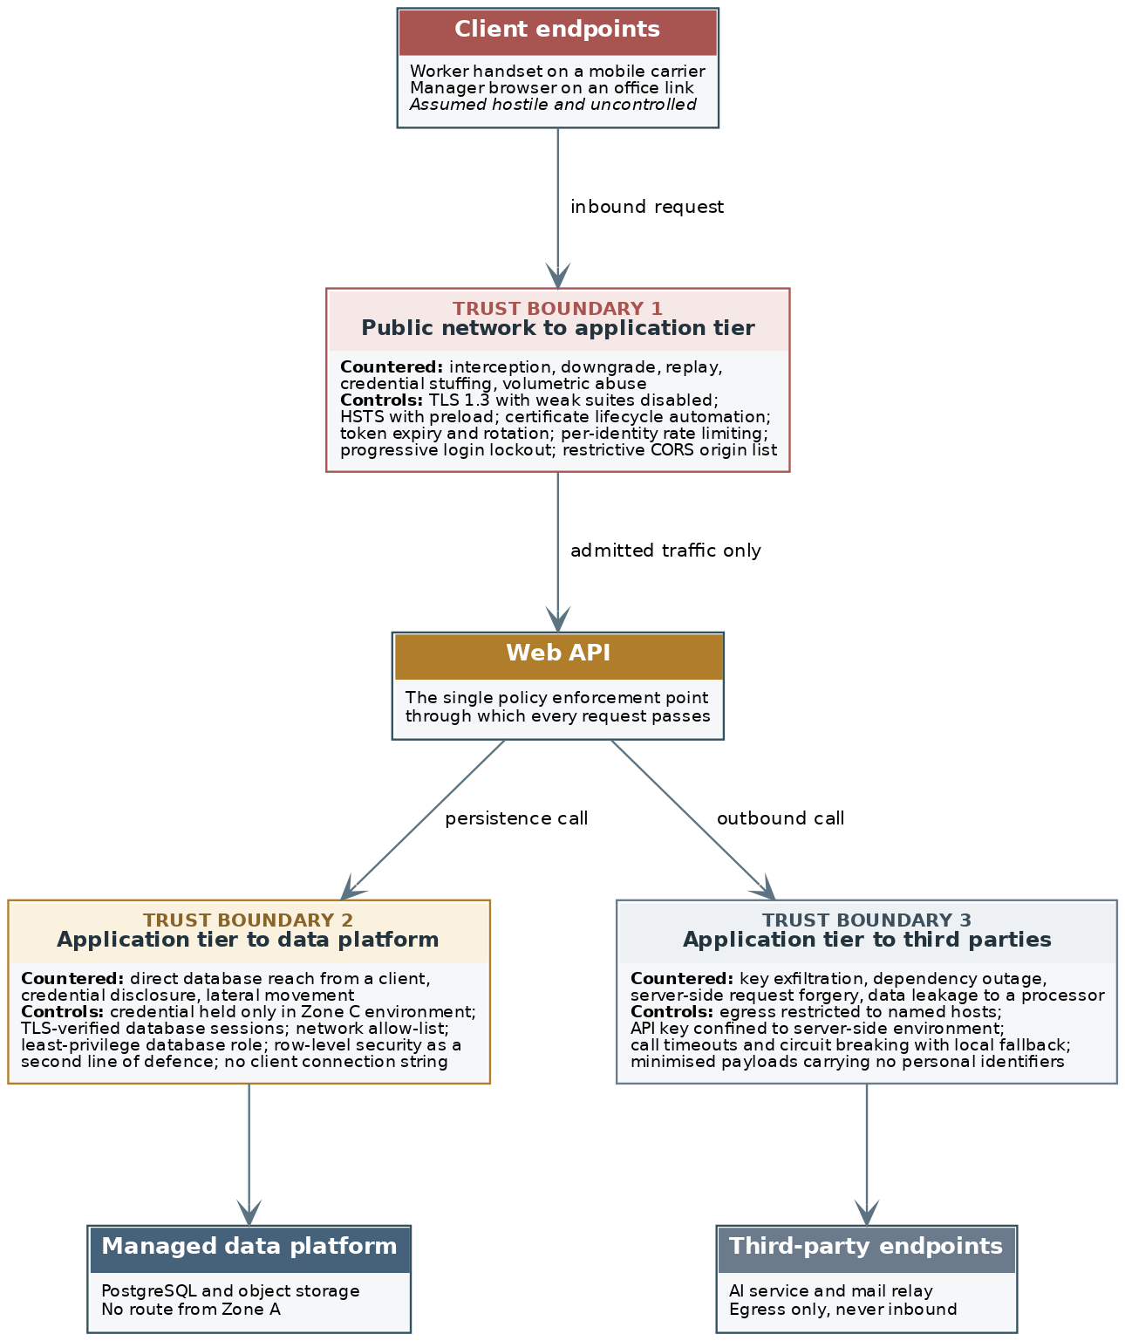
Figure 8.1: The three trust boundaries of the platform, showing at each the threats countered and the controls applied. The application tier constitutes the single policy enforcement point through which every request is obliged to pass.
Figure 8.2 restates the same three boundaries as a network topology drawn with device symbols. The control sets are identical to those tabulated in the sections that follow, and the purpose of the second rendering is to make the position of each control upon the path of a request apparent, given that a control is only able to be evaluated once the traffic it governs is visible.
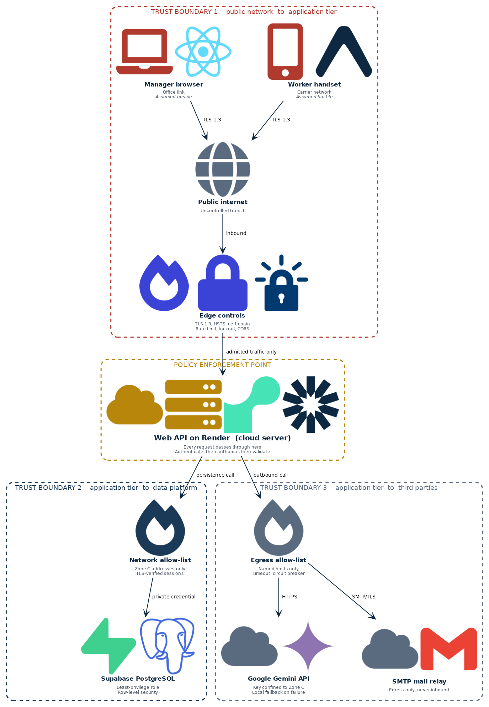
Figure 8.2: The network topology drawn pictorially, showing the position of each control upon the path that a request travels. A firewall symbol denotes filtering control irrespective of whether that control is implemented as a firewall, an allow-list or an application-tier policy.

8.4 Boundary one: the public network and the application tier
Author: Bradley Rwafa (ST10458380)
This is the boundary that carries the greatest exposure, given that it is addressable by any party upon the public internet and that it is the boundary across which every credential and every operational figure travels.
Threat | Control applied | Basis
Interception of credentials or of operational data in transit upon a carrier or public network | Transport Layer Security version 1.3 is required upon every connection, cleartext being refused as opposed to redirected at the application. The protocol removes the obsolete key exchange and cipher constructions retained by its predecessors and encrypts a greater proportion of the handshake. | Rescorla (2018); McKay and Cooper (2019)
Downgrade of a connection to an unprotected or weaker channel by an intermediary | Strict transport security is asserted with a substantial maximum age and with subdomains included, so that a compliant client refuses a subsequent cleartext connection without consulting the server. Cipher suites known to be weak are disabled rather than merely deprioritised. | Hodges, Jackson and Barth (2012); McKay and Cooper (2019)
Interception by means of a substituted or fraudulent certificate | Certificates are issued and renewed automatically by the platform providers, and the client verifies the chain. The absence of a manual renewal step removes the expiry that is, in practice, the most frequent cause of certificate failure. | ISO (2015a)
Replay of a captured token, or continued use of a token after the departure of its holder | Access tokens are short-lived and are accompanied by a refresh token that is revocable, so that the withdrawal of access takes effect within the life of one access token as opposed to at its natural expiry. | Jones, Bradley and Sakimura (2015)
Credential stuffing and brute-force attempts against the authentication endpoint | Attempts are throttled per identity and per source address, and repeated failure produces a progressive lockout. The control is applied at the tier rather than at the client, given that a client-side control is trivially bypassed by addressing the interface directly. | OWASP (2021); ISO (2015a)
Volumetric abuse of the interface, whether deliberate or occasioned by a defective client | Requests are limited per identity, the limit being applied to the authentication, registration and reset endpoints in particular. The provider absorbs volumetric flooding beneath the application, which is one of the material advantages of the managed arrangement. | ISO (2015a); OWASP (2021)
Invocation of the interface from an unapproved origin | Cross-origin resource sharing is configured with an explicit list of permitted origins, wildcards being refused. Credentialed cross-origin requests are permitted only from the origin serving the dashboard. | OWASP (2021)

8.5 Boundary two: the application tier and the data platform
Author: Bradley Rwafa (ST10458380)
The controls at this boundary exist to ensure that the layering described in Section 7.2 is a property of the deployment as opposed to a convention observed by the code. The distinction proves to be material: a layering that rests upon convention is violated by the first developer who is pressed for time, whereas a layering that rests upon the absence of a credential is not able to be violated at all.
Threat | Control applied | Basis
A client application reaching the database directly and circumventing the authorisation pipeline | The credential exists only within the environment of the application tier. No client artefact contains a connection string, and no client is issued one, with the consequence that the circumvention is not available irrespective of the intent of the party attempting it. | ISO (2015a); Rose et al. (2020)
Disclosure of the database credential by means of the source repository or a build artefact | Secrets are supplied as environment variables at runtime and are held as encrypted secrets within the pipeline. The repository holds an example file recording the names of the variables and none of their values. | ISO (2015b)
Interception or redirection of the connection between the application tier and the database | The session is established over Transport Layer Security with verification of the certificate of the server, so that an endpoint substituted upon the path is refused as opposed to trusted. | McKay and Cooper (2019)
Lateral movement following the compromise of the application tier | The database role granted to the application holds the least privilege sufficient for its function, with no authority to alter the schema at runtime. Row-level policies constrain what the role is able to read even where the query does not. | ISO (2015a); OWASP (2025)
Reachability of the data platform from an unexpected source address | Access is confined to the addresses of the application tier by the network controls of the provider, so that a credential disclosed in isolation is not sufficient to establish a connection from elsewhere. | ISO (2015a)

8.6 Boundary three: the application tier and the third-party services
Author: Bradley Rwafa (ST10458380)
This boundary receives attention disproportionate to the volume of traffic that crosses it, because it is the boundary at which the platform depends upon parties over whom REEF exercises no control whatsoever, and because traffic crossing it is outbound, which is the direction that perimeter controls have historically been least inclined to inspect.
Threat | Control applied | Basis
Exfiltration of the key belonging to the artificial intelligence service | The key is held within the environment of the application tier and the service is addressed from the server alone. Were the key placed within a client bundle it would be extractable by any user who opened the developer tools of the browser, which is the reason the call is not made from the client. | ISO (2015b); OWASP (2021)
Server-side request forgery, in which a crafted input induces the tier to address an unintended host | Outbound connections are restricted to a list of named hosts, and no destination is ever constructed from data supplied by a user. | OWASP (2021)
Failure or rate limiting of an external dependency propagating into a failure of the platform | Every outbound call is bounded by a timeout and by a circuit breaker, and the caller applies a deterministic local fallback. The failure is thereby confined to a reduction in the quality of the narrative as opposed to the loss of the report. | ISO (2022a)
Disclosure of personal or commercially sensitive information to a third-party processor | The payload transmitted to the artificial intelligence service carries aggregate operational figures and carries no employee identifier and no client name. The minimisation is a design property of the request as opposed to a matter of trust in the recipient. | Republic of South Africa (2013)

8.7 Monitoring, and the residual risk that remains
Author: Bradley Rwafa (ST10458380)
Controls that are not observed cannot be shown to be operating. The application tier accordingly emits, in order that the controls may be observed, structured records of authentication outcomes, of authorisation refusals, of throttling decisions and of the failure of any outbound call, each carrying a correlation identifier and none carrying a credential or a token. The purpose is twofold, in that the records support the diagnosis of a fault and equally supply the evidence by which an assertion made in this section may be tested.
It would amount to a distortion to present the arrangement as complete, and the residual risks are therefore recorded. Firstly, the platform depends upon the network controls of providers whose configuration REEF is not able to inspect, with the consequence that a portion of the assurance rests upon the certifications of those providers as opposed to upon direct verification. Secondly, the free tier does not furnish a web application firewall, and the filtering of malicious payloads therefore occurs within the application rather than in front of it. Thirdly, the mobile client retains captured entries upon a device that REEF does not administer, so that the loss of a handset exposes whatever has not yet been transmitted, a risk mitigated by encryption at rest upon the device and by the deletion of an entry upon acknowledgement but not eliminated by either. Fourthly, no independent penetration test has been conducted, with the consequence that the controls described are designed and reasoned but is not presently verified in an adversarial manner. Each of these proves to be a limitation of the present arrangement, and each is recorded here in preference to being discovered later.
A fourth residual risk arises from the transition recorded in Section 7.3.4. Until package 5.2 completes, the browser holds a publishable key and reaches the data platform directly, with the consequence that the boundary described in Section 8.5 is presently held by row-level security alone rather than by row-level security behind the absence of a credential. The control is real and is not bypassed by a modified client, but it is one control where the design specifies two in series, and the direct path carries none of the request validation, rate limiting or structured logging that the application tier applies. The practical consequence is that abuse of that path is refused correctly but is neither throttled nor observed. The risk is accepted knowingly for the duration of the prototype, it is bounded by the fact that every policy is evaluated per row and per request, and it closes when the direct path does.

8.8 The principles of secure design applied beyond least privilege and secure defaults
Author: Bradley Rwafa (ST10458380)
Sections 8.1 and 8.2 each take one principle of secure design and follow it into the implementation. Least privilege and secure defaults are, however, two of a set, and the remainder of that set is applied within this platform whether or not it is named. The principles were set out in their durable form by Saltzer and Schroeder (1975), and they are recorded here for two reasons: firstly because a design that satisfies a principle by accident is not able to be shown to satisfy it, and secondly because naming the principle is what permits a reviewer to ask whether it holds at a place the authors did not consider.
Each principle below is accompanied by the decision within this platform that answers it and, where the principle is not fully satisfied, by a statement of where it is not. The latter is the more useful column, given that a table in which every principle is marked as satisfied is a table that has been written to reassure as opposed to one that has been checked.
Principle | What it requires | How the platform answers it, and where it does not
Economy of mechanism | The protection mechanism should be as small and as simple as it is able to be, given that a mechanism no one is able to hold in mind is a mechanism no one is able to verify. | Authorisation is decided at one place, the guard pipeline described at Section 7.2.8, and expressed in one artefact, the permission matrix at Section 2.2.2. The matrix carries thirty-six cells and each is a test, which is a mechanism a reviewer is able to read in a minute. The prototype does not yet satisfy this: it decides authorisation at two places, the server routes and the database policies, which is the divergence recorded at Section 7.3.4.
Fail-safe defaults | Access should rest upon permission rather than exclusion, so that the default outcome of an omission is refusal. | Every row of the permission matrix states a denial explicitly rather than leaving it implied, and the guard refuses a request carrying no recognised role as opposed to admitting it. Section 8.2 follows the same principle into rendering, where the default escapes and the exception is audited.
Complete mediation | Every access to every object should be checked, and no result of an earlier check should be reused. | Authorisation is evaluated for each request rather than at the point of signing in, which is what requirement FR-30 demands when it obliges the restriction to be enforced by the system as opposed to being concealed within the interface. Row-level security applies the same rule at the data layer, where the policy is evaluated per row and per query.
Open design | The security of a mechanism should not depend upon the ignorance of an adversary regarding its design. | The whole of the security design is recorded in this document, and none of it depends upon the design remaining unread. What must remain secret is confined to the credentials themselves, which is the distinction the secrets discipline at Section 5.4.6 rests upon.
Separation of privilege | Where it is practicable, an action of consequence should require more than one condition to be satisfied. | The commitment of REEF funds requires two: the reorder rule raises a draft, and a Manager approves it, which is the control at US-08. The person whose consumption entries caused the draft to be raised is not the person able to approve it, and the correction of a submitted record is separated from its capture upon the same reasoning at US-11.
Least common mechanism | The extent of mechanism shared between users should be minimised, since a shared path is a shared failure. | Each client environment holds its own database project, so that a destructive migration rehearsed in staging is not able to reach production, which is the decision recorded at Section 5.4.3. Against this principle the platform accepts one deliberate exception: all sites share one schema, because the single source of truth upon which cross-site reporting depends is precisely a shared mechanism.
Psychological acceptability | A protection mechanism that obstructs the work will be circumvented, and a mechanism circumvented is not a mechanism. | The session timeout is set against the conditions at a plant rather than against a notional ideal, for the reason recorded in Section 3, and offline capture exists so that a worker is never placed in the position of choosing between recording the shift and observing the rule. A control that would have obliged a worker to remain within signal in order to record a repair would have been abandoned within a week.
Defence in depth | No single control should be the whole of the protection, given that every control is eventually defective. | The delivered architecture places two controls in series upon the persistence path: authorisation at the application tier, and row-level security at the database beneath it. Section 7.3.4 records that the second is retained after the transition precisely so that a defect in the first does not by itself expose a row. The prototype presently has one control upon that path rather than two, which is the residual risk at Section 8.7.
Two of the eight are not fully satisfied, and both failures share a cause. Economy of mechanism and defence in depth are each compromised by the direct client path that the Task 1 prototype retains, the first because authorisation is decided at two places rather than one, and the second because the two places operate upon alternative paths as opposed to in series upon the same one. Both are answered by the same package, namely 5.2, and the fact that a single outstanding decision accounts for both failures is itself the argument for taking it.

8.9 A threat model for the platform
Author: Bradley Rwafa (ST10458380)
The boundaries at Sections 8.4 to 8.6 record the controls applied where traffic crosses from one zone into another. What they do not record is the systematic derivation of the threats those controls answer, and the omission is worth repairing, given that a control list assembled without a threat model is a list of the threats its authors happened to think of. The model below proceeds from the assets rather than from the controls, which is the orientation the risk assessment guidance prescribes, and it considers each asset against the six categories of the STRIDE decomposition (Joint Task Force, 2012; ISO, 2022c).
An asset, for the purposes of this section, is a thing whose loss, alteration or disclosure would cost REEF something. Four qualify. The operational record is the substance of the platform and the reason it exists. The credentials are the means by which the record is reached. The cost and comparison figures are commercially sensitive across clients, which is the confidentiality concern that FR-29 exists to answer. And the audit trail is the evidence by which any of the other three is able to be reconstructed after a dispute.
Asset | Threat category and how it would present | Control, and where it is documented
The operational record | Tampering. A submitted repair, tonnage or downtime figure is altered after capture, whether by a person correcting an embarrassment or by a modified client. | Correction is permitted to the Manager and denied to the Worker, and every correction retains the previous value, the new value, the editor and the time. Sections 2.2.2 and 8.7, and story US-11.
The operational record | Repudiation. A figure is disputed and no party is able to establish who submitted it. | Every record is attributed to the authenticated identity that submitted it and timestamped at the server as opposed to the device. The audit trail is readable to the Owner-Administrator alone and its entries are not able to be edited. Story US-19.
The operational record | Denial of service. Volumetric abuse of the capture endpoints renders the platform unavailable during a shift. | Per-identity rate limiting and progressive lockout at the application tier, Section 8.4. The offline queue reduces the consequence rather than the likelihood: capture continues and transmission is deferred, Section 7.2.7.
The credentials | Spoofing. A party presents itself as a user it is not, whether by guessing a password, replaying a token or intercepting one in transit. | Transport hardening at Section 8.4; token expiry and rotation; brute-force lockout; and the authentication construction at Section 8.11. Interception is countered by TLS 1.3 with weak suites disabled (Rescorla, 2018).
The credentials | Elevation of privilege. A holder of one role obtains the authority of another, whether by editing a request, by calling an endpoint the interface does not offer, or by invoking a privileged database function directly. | Authorisation evaluated per request at the application tier; row-level security beneath it; and the revocation of execute permission upon the security-definer functions from public, anonymous and authenticated roles, which is the control recorded at Section 7.1.6.
The cost and comparison figures | Information disclosure. A worker or a manager at one client's site obtains the commercial position of another client. | Cross-site comparison is permitted to the Owner-Administrator alone, and every other permission is scoped by site assignment. The scoping is a confidentiality control as opposed to a convenience of navigation, which is the point Section 2.2 makes explicitly. Requirement FR-29.
The cost and comparison figures | Information disclosure by an indirect route. The assistant is asked a question whose answer the asker is not permitted to see directly. | Requirement FR-33 confines the assistant to the data the asker may already see, and the facade at Section 7.1.7 exposes three bounded operations rather than the schema, so that the assistant is not able to compose a query of its own.
The audit trail | Tampering and repudiation together. The record of who did what is altered, with the consequence that every other control becomes unprovable. | The trail is append-only to the application, readable to one role and not editable through any interface the platform exposes. This is the asset upon which the assurance of the other three rests, and it is accordingly the one whose protection is least negotiable.
One category is deliberately absent from the table, and its absence is a finding as opposed to an oversight. Spoofing of the platform to the user, by which is meant a counterfeit site collecting credentials, is not answered by any control within the platform's gift beyond the certificate chain and the strict transport policy recorded at Section 8.4, both of which depend upon the user reaching the correct address in the first instance. The residual exposure is therefore carried by REEF as an operational matter rather than by the platform as a technical one, and it is recorded among the residual risks at Section 8.7 for that reason.

8.10 Injection, request forgery and the neutralisation of untrusted input
Author: Bradley Rwafa (ST10458380)
Two of the three risks the departmental build standard names by name are addressed elsewhere or not at all. Cross-site scripting is the subject of Section 8.2, which follows it through the codebase and identifies the single place at which the default protection is deliberately disabled. Injection and request forgery have until now been treated implicitly, and the purpose of this subsection is to state the position upon each explicitly, given that a protection which is present but undocumented is indistinguishable, to a reviewer, from one that is absent.
The two risks share a structure, which is why they are treated together. In each case a value that originated outside the platform is interpreted by something within it as an instruction rather than as data: as a fragment of a query in the first instance, and as the intent of an authenticated user in the second. The defence in each case is likewise structurally the same, namely to establish, at a single identified point, that the value is data and to deprive it of any means of becoming anything else (OWASP, 2021b).
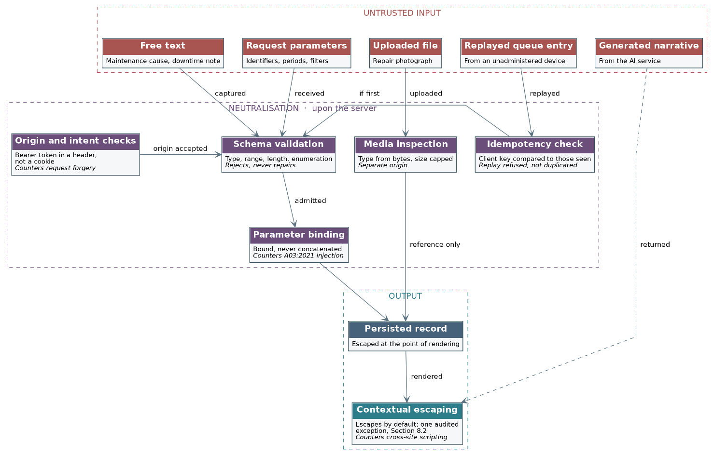
Figure 8.3: The path of an untrusted value through the platform, showing at each stage the control that deprives it of the capacity to be interpreted as an instruction. Values enter at five points and are dangerous at two: the moment they reach the query, and the moment they reach the page.
Injection is countered by construction rather than by inspection. Every value reaching the data platform is bound as a parameter and none is concatenated into a statement, which is the practice the build standard requires and which the generic access module described at Section 7.2.6 enforces by its shape: the callers supply values and the module supplies the statement, so that a caller has no means of contributing to the statement even if it wished to. The one place at which a caller does contribute structure is the table name, and that argument is constrained to a closed union of the sixteen operational tables, which is a whitelist expressed in the type system as opposed to a filter applied at run time. Filtering is refused deliberately: an escaping routine is a thing that must be remembered, whereas a bound parameter is a thing that cannot be forgotten, and the distinction is the whole of the reason the first approach fails in practice and the second does not.
The database functions attached as triggers, described at Section 7.1.6, warrant separate statement because they execute with the privileges of their owner rather than of the caller. Each is written to operate upon the row supplied by the trigger rather than upon a constructed statement, and execute permission upon each is revoked from the public, anonymous and authenticated roles, with the consequence that a value which reached such a function would still have no path by which to alter what the function does. This is the arrangement that makes a security-definer function a control as opposed to a vulnerability.
Request forgery is answered principally by a decision taken for another reason. The application tier authenticates by a bearer token presented in a request header rather than by a cookie, and a browser does not attach a header of its own accord to a request originating from a page it did not serve. The classic forgery, in which a page under an adversary's control causes a request to be issued carrying the user's ambient authority, therefore has no ambient authority to carry. Two qualifications belong with that claim rather than after it. Firstly, the session that the prototype's server routes maintain does rest upon a cookie, and for so long as it does, that cookie carries the SameSite attribute and the state-changing routes require a token that a cross-origin page is not able to read. Secondly, the restrictive origin list at Section 8.4 is a second line and not the first, given that it governs what a browser will reveal of a response as opposed to whether the request was issued at all (OWASP, 2025b).

8.11 Authentication as it is to be constructed
Author: Bradley Rwafa (ST10458380)
Section 3 states what the authentication of the platform must satisfy, expressed as requirements. This subsection states how those requirements are to be met, which is a different question and one a design document is obliged to answer, given that a requirement recorded without a construction is a statement of intent as opposed to a design. The departmental build standard is unusually specific upon this subject, and each of its provisions is taken in turn below.
One matter is settled before the table, because it governs the rest. The build standard requires that registration, sign-in and sign-out be implemented by the team as opposed to being adopted from a purchased or plugged-in solution. The Task 1 prototype does not satisfy that requirement: it authenticates through the identity service of the managed data platform, which is a reasonable choice for a task that required no back end and an unreasonable one for a submission assessed against this standard. The construction below is therefore what package 5.2 delivers alongside the application tier, and the prototype's arrangement is recorded at Section 7.1.4 as what precedes it. The distinction is stated here rather than left for a demonstration to expose.
Provision of the build standard | How it is constructed | Basis
Registration, sign-in and sign-out implemented by the team | The application tier exposes the three flows at the versioned contract, holds the identity records in the platform's own schema, and issues its own tokens. No third-party identity service participates in the delivered flow. | Departmental build standard; package 5.2 of the work breakdown structure.
Passwords hashed with a library appropriate to the stack | Passwords are stored as the output of a memory-hard adaptive function, Argon2id where the runtime provides it and bcrypt with a work factor reviewed at each release otherwise. The plaintext is never written to a log, a trace or an error, and the comparison is made in constant time. | OWASP (2021a); NIST (2017).
Email confirmation before activation, sent by a real service | Registration creates the account in an unconfirmed state which is refused authentication. A single-use token of limited life is despatched through the mail relay in Zone E, and confirmation consumes the token rather than merely reading it. | Section 7.3.1, Zone E; the flow is exercised by the security testing listed in Section 3.
Token or session authentication with expiry and refresh | Authentication yields a short-lived access token carrying the subject, the role and an expiry, accompanied by a refresh token of longer life held apart from it. Refreshing rotates the refresh token and invalidates its predecessor, so that a stolen refresh token is usable once and its use is detectable by the arrival of the superseded token thereafter. | Jones, Bradley and Sakimura (2015); NIST (2017).
Password reset | Reset issues a single-use, time-limited token to the registered address, invalidates every active session upon completion, and discloses nothing about whether the address is registered, so that the flow is not able to be used to enumerate accounts. | OWASP (2021a); Section 3, session management.
Brute-force protection | Failed attempts are counted against the identity and against the source, and the response is progressive delay followed by temporary lockout rather than immediate permanent lockout, which would itself constitute a denial of service against a known account name. Every refusal is logged without the credential. | Section 8.4; OWASP (2024).
Role-based access control wherever more than one user type exists | The role is a claim within the access token, and it is re-evaluated at the guard for each request as opposed to being trusted from the session. The matrix at Section 2.2.2 is the specification the guard is tested against. | Requirement FR-30; Section 7.2.8.
Secrets held in environment variables and never committed | The token signing secret, the database credential and the third-party keys are held as environment variables within Zone C. A committed example file records which variables are required without disclosing a value, and the pipeline scans for committed secrets, as Section 9.25 records. | Section 5.4.6; Wiggins (2017).
One consequence of the construction deserves to be stated, because it is the question a demonstration is most likely to reach. The build standard anticipates that the team will be questioned upon the authentication flow and will be expected to demonstrate understanding as opposed to recitation. The arrangement above is accordingly designed so that each element is able to be pointed at: the hash function is a named algorithm with a stated work factor, the token is a structure whose claims are able to be read aloud, the refresh rotation is a behaviour able to be demonstrated by presenting a superseded token, and the lockout is a threshold able to be reached in front of an examiner. A flow that is not able to be demonstrated in that manner is not able to be defended either.

8.12 Coverage of the departmental security requirements
Author: Bradley Rwafa (ST10458380)
The security material within this document is distributed across two sections and several subsections, which is a consequence of the two serving different purposes: Section 3 records what must hold and this section records why it holds and what enforces it. A reader checking the document against the departmental build standard should not be obliged to reconstruct that distribution, and the table below accordingly records where each provision of the standard is answered.
Provision of the build standard | Where it is answered
Permission checks enforced on the back end for every role-restricted action | Sections 2.2.2, 7.2.8, 8.1 and 8.8, under complete mediation.
Audit trail recording who did what and when | Section 3, audit trails; story US-19; Section 8.9, against tampering and repudiation.
Registration, sign-in and sign-out implemented by the team | Section 8.11, first row, with the prototype's divergence stated.
Passwords securely hashed | Section 3, password protection; Section 8.11, second row.
Email confirmation before activation | Section 8.11, third row; Zone E at Section 7.3.1.
Token or session authentication with expiry and refresh | Section 3, session management; Section 8.11, fourth row.
Role-based access control | Sections 2.2.2, 7.2.8 and 8.11, seventh row.
Password reset flow | Section 3, authentication; Section 8.11, fifth row.
Brute-force protection on sign-in | Sections 8.4 and 8.11, sixth row.
Protection against injection, cross-site scripting and request forgery | Section 8.10 for injection and request forgery, with Figure 8.3; Section 8.2 for cross-site scripting.
Parameterised queries or an object-relational mapper, no concatenated SQL | Section 8.10, third paragraph; Section 7.2.6.
Environment variables for all secrets, never committed | Sections 5.4.6, 8.11 eighth row and 9.25.
HTTPS documented as part of deployment | Sections 5.4.2, 7.3.2 and 8.4.
No direct database access from client applications | Sections 5.4.2, 7.2.2, 7.3 and 7.3.4, where the transition is recorded.

9. DevOps

9.1 Introduction
The rapid deployment of a high-quality application is one of the non-functional requirements for the REEF Operations Platform. REEF is a mining services company that wants to have a centralized platform to access information regarding maintenance of the mining equipment, the stock of the company, the amount of minerals that are produced by the company’s mining operations, and the operational performance of those mines.
Because there are multiple developers that will be working simultaneously on the application, a development process will have to be implemented that allows for the individual developers to collaborate on the project without creating negative impacts upon the stability of the application. Such a process can be performed through the use of GitHub, pull requests, code reviews, automated testing software, and GitHub Actions deployment tools.
The technology that will be used for the application’s backend is JavaScript and TypeScript, as well as Supabase. The development and testing will therefore occur in relation to these technologies, not with the technologies that are represented in the different backend architecture diagrams.
The overall purpose of the testing effort is to allow the team to introduce new functionality to the application at a rapid rate while maintaining the quality, reliability, security, and maintainability of the software.

9.2 GitHub for Version Control
GitHub will be used as the version control platform for the REEF application. Version control allows developers to track the changes that are made to the code base for the application.
This is particularly important for project groups in which different individuals are developing different components of the project. For example, while one developer may be creating the authentication and login functionality for a website, other developers may be creating the functionality related to the website’s dashboard or operational components.
Each of these developers can commit their changes to the project. These commits can help to trace the changes that were made to the project, as well as to identify the history of the development of those features.
Pull requests on GitHub allow for developers to continue to create and modify the project without affecting the stable version of the website, and to submit their changes for review to other team members.
The use of GitHub therefore provides several advantages to the REEF project. It allows for collaboration between developers, as well as provides a history of the changes that have been made to the project, allowing for the recovery of previous versions of the application if necessary.

9.3 Branching Strategy
The branching strategy that will be used for the REEF project will be based upon the features that are to be developed for the application. The main branch of the project will contain the stable version of the application, and individual branches will be created to develop the features.
For instance, branches can be created named:
- feature/login
- feature/dashboard
- feature/maintenance
- feature/stock
- feature/production
- fix/authentication
Each of these branches will be created from the main branch, allowing for the developers to develop the features without impact upon the stable version of the application.
This approach is beneficial in that multiple developers can work simultaneously on the project. For instance, one developer can be working on the login interface while another developer is working on database functionality. Changes can be made separately by each developer, and those changes are not incorporated into the project until the developer is ready to share the changes with others.
Branching allows for changes to be made separately by each developer. The changes can then be incorporated into the project through a pull request. GitHub Flow documentation
Thus, this strategy allows for rapid development of the software while reducing the likelihood of stable application incorporating buggy or incomplete functionality.

9.4 Development Workflow
The development workflow for REEF includes the steps to be taken to go from requirement to deployment of the website.
The general process is as follows:
Requirement → Feature Branch → Development → Local Testing → Commit → Pull Request → Automated Checks → Code Review → Merge → Deployment
When a requirement is identified, the developer that is to implement the software requirement creates a feature branch and develops the required functionality.
After the development phase is complete, the developer tests the software locally to identify any problems. Following the local testing phase, the developer commits the changes to their local repository and pushes them to GitHub.
Finally, the developer creates a pull request that proposes the merging of the feature branch into the main branch. During this phase, another team member can review the developer’s code before it is merged into the main codebase.
This approach creates multiple opportunities to identify errors prior to the deployment of the software system.

9.5 Pull Requests and Code Review
Pull requests are one of the quality control steps within the REEF development process. Rather than allowing the developers to directly place the application into the stable branch, they must create a pull request.
Within the pull request, another team member can review the changes that have been made by the developer to determine whether the code adheres to the requirements of the application.
During this process, the reviewer should consider the following:
Whether the developer met the requirement for that section of the application
Whether the code is easily understood and maintained
Whether any changes were made that are not required by the application
Whether the tests have been written and followed
Whether security measures have been taken into account
Whether the code adheres to the standards of the remainder of the application
Pull requests can be submitted on GitHub to allow for the review and integration of the changes. GitHub Pull Requests documentation
As with REEF, pull requests are valuable because the project is developed by several people. Having a second developer review the implementation of the code ensures quality control prior to the integration of that code into the stable application.

9.6 Automated Testing
Automated testing is incorporated into the development of REEF. Manual testing of the software is performed, but automated testing ensures that critical functions are tested each time the software is changed.
The main language used to develop REEF is JavaScript and TypeScript. The unit testing framework used in the project is Vitest, run through Vite.
Automated tests can be developed for functionality such as:
Authentication and login
Form validation
Stock calculations
Production calculations
Maintenance functionality
Data processing
Error handling
For instance, a test can be made certain that the quantity of an item in stock is correctly updated after a stock transaction. Furthermore, authentication tests can ensure that login attempts with invalid credentials are rejected.
Automated testing is important for the REEF system in particular due to the fact that the different components of the system are connected to one another. Changes to one component of the system could potentially impact another component. Thus, automated tests that are performed after any changes to the system will help to detect these potential issues.
The purpose of automated testing is therefore not simply to increase the number of tests that are executed, but also to provide confidence in the critical functionality of the system.

9.7 Automated Testing within Continuous Integration
The value of automated testing becomes particularly apparent within the context of continuous integration.
Continuous integration is a process in which developers very regularly commit their code to a shared repository, automatically triggering tests to ensure that the code changes do not introduce any new problems into the system.
For REEF, automated tests can be performed automatically whenever a developer pushes code to the repository, or creates a pull request to suggest changes to the project codebase.
This process can be understood as the following steps:
Code Change → GitHub → Install Dependencies → Code Checks → Automated Tests → Result
If the tests pass, the proposed changes will continue through the development workflow.
If the tests fail, developers will receive feedback and be able to correct the problem with the code before it is merged into the repository.
This process will provide faster feedback to developers than testing the complete system at the end of development.

9.8 GitHub Actions Pipeline
GitHub Actions is the automation that enables the REEF system’s CI/CD pipeline. GitHub Actions automatically executes workflows in response to specific events in the GitHub repository. These events can include committing code to the repository or creating a pull request between branches. For instance, whenever a developer commits code to the git repository, GitHub Actions will automatically trigger a workflow to perform the actions specified in the workflow file. GitHub Actions documentation
The process can be broken down as follows:
Feature Branch → Pull Request → GitHub Actions → Dependency Installation → Code/Type Checks → Automated Tests → Build → Result → Code Review → Merge → Deployment
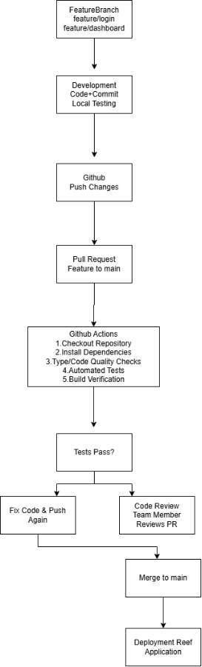
These stages describe the process that the code must pass through before it is deployed to the live application.
Although this process is more involved than simply committing the code to be deployed, it is also important to this software development process due to the requirements regarding the rapid deployment of features.
As the GitHub Actions will automatically initiate upon certain events in the repository, the software deployment pipeline can be automatically initiated when relevant events occur in the Git repository.
Two important events are:
A developer pushes changes to a branch.
A pull request is created or updated.
When either of these events occurs, GitHub Actions starts the configured workflow.
This allows the team to quickly receive feedback about the quality of the change that the developer has written.
For instance, if a developer pushes changes to a branch, the CI workflow can automatically execute. If the developer makes changes to the code again, the workflow can run again.
GitHub Actions workflows can be configured to respond to events like a push or a pull request. GitHub Actions workflows

9.9 Dependency Installation
The first stage of the CI pipeline will prepare the CI environment for the tests.
This involves checking out the code from the repository and installing the dependencies that the REEF application requires.
This is important to ensure that the tests can be executed in a clean environment rather than on the developer’s computer and in their local environment.
The general process will be:
Repository → Checkout Code → Install Dependencies → Continue Pipeline
Should anything fail during this first stage, the CI pipeline will halt execution of the remaining stages.

9.10 Type and Code Quality Checks
Since REEF uses TypeScript, type checking can be incorporated into the CI process.
TypeScript allows developers to define the types of the data that is used in the application. Type checking can find issues with the data before it is deployed into the application.
The CI process will, therefore, perform type checking before the tests are performed on the application.
In addition to the type checking, tools such as ESLint and Prettier are also used to ensure the JavaScript code is of high quality.
ESLint will identify problematic coding patterns in the application code. Prettier will format the code in a consistent manner throughout the project.
These tools will be especially useful for the project’s many developers who may have different coding styles for their projects. Having the code formatted in a consistent manner will make it easier to read and review the projects’ code.

9.11 Automated Tests in the GitHub Actions Pipeline
Automated tests are executed as part of a dedicated stage in the GitHub Actions pipeline.
The process entails the following steps:
Install Dependencies → Type/Quality Checks → Run Tests → Test Result
The automated test must be executed before the code is deployed.
For example, if the login functionality has a regression that causes the authentication test to fail, the GitHub Actions will detect this failure.
The developer can fix the issue and push the code to the branch. The automated tests in GitHub Actions will run the new code and report on its status.
This creates a continuous feedback cycle between development and testing.
The location of automated testing within the software development life cycle is therefore important. Automated testing occurs not just after deployment, but during the continuous integration process, prior to the stable release of the software.

9.12 Build Verification
If the quality checks and automated tests have all passed, the application can be built.
Building the application ensures that the application can be successfully compiled and created into an application that can be deployed.
If the application fails to build, the software development life cycle will report this failure and prevent the change from being deployed into the live environment.
This is another quality gate within the continuous integration process.

9.13 Handling Failed Pipeline Checks
One of the benefits of using the GitHub Actions pipeline is that it can halt the development process if the checks fail.
For example:
Developer Pushes Code → GitHub Actions → Test Failure → Pipeline Fails → Developer Receives Feedback → Developer Fixes Code → Pipeline Runs Again
Thus, the CI process ensures that failures in the development process are caught early and prevented from being treated as successful changes.
Developers do not have to wait until the project is complete to discover these issues. Instead, they receive feedback shortly after implementing a new piece of code.
This contributes to rapid deployment as defects can be resolved while the developer is still working on the feature.

9.14 Successful Pipeline Execution
If the installation of the project’s dependencies, the performance of the static code checks, and the execution of the automated tests and builds are all successful, GitHub Actions will report that the pipeline was successful.
The change can then proceed to the code review stage.
The pull request will now have passed automation software tests and will proceed to the developer review stage. Thus, the process will be as follows:
Pull Request → Automated Checks → Tests Pass → Build Passes → Code Review → Approval → Merge
The automated tests will not replace the requirement for a human reviewer in this process. While the automated tests will ensure that certain checks pass before the developers’ review of the code changes, the developers will review the changes for other reasons such as maintainability of the code and if it adheres to the requirements of the project.
This combination of automation and human review provides stronger quality assurance than either approach on its own.

9.15 Merge into the Main Branch
Once the automated checks and human reviews have passed, the feature branch can be merged into the main branch of the code repository.
The main branch will continue to maintain a representation of the stable version of the application.
By requiring a feature branch to be merged into the main branch before being developed further, this process ensures that developers do not develop directly on the main branch, and that unfinished projects are not accidentally deployed to production.
The process for implementing features will, therefore, follow the following steps:
Feature Branch → Pull Request → Automated Verification → Review → Main Branch
This also provides evidence of the team's development process because GitHub maintains the history of the branches, commits and pull requests.

9.16 Deployment
After the integration of the features into the stable branch of the code base, the application can be deployed so that it can be made available to the users.
The hosting platforms for the various components of the project are Vercel for the web application's dashboard, Render for the backend API, Supabase for the database and storage, and Expo EAS Build for the mobile application's build.
The separation of these platforms allows for each component of the REEF application to be deployed according to their requirements.
Finally, GitHub Actions will form the connection between the source code and the deployment of the application to ensure that only checked out and tested code is released.
The purpose is not to automatically deploy every change that is made to the application, regardless of the quality of that change. Instead, automation will allow for changes to be tested prior to their deployment to the live application.
Supabase is a component of the backend of the REEF application, providing database functionality to the application.
The way in which the application interacts with Supabase should also be tested. The system should be able to handle both successful and unsuccessful database operations.
These operations could include, for example:
A record that is requested by the application does exist within the database.
A record that is requested by the application does not exist within the database.
An operation that attempts to interact with the database fails.
Information that is submitted to the database is invalid.
A user attempts to access information in the database that they are not authorised to access.
Supabase provides Row Level Security (RLS) which allows for Row access within the Supabase database to be controlled through policies. Supabase Row Level Security documentation
This becomes relevant to REEF as there is sensitive operational information that will need to be managed by the application, thus control of access to this data will need to be according to the permissions of each individual user.

9.17 Security in the DevOps Process
As with all important aspects of the software development process, security should also be considered throughout the DevOps process for the REEF application.
Information that is sensitive to the application and its functions, such as database keys, API keys and service-role credentials will not be directly placed within the source code that is committed to GitHub. Instead, environment variables and protected GitHub secrets will be utilized to provide the application and CI/CD processes with the information that they require to function in a secure manner.
The project’s development documentation also makes clear that the project is to use environment configuration to manage its application settings, and that the application’s secrets should not be committed to the repository.
Supabase also specifically warns developers that the service-role and secret keys for databases should not be exposed in frontend applications, as such keys can be used to bypass the Row Level Security (RLS) configurations that are established in the database. Supabase security documentation
Ensuring that credentials are handled in a secure manner is one of the features of the application that makes up a high-quality application.

9.18 Example of a REEF Feature Moving Through the Pipeline
One of the features of the application that exemplifies how it passes through the DevOps process is the login functionality of the application. The developer creates a branch of the application repository, such as:
feature/login
The developer then creates the login interface and functionality for the application.
Once the developer is satisfied with the implementation of the changes, they commit the changes to their branch and push them to GitHub.
A pull request is created that targets the main branch of the repository.
GitHub Actions will automatically perform the checks. These checks will install the project’s dependencies, perform checks on the code and types of the project, and automatically test and build the project.
In the case of a failed test, the developer must correct the problem and push another commit. The Actions will automatically run these tests again.
If all checks pass successfully, another team member will review the changes proposed by the developer. After the changes are approved by the other team member, they can be merged into the main branch. The merged changes will go through the deployment process.
This example of GitHub Actions connects to the rest of the development and deployment process of REEF.

9.19 Contribution to Rapid Deployment
The DevOps approach helps to enable rapid deployment through the reduction of manual processes and the feedback provided to developers.
Without automation, developers would have to manually install the packages, test, and review the application for every contribution that is made to the project.
With GitHub Actions, however, these steps can be automatically performed whenever changes are made to the project.
The following steps can then be taken by developers:
Develop → Push → Automatically Verify → Review → Merge → Deploy
This process significantly reduces the time between the creation of a feature and the determination of whether that feature should be merged into the project.
More importantly, rapid deployment does not have to mean rapid release without regard to quality. Quality gates can be established within the automated GitHub Actions process that must be satisfied before any changes can be deployed.

9.20 Contribution to Application Quality
The process helps improve the quality of the developed application through the following components of the REEF DevOps process:
GitHub
Feature branches
Pull requests
Code reviews
Type checking
ESLint and Prettier
Automated tests
GitHub Actions
Controlled deployment
These components ensure that the development process of the REEF application has a higher reliability rate than if each component had been performed manually before the application’s submission or deployment.

9.21 Continuous Integration and Continuous Deployment
Continuous integration enables the validation of changes to the application code automatically when developers commit their code or create a pull request.
Continuous deployment allows the successfully-verified changes to be automatically deployed to the appropriate environment.
The relationship between these two DevOps practices can be summarised as:
Continuous Integration
Development → Push → Automated Checks → Automated Tests → Build
followed by:
Continuous Delivery/Deployment
Successful Build → Review → Merge → Deployment
This workflow establishes a development lifecycle that can be continuously repeated as needed.

9.22 Trunk-based development and the protection rule upon main
Author: Bradley Rwafa (ST10458380)
The branching arrangement described above is trunk-based, and naming it as such is worth the sentence, given that the name carries a commitment the description alone does not. A trunk-based model holds that main is at every moment fit to deploy, that branches are short lived, and that integration happens continuously as opposed to at the end of a phase. The alternative, in which long-lived branches are reconciled at a release, produces an integration that is deferred rather than avoided, and deferred integration proves to be the more expensive of the two because the conflicts arrive together and arrive late (Humble and Farley, 2010).
A branch is expected to live for a day or two rather than for a sprint. That expectation is not enforceable by a rule and is not treated as though it were; what is enforceable is the state of main, and it is upon that state that the arrangement actually rests. Main is a protected branch. A commit is not able to reach it directly, a pull request is not able to be merged until the pipeline described below reports success upon every stage, and a pull request is not able to be merged until a second member has approved it. The naming convention is a convenience and the protection rule is the control, and the distinction matters because a team is able to abandon a convention quietly whereas a rule refuses in a manner that is visible to everyone.
One property of this arrangement is worth drawing out because it bears upon the evidence the assessment requires. Every change that has ever reached the delivered system is attached to a pull request, which carries the branch it came from, the checks that ran against it, the member who approved it and the discussion that preceded the approval. The development history is therefore not something the team assembles afterwards in order to demonstrate a process; it is a by-product of having followed one, which is the same relationship the operational record bears to the work at a plant.

9.23 The test framework, and the shape of the coverage sought
Author: Bradley Rwafa (ST10458380)
The unit testing framework is Vitest, and the choice rests upon a property of the toolchain rather than upon a preference. The application is built with Vite, and Vitest executes against that build's existing configuration and resolves TypeScript without a separate compilation step, with the consequence that the tests and the application share one configuration as opposed to maintaining two that are able to drift apart. A framework requiring its own build configuration introduces a second definition of how a module is resolved, and a test suite that passes against a resolution the application does not use is a suite that proves nothing (Vitest, 2026).
Coverage is targeted as opposed to uniform, and the reasoning should be recorded because a uniform percentage is the more conventional target and the weaker one. A fixed proportion across the whole codebase rewards the writing of easy tests against trivial code, given that the cheapest way to raise such a figure is to test the code that was never going to fail. Effort is directed instead at the calculations upon which REEF's decisions actually rest: the quantity on hand after a repair has consumed parts, the reorder threshold and the draft it raises, the cost per ton across a selected period, and the derivation of a downtime duration from its start and end. Each of these is a pure function of its inputs, which is what makes it able to be tested exhaustively, and each is a figure a manager would act upon, which is what makes the testing worth doing.
Three classes of behaviour are tested in addition to the calculations, and they are named because each is a place where a defect would be silent rather than loud. The first is authorisation, where every denial in the matrix at Section 2.2.2 is asserted alongside every permission, upon the reasoning that a test suite which only confirms that permitted actions succeed is not able to detect a control that has ceased to refuse. The second is the replay of a queued entry, where the assertion is that a second arrival of the same entry produces no second record. The third is the failure path of the artificial intelligence adapter, where the assertion is that an unavailable provider yields the deterministic template as opposed to an error reaching the user, which is the behaviour Section 7.2.9 undertakes and which would otherwise be exercised for the first time on the day the provider failed.

9.24 The ordering of the pipeline stages, and what the pipeline deliberately excludes
Author: Bradley Rwafa (ST10458380)
The pipeline runs upon every push to a branch and upon every pull request raised against main, and it executes five stages in a fixed order: install the dependencies, lint, check the types, run the test suite, and produce a production build. The order is not arbitrary and is worth stating, given that it is the difference between a pipeline that is used and one that is worked around. The cheapest checks run first, so that a misplaced import is reported within seconds rather than after the suite and the build have consumed several minutes establishing the same thing. A developer who receives an answer in seconds consults the pipeline; a developer who receives one in ten minutes learns to push and look away, and the feedback the arrangement exists to provide is thereby lost.
The final stage produces a production build even though nothing is deployed from a branch. The reason is that a project is able to satisfy its types and pass its tests and still fail to build, most commonly where an environment variable is absent or a dependency is present in development and absent in production, and the moment to discover that is upon the branch as opposed to upon main. Placing every one of these checks at the pull request rather than after the merge is the point of the whole arrangement: a defect caught before main is a comment upon a branch, whereas the same defect caught after main is a rollback, and Section 5.4.8 records what that costs.
Two things are deliberately excluded from the pipeline, and the exclusions are decisions rather than omissions. The first is the schema migration. Migrations are applied as an explicit release step, as Section 5.4.5 describes, so that a change to the schema is always something a person decides as opposed to something that occurs quietly alongside an application deployment; a migration that runs automatically at start-up is a migration that is able to run against a database already in use, and it is the only operation in the release process able to destroy data irreversibly. The second is the keep-alive probe, which runs as a separate workflow upon a timer rather than as a pipeline stage, because its purpose is unrelated to any change: the free tiers upon which the platform depends suspend an idle service and pause a database that receives no request across a period of days, and the probe exists to keep the system reachable rather than to verify anything about it.
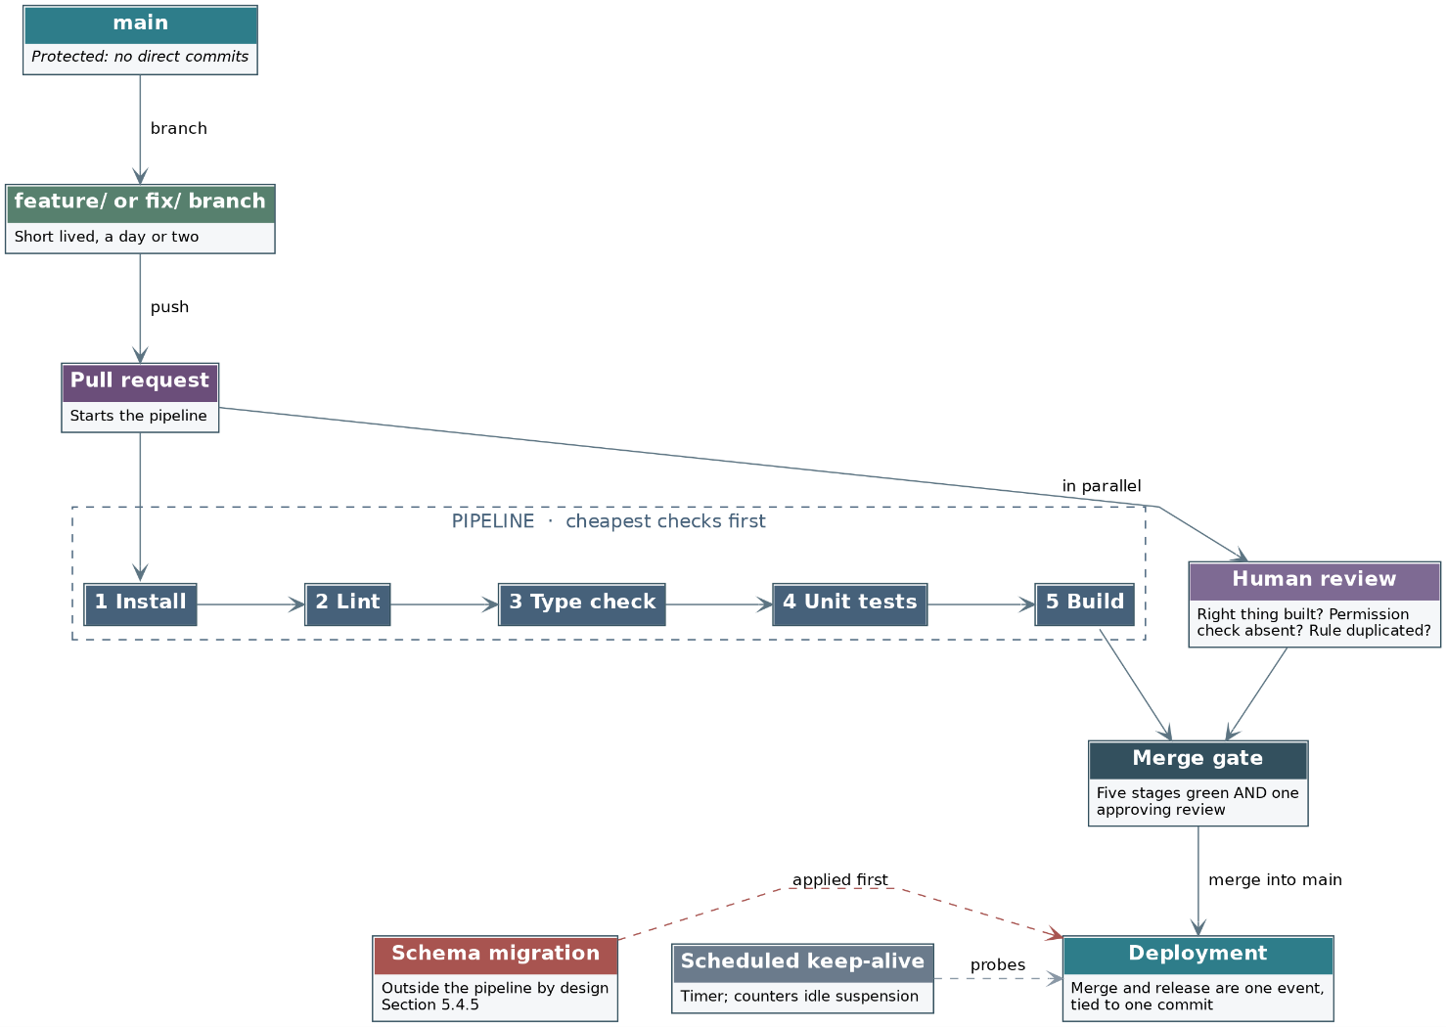
Figure 9.2: The trunk-based model and the pipeline that guards it. Main is protected, so the merge gate is a rule rather than a convention; the five stages run cheapest first; and the schema migration and the keep-alive probe sit outside the pipeline by design.
Figure 9.2 draws the arrangement, and one feature of it repays attention. The human review proceeds in parallel with the pipeline as opposed to after it. This is deliberate: the checks and the review answer different questions, and neither is able to answer the other's. The checks establish that the code compiles, satisfies its types and passes its tests. None of that is able to establish whether the thing built is the thing the requirement asked for, whether a permission check was omitted, or whether a rule now exists in two places and will shortly disagree with itself. Only a reader is able to establish those, and running the two concurrently means the reading is not waiting upon the machine.

9.25 Supply-chain and secret hygiene within the pipeline
Author: Bradley Rwafa (ST10458380)
Two hazards attach to a pipeline rather than to the code passing through it, and both are addressed here because neither is addressed anywhere else in this document. The first is the dependency. A JavaScript project of this kind draws upon several hundred packages transitively, none of which the team wrote and any of which is able to be compromised at its source, with the consequence that a build which resolves its dependencies afresh on each run is a build whose contents are not knowable in advance. The install stage accordingly resolves from the locked dependency file rather than from the declared version ranges, so that the same input produces the same tree, and a change to that file is a change to the repository which is reviewed like any other. Automated alerts upon known vulnerabilities in those dependencies are enabled at the repository, and an alert is treated as a defect rather than as information.
The second is the credential. A pipeline necessarily holds the means to deploy, which makes the repository's stored secrets a target of a different order from anything in the application, given that a credential taken from a pipeline is a credential taken with the authority to release. Three measures follow. Secrets are held as encrypted repository secrets and are exposed to a workflow as environment variables at the moment of use rather than written into any file. Scanning for committed credentials is enabled upon the repository, so that a key pasted into a commit is detected at the push as opposed to being discovered later by someone else. And the workflow definitions themselves are held in the repository and reviewed through the same pull request mechanism as the application, upon the reasoning that a change able to alter what the pipeline does is at least as consequential as a change to what the application does, and is not able to be exempted from review without exempting the control itself (GitHub, 2026).
One limitation is recorded rather than concealed. Every measure above rests upon the configuration of a hosted service whose implementation REEF is not able to inspect, which is the same dependency upon provider assurance that Section 8.7 records in respect of the network controls. The measures are therefore proportionate to a student project operating at zero cost as opposed to sufficient for a system holding regulated data, and the distinction is stated so that the receiving team is able to revisit it when the second condition begins to apply.

9.26 Conclusion
The REEF Operations Platform’s approach to development and deployment satisfies the non-functional requirement regarding the deployment of the high-quality software application. GitHub is utilized to create the DevOps lifecycle, enabling different developers to simultaneously contribute to the project without negatively impacting the main branch of the software application.
Pull requests and code reviews allow for the integration of changes into the codebase. Automated testing allows for the verification of important functionality within the code. Additionally, the use of TypeScript checks, ESLint, and Prettier helps to ensure the code quality of the software.
The GitHub Actions pipeline is important for the process of integrating the changes from the feature branch to the main branch. When a developer commits to a feature branch, GitHub Actions will automatically install the project dependencies, perform code and type checks, perform automated tests to verify the changes, and compile the software. If any of these steps fail, the developer will be notified of the failure and can make the necessary changes to correct the error. If the steps are successful, however, the changes can be submitted for review, once merged with the stable branch will be deployed to production.
Supabase provides the necessary backend and database functionality to the application, as well as security mechanisms to protect its data.
The DevOps cycle for REEF allows the organization to maintain a balance of speed, quality, reliability, security and collaboration in the operations of its development and operations teams. Through automating many of the tasks within the SDLC, the developers can reduce the amount of repetitive work they must complete in production, while also ensuring that the software has been thoroughly tested prior to being deployed to live environments. Thus, the organization is able to more efficiently and confidently roll out updates to the REEF Operations Platform.

10. Running Costs
Author: Joe Leo Van Niekerk (ST10445055)

10.1 Cost Model and Assumptions

REEF designs and builds coal washing plants, and this system is a stock management platform for that business, not a public or consumer-facing product. It is a single web application, accessed through a browser on whatever device each user has (desktop at the office, phone or tablet on site), rather than a native mobile app. It is built entirely on free-tier infrastructure: Supabase provides the Postgres database, authentication, file storage and realtime sync; Google's Gemini API powers AI-generated summaries and digests; and the application is deployed on a free static/serverless web hosting tier (e.g. Vercel or Netlify).
Because it is browser-based, there is no app-store listing, packaging, or installation cost of any kind: updates ship instantly to every user the moment they're deployed.
The brief's 100 / 1,000 / 10,000 "users" tiers do not reflect how this system will actually be used. The real user base is three fixed roles: site managers (stock entries at each plant), finance (stock and cost oversight), and the owner/CEO, Dave Goddard (dashboard and reporting), and that base is bounded by the number of physical washing plants REEF operates, not by market adoption. REEF has historically run largely off-grid on manual processes, so there is no existing pool of digital users waiting to "sign up"; every named account has to be deliberately provisioned by REEF itself. This means usage will not organically skyrocket the way it might for a consumer app, even if REEF's business grows substantially.

Realistic user ceiling, independent of business growth:
Role | Typical count | Basis
Site manager | 1 per washing plant | One responsible logger per physical site — REEF currently operates a small number of plants.
Finance | 1–2 total | Shared across all plants; oversight role, not per-site.
Owner / CEO (Dave Goddard) | 1 | Single dashboard user for reporting and sign-off.

Even if REEF commissioned several additional washing plants, total named users would likely stay in the low tens, nowhere near the 1,000-user tier, let alone 10,000. The tiers below are still provided in the format the brief asks for, but they are best read as stress-test bands for data and request volume (more stock entries, photos and AI calls as more plants come online) rather than as a realistic headcount forecast:
 100 users, Pilot: today's actual usage (a handful of site managers, finance, and Dave), used as a small-load benchmark rather than a literal target.
 1,000 users, Multi-plant stress test: a hypothetical scenario with proportionally higher data and AIcall volume if REEF operated many more plants than it realistically will in the medium term.
 10,000 users, Theoretical ceiling: included only to satisfy the brief's required tier structure; there is no plausible path to this scale for an internal stock system used by a fixed set of site managers, finance staff and one owner.
10.2 Monthly Cost Table by Tier
Component | 100 users (Pilot / actual) | 1,000 users (stress test) | 10,000 users (theoretical ceiling)
Supabase (DB, Auth, Storage, Realtime) | Free — R0/mo (500MB DB, 1GB storage, 50k MAU) | Pro plan — ≈R405/mo ($25 base + Micro compute, once DB/storage limits are exceeded) | Team plan — ≈R9,700/mo ($599, compliance & backup tier needed at this scale)
Gemini API (digest summarisation, analytics) | Free — R0/mo (well inside daily request quota on Flash/Flash-Lite models) | Low paid usage — ≈R80–245/mo ($5–15, once free daily request cap is exceeded) | Paid, higher volume — ≈R1,300–2,230/mo ($80–150, heavier analytics + digest volume)
Web hosting (owner dashboard) | Free — R0/mo (hobby/free tier) | ≈R370/mo ($20 Pro tier, once bandwidth/function limits are hit) | ≈R370–740/mo ($20–40, higher-traffic tier)
WhatsApp Cloud API (digest delivery to Dave) | Free — R0/mo (low volume, service-window replies) | ≈R0–55/mo (occasional business-initiated template sends per site) | ≈R550–1,850/mo (many sites sending scheduled digests as template messages)
Domain & misc (backups, monitoring) | R0/mo (free subdomain) | ≈R21/mo (R250/yr custom domain) | ≈R571/mo (custom domain + monitoring/alerting tools)
Estimated Monthly Total | ≈R0 | ≈R830–1,050 | ≈R12,450–15,200
Estimated Annual Total | ≈R0 | ≈R9,970-12,610 | ≈R149,350–182,400

10.3 Two-Year Cost Projection
The tiered table above is a stress test, not a forecast. Because the actual user base is fixed to site managers, finance and the owner/CEO across a small, known number of washing plants, the realistic two-year path stays inside the free tier for the great majority of that period: REEF is not going to organically acquire enough named users or data volume to force a paid upgrade on usage grounds alone. The table below gives that realistic path alongside the tiered figures from 3.2, so both are on record.

Period | Realistic REEF path | Estimated cost | Notes
Year 1 | Pilot : actual usage (site managers, finance, Dave) | ≈R0 – R300 | Free tiers comfortably cover this user base; the only likely cost is an optional custom domain.
Year 2 | Pilot, possibly extended to 1–2 additional plants | ≈R0 – R500 | Adding a plant means one more site manager account, not a step-change in data volume — still well inside free-tier limits.
Two-year total (realistic) | Combined pilot period | ≈R0 – R800 | The R14,000+/year figures in 3.2 only apply if REEF's usage pattern changes fundamentally (e.g. licensing the system to other operators) — not under normal, organic growth.

10.4 Caveats — Why This Is an Initial Plan

The brief is right to flag this as an initial estimate subject to change, for four concrete reasons:
 | Provider pricing has already moved multiple times in the last year: Gemini's free-tier request quotas were cut in December 2025, and WhatsApp shifted from conversation-based to permessage billing in mid-2025, so the same table produced six months from now could look different.
 | Costs above are converted at an approximate exchange rate and will shift with the Rand; all provider billing is in USD.
 | Actual REEF data volume (stock-entry photos/attachments, record counts, digest frequency) has not been measured yet, so free-tier ceilings may be reached sooner or later than modelled here.
 | The 10,000-user tier assumes REEF stays a single client absorbing its own costs; if the multitenant/licensing path is pursued instead, the cost structure changes to a revenue-sharing model rather than a pure internal cost centre.
 | Unlike a typical SaaS product, growth in named users here is bounded by the number of physical washing plants REEF operates and staffs, not by market demand, so the usual assumption that a system "must" plan for organic user growth over time does not really apply, and the realistic path in 3.3 should be weighted more heavily than the tiered stress-test figures when REEF actually budgets for this system.

For these reasons this table should be revisited at each project review gate rather than treated as fixed for the life of the system.

11. Change Management
Author: Joe Leo Van Niekerk (ST10445055)

11.1 Why Change Management Looks Different for REEF
REEF's change-affected population is smaller than a typical rollout implies. Workers continue reporting stock movements to their site manager exactly as they do today: verbally, on paper, or over radio. The site manager is simply the one who now captures that report in the web application, from a browser on whatever device is on hand, instead of writing it into a paper stock sheet or texting Dave Goddard directly. Individual workers never touch the system at all.
This narrows training and adoption effort down to one site manager per site plus Dave Goddard on the receiving end. The digital-literacy and resistance risk that would normally apply to an entire on-site workforce is confined to a small group of supervisory staff who already handle basic admin and reporting duties, which is a genuine advantage worth stating plainly rather than hedging against a problem REEF's workflow doesn't actually have.

11.2 Adoption Strategy

 | Executive sponsorship: Dave Goddard, as owner, is the natural change champion. His visible, consistent use of the dashboard signals to site managers that logging is being watched and matters, which is the strongest single adoption lever available in a small owner-run business.
 | Replace, don't add: the web application should be framed as "how you already report to Dave, just faster" rather than as a new system layered on top of existing reporting. It genuinely replaces the paper/WhatsApp report; it doesn't duplicate it.
 | Pilot with a champion: start with whichever site manager is most comfortable with a smartphone, running live on one site for 2 to 3 weeks before wider rollout, so friction is found and fixed on a small scale first.
 | Sell the personal time-saving: logging stock in the web application, instead of on a paper stock sheet that later has to be re-entered or phoned through, should be pitched to site managers on the time it saves them personally, not only on the data quality benefit to REEF and Dave. That is what will actually motivate daily use.
 | Fast feedback loop: a short weekly check-in call with each site manager during month one, so the small dev team can fix real friction points quickly while the system is still under warranty.

11.3 Training Plan
 | Format: one hands-on session per site manager (60 to 90 minutes), logged into the actual web application from their own browser. A slide deck alone under-delivers for a small, non-technical user group learning a new daily habit.
 | Materials: a one-page quick-reference card (how to log in, where to find each stock item, how to log a movement or adjustment) plus a short screen-recorded walkthrough shared over WhatsApp for later reference.
 | Content order: (1) logging a routine stock entry, (2) what to do if site connectivity drops mid-entry, worth confirming and rehearsing explicitly, since a browser-based system depends on a live connection unless offline support is specifically built in, (3) correcting a mistaken entry, (4) who to call if the app misbehaves.
 Trainer: whichever team member owns the stock-logging module of the web application, since they can answer questions on the spot rather than escalating.
 Dave Goddard gets a separate, shorter session focused on reading the dashboard, financial analytics and WhatsApp digest, not on data entry, which he will never do.

11.4 Handover Plan
 | Documentation: a user guide (site-manager and owner versions), a technical handover pack (Supabase project access, Gemini/Google AI Studio API key, hosting account, source repository, environment secrets), and a short runbook covering common issues: login problems, slow load times, browser compatibility quirks.
 | Account ownership: every third-party account (Supabase, Gemini, hosting) should be transferred to a REEF-owned account before handover, not left under a student team member's personal login. This avoids the common WIL-project failure mode where a finished system quietly depends on a student who has since moved on.
 | Support window: agree a defined post-handover support period (4 to 6 weeks) during which the team remains reachable for bug fixes, since real usage issues typically only surface once site managers are logging daily under live conditions.
 | Formal sign-off: Dave Goddard accepts the system against the four agreed modules (maintenance, stock, financial analytics, performance/downtime) at the end of the support window, closing the engagement cleanly.
11.5 Timeline
Phase | Weeks | Key activities
1. Pilot | Weeks 1–2 | Champion site manager trained and live on one site; Dave receives the first WhatsApp digests.
2. Feedback & iteration | Weeks 3–4 | Daily use monitored; bugs and UX friction fixed; training material refined against real questions asked.
3. Full rollout | Weeks 5–6 | Remaining site managers trained and onboarded; all sites logging live.
4. Stabilisation & handover | Weeks 7–10 | Support window runs; documentation finalised; account ownership transferred to REEF; formal sign-off from Dave Goddard.

12. Appendices

12.1 Declaration of Authenticity

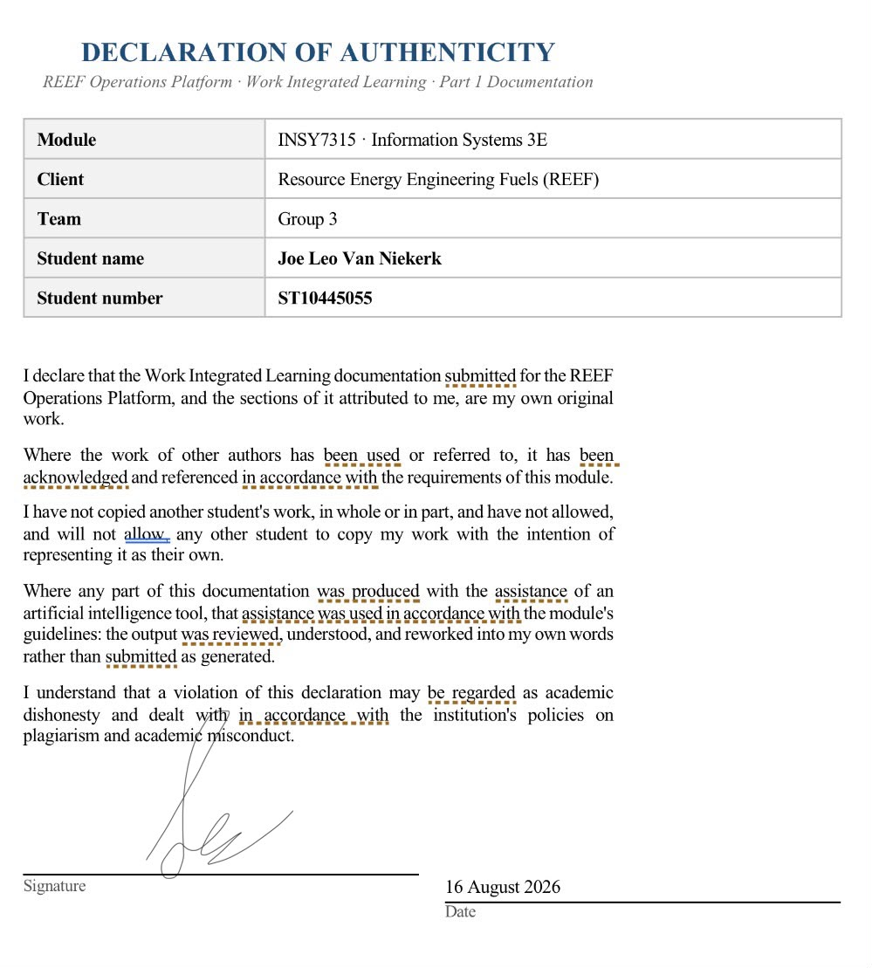




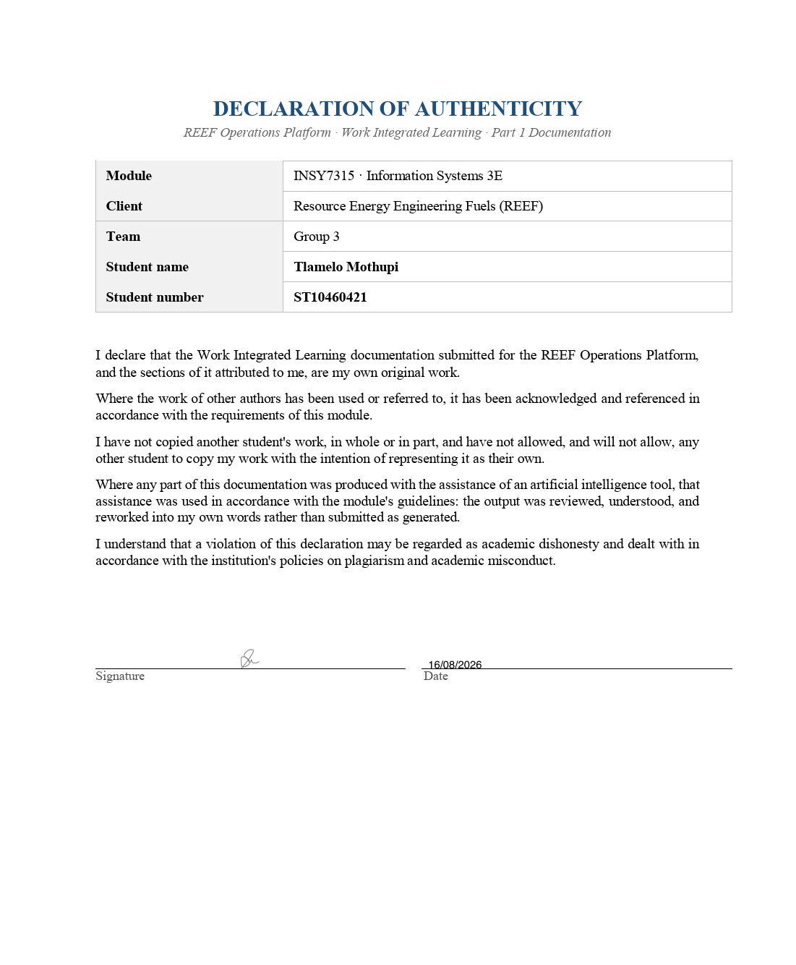



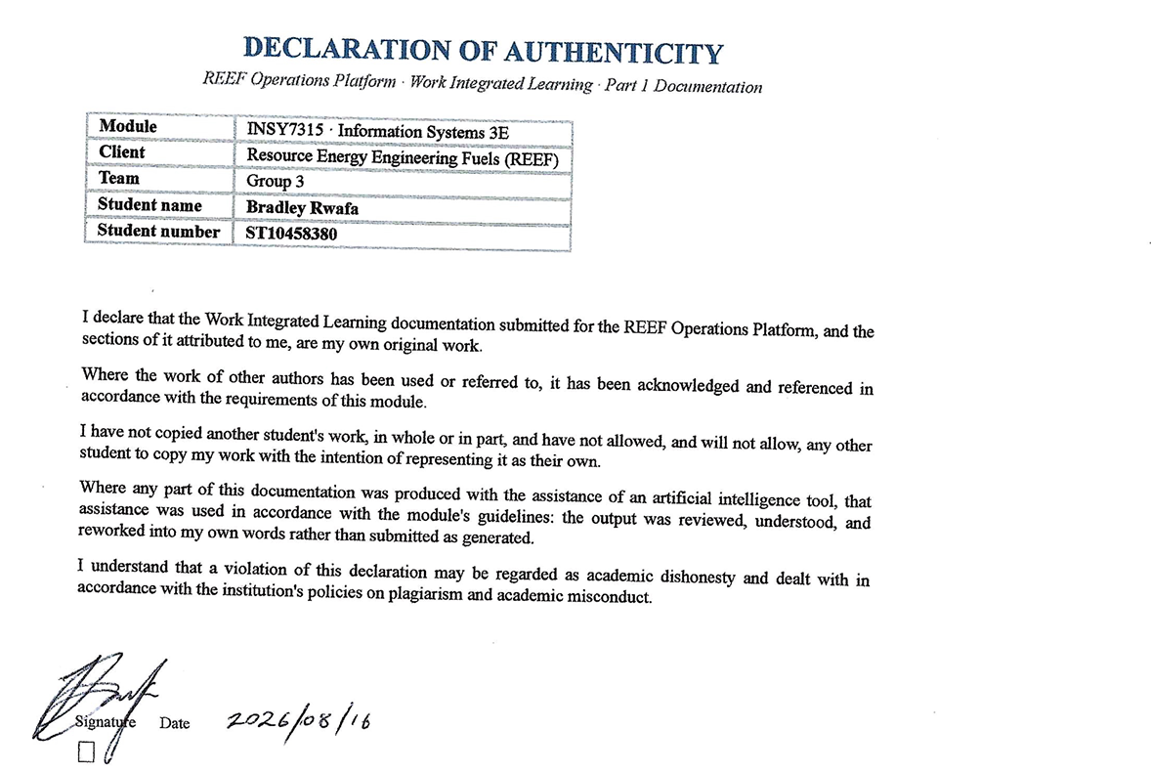

12.2 Prototype
Author: Joe Leo Van Niekerk (ST10445055)

GITHUB LINK : https://github.com/VanNiekerkJoe/reef-development-.git

GITHUB50 LINK : https://github.com/EMGPRS/insy7315-2026-task-1-rwafabradley/

Owner / Finance Screen:

Homepage :

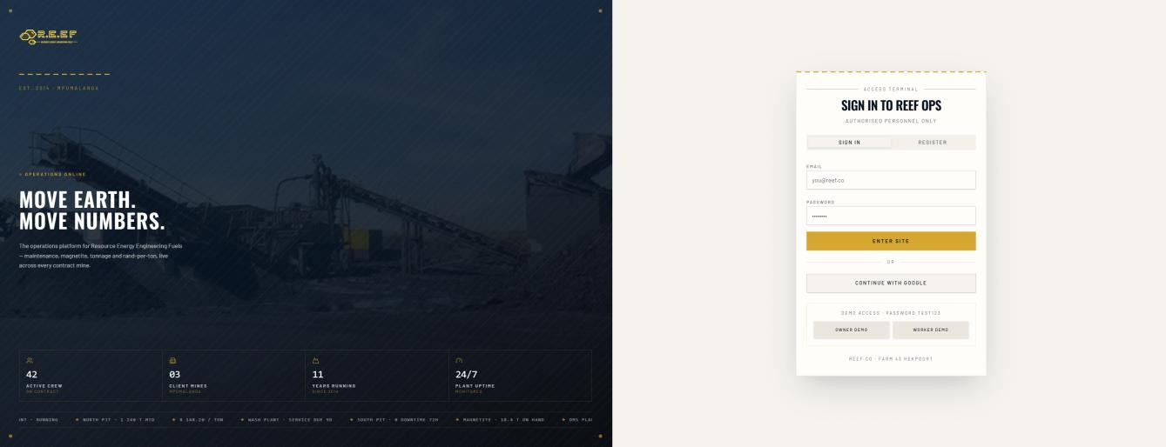

Dashboard :

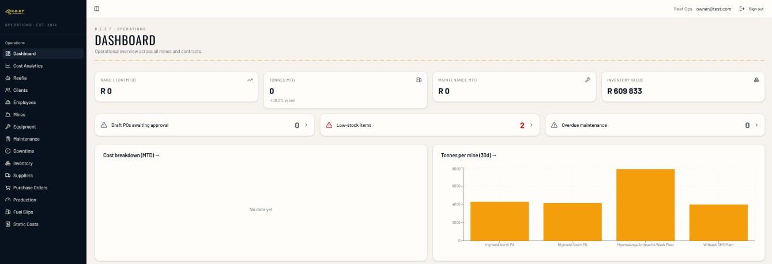

Dashboard :

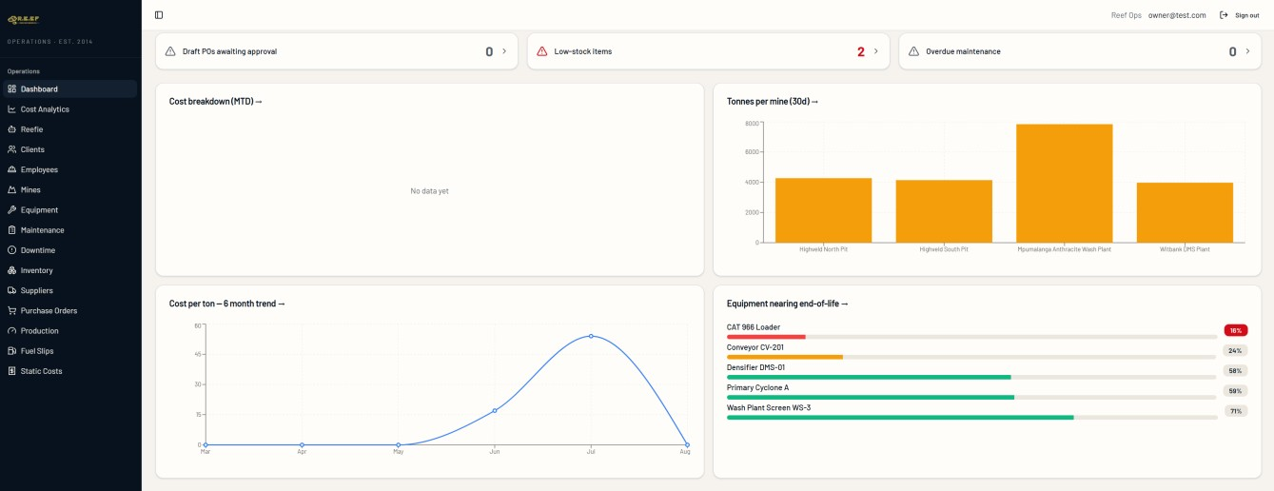

Cost Analytics :
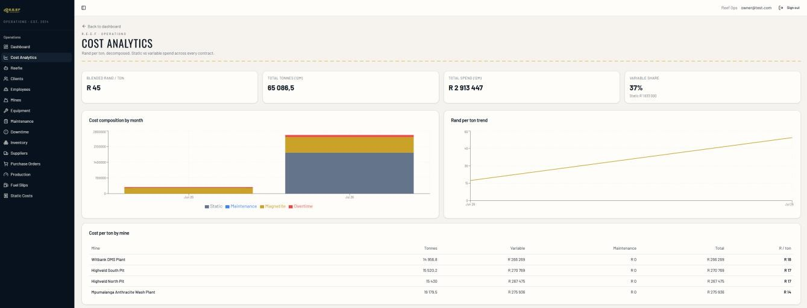

Reefie (AI) :
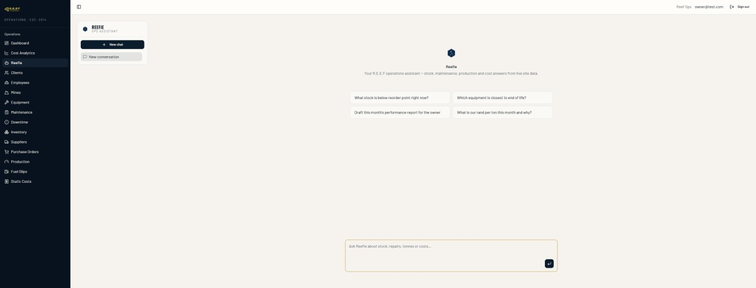

Clients :
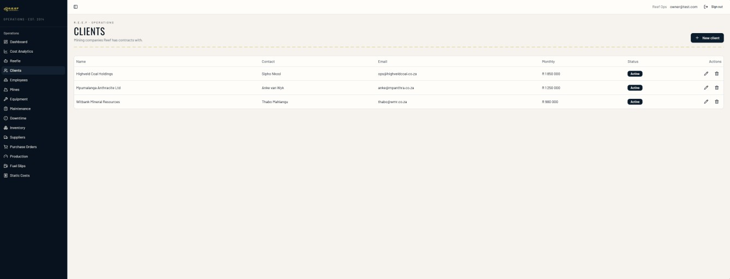

Employees :
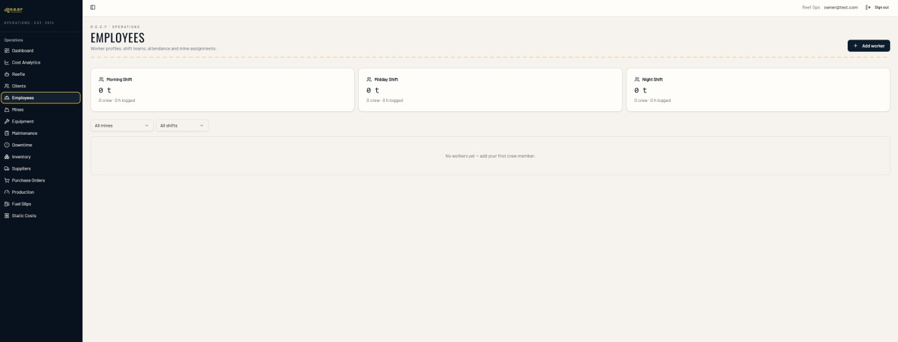

Mines :
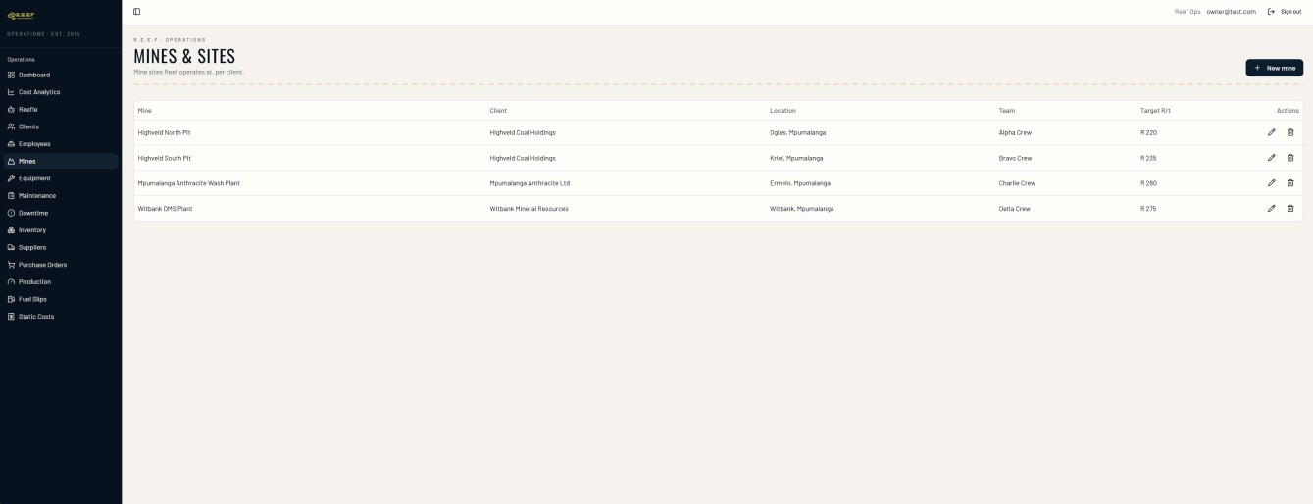

Equipment :

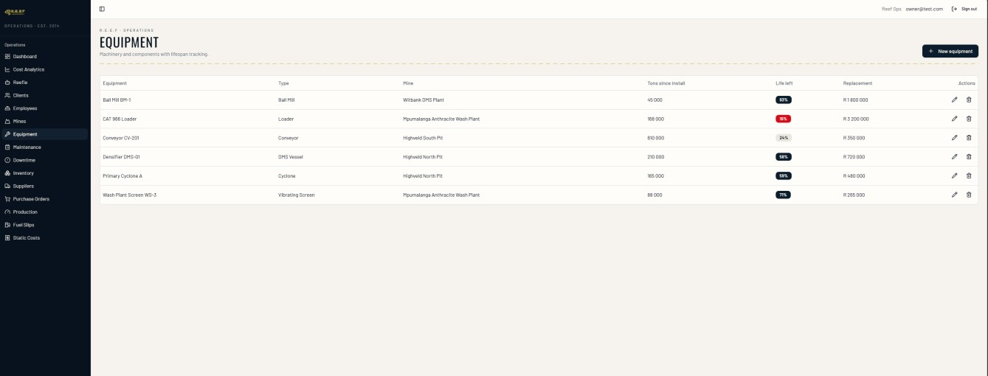

Maintenance :
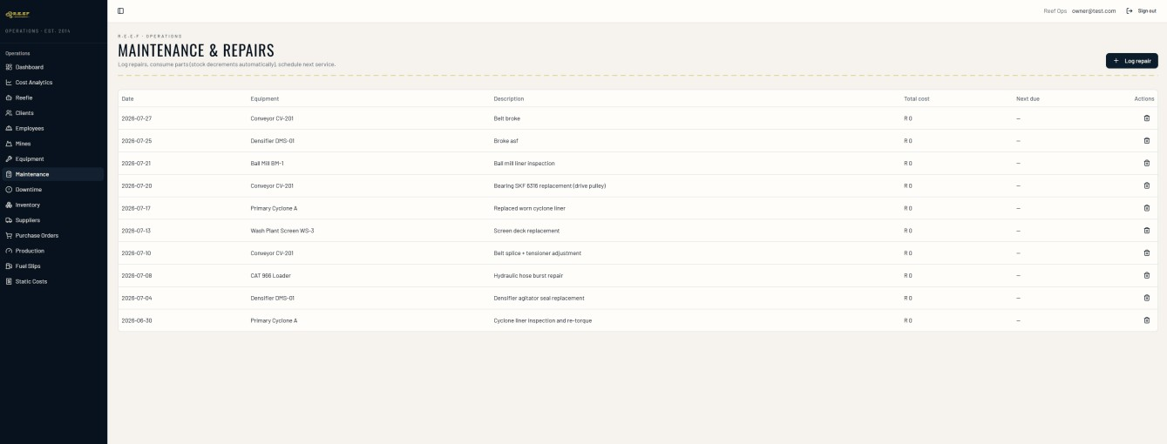

Downtime :
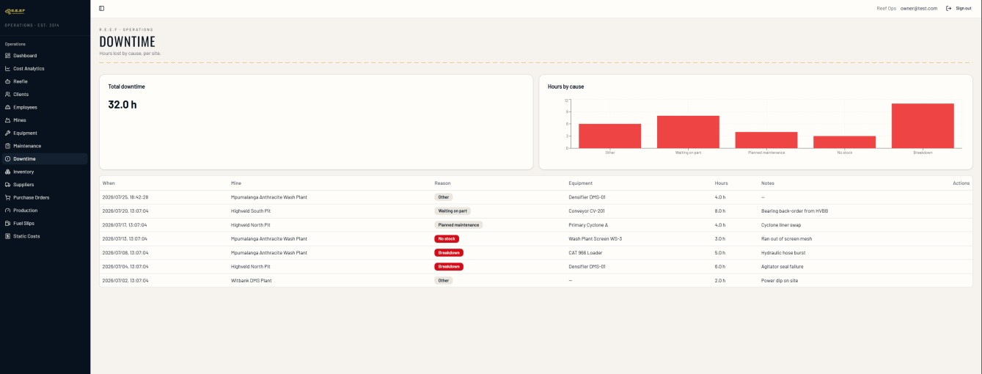

Inventory :

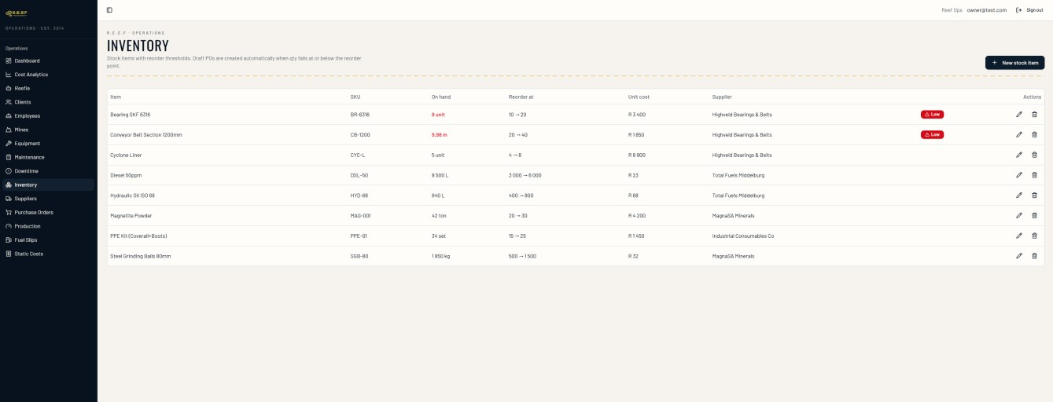

Suppliers :
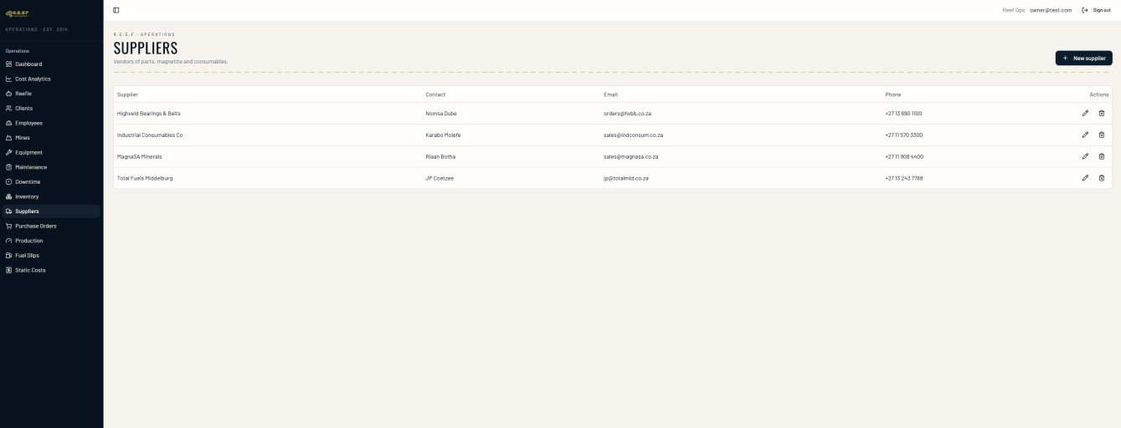
Production :
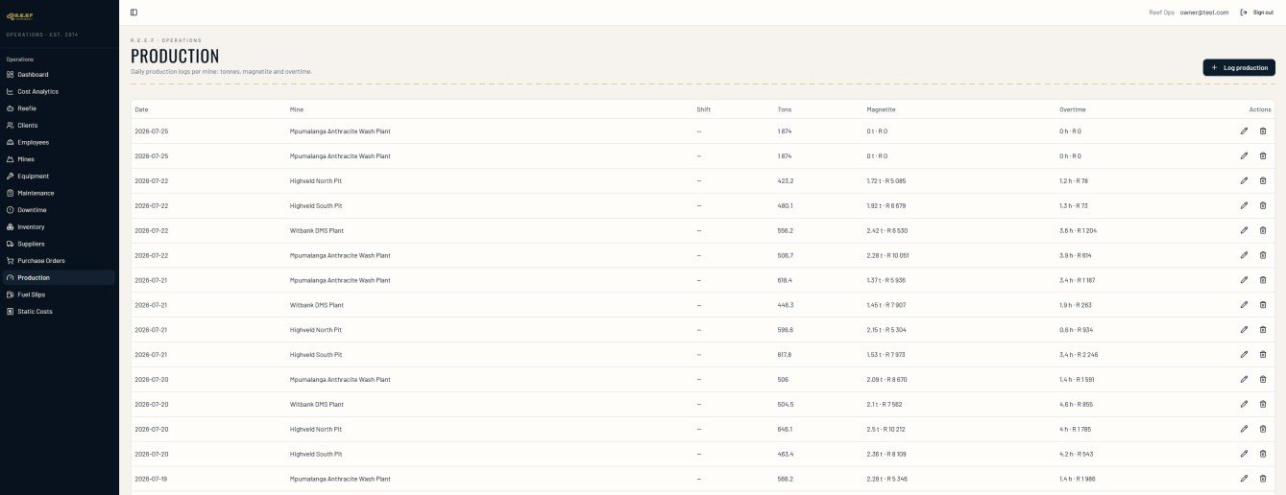

Fuel Slips :

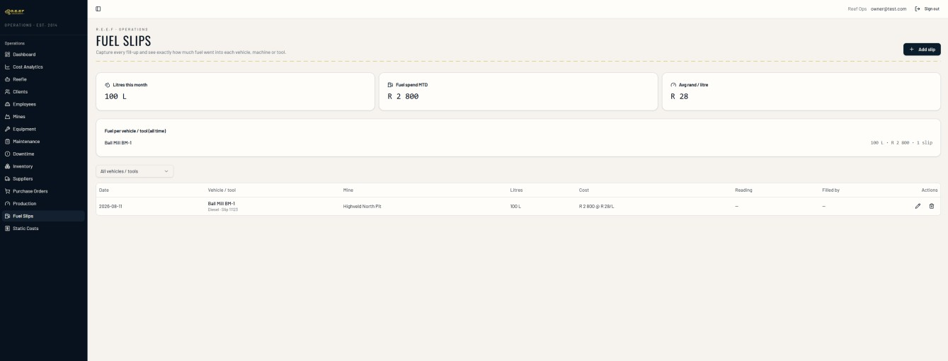

Static Costs :

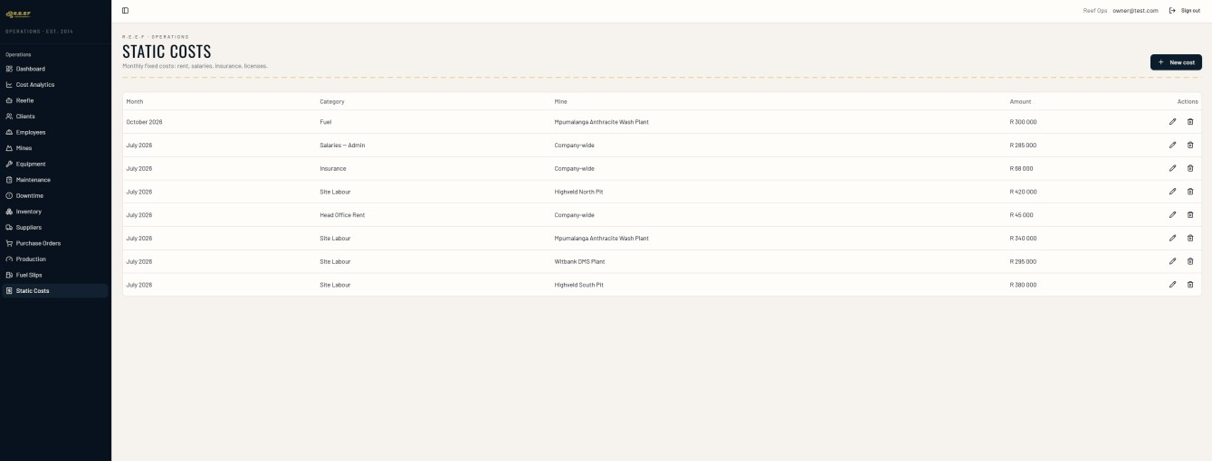

Worker Screen :

Dashboard :


Log usage :


Log repairs :


Log Downtime :


Log Production :

Log Fuel :


References

Ambassador Team (2025). Mocking APIs with Chaos Engineering: Guide to Controlled Failure Tests. [online] Gravitee.io. Available at: https://www.gravitee.io/blog/chaos-engineering-api-failure-simulation [Accessed 29 July 2026].
Anthropic (2026) Claude (Aug 2026 version) [Large language model]. Available at: https://claude.ai (Accessed: 12 August 2026).
Appinio (n.d.). What is Interaction Design? Process, Examples | Appinio Blog. [online] www.appinio.com. Available at: https://www.appinio.com/en/blog/market-research/interaction-design [Accessed 29 July 2026].
Batool, A., Zowghi, D. and Bano, M. (2025). AI governance: A systematic literature review. AI and Ethics, [online] 5. doi:10.1007/s43681-024-00653-w.
Cannonito, F. (2025). What defines Software Quality? Standards, features, and ISO/IEC 25010 | noname.solutions s.n.c. [online] noname.solutions. Available at: https://www.noname-solutions.com/en/software-quality-iso-iec-25010/#affidabilita [Accessed 29 July 2026].
Chen, P.P. (1976). 'The entity-relationship model: toward a unified view of data'. ACM Transactions on Database Systems, 1(1), pp. 9-36.
CISA (2025). Ransomware guide | CISA. [online] www.cisa.gov. Available at: https://www.cisa.gov/stopransomware/ransomware-guide [Accessed 16 Aug. 2026].
Cohn, M. (2004). User Stories Applied: For Agile Software Development. Boston: Addison-Wesley.
Content, A. (2025). 3 Best Mining Apps for Android & iPhone: Cost, Features & Alternatives. [online] AlphaSoftware. Available at: https://www.alphasoftware.com/blog/3-best-mining-apps-for-android-iphone-cost-features-alternatives [Accessed 29 July 2026].
Fielding, R.T. (2000). Architectural Styles and the Design of Network-based Software Architectures. Doctoral dissertation. Irvine: University of California. [Online]. Available at: https://www.ics.uci.edu/~fielding/pubs/dissertation/top.htm [Accessed 3 July 2026].
Fowler, M. (2002). Patterns of Enterprise Application Architecture. Boston: Addison-Wesley.
Gamma, E., Helm, R., Johnson, R. and Vlissides, J. (1994). Design Patterns: Elements of Reusable Object-Oriented Software. Reading, MA: Addison-Wesley.
GeeksforGeeks (2020a). Functional vs. Non Functional Requirements. [online] GeeksforGeeks. Available at: https://www.geeksforgeeks.org/software-engineering/functional-vs-non-functional-requirements/ [Accessed 28 July 2026].
GeeksforGeeks (2020b). Nonfunctional requirements in software engineering. [online] GeeksforGeeks. Available at: https://www.geeksforgeeks.org/software-engineering/non-functional-requirements-in-software-engineering/ [Accessed 28 July 2026].
GeeksforGeeks (2020c). Recovery testing software testing. [online] GeeksforGeeks. Available at: https://www.geeksforgeeks.org/software-testing/recovery-testing-in-software-testing/ [Accessed 16 Aug. 2026].
Goroshkevych, M. (2023). Must have inventory management system requirements and features – inventorsoft. [online] inventorsoft.co. Available at: https://inventorsoft.co/blog/inventory-management-requirements-and-features [Accessed 28 July 2026].
Hodges, J., Jackson, C. & Barth, A. (2012). HTTP Strict Transport Security (HSTS). RFC 6797. Fremont, CA: Internet Engineering Task Force. DOI: 10.17487/RFC6797.
Humble, J. and Farley, D. (2010). Continuous Delivery: Reliable Software Releases through Build, Test, and Deployment Automation. Boston: Addison-Wesley.
IBM (2021). Backup and restore. [online] Ibm.com. Available at: https://www.ibm.com/think/topics/backup-and-restore [Accessed 16 Aug. 2026].
IBM (2025). Interoperability. [online] Ibm.com. Available at: https://www.ibm.com/think/topics/interoperability [Accessed 29 July 2026].
IBM (2025). What is three-tier architecture? [online] IBM Think. Available at: https://www.ibm.com/think/topics/three-tier-architecture [Accessed 4 August 2026].
Information Regulator South Africa (2022). Popia. [online] Empowered to monitor and enforce compliance by public and private bodies. Available at: https://inforegulator.org.za/popia/ [Accessed 28 July 2026].
International Organization for Standardization (ISO) (2008). ISO/IEC 25012:2008 – Data quality model. [online] ISO Standards. Available at: https://www.iso.org/standard/35736.html [Accessed 29 July 2026].
International Organization for Standardization. (2015a). ISO/IEC 27033-1:2015 Information technology — Security techniques — Network security — Part 1: Overview and concepts. Geneva: ISO. [Online]. Available at: https://www.iso.org/standard/63461.html [Accessed 13 July 2026].
International Organization for Standardization. (2015b). ISO/IEC 27017:2015 Information technology — Security techniques — Code of practice for information security controls based on ISO/IEC 27002 for cloud services. Geneva: ISO.
International Organization for Standardization. (2018). ISO/IEC/IEEE 29148:2018 Systems and software engineering — Life cycle processes — Requirements engineering. Geneva: ISO.
International Organization for Standardization. (2020). ISO 21502:2020 Project, programme and portfolio management — Guidance on project management. Geneva: ISO.
International Organization for Standardization. (2022a). ISO/IEC/IEEE 42010:2022 Software, systems and enterprise — Architecture description. Geneva: ISO. [Online]. Available at: https://www.iso.org/standard/74393.html [Accessed 20 July 2026].
International Organization for Standardization. (2022b). ISO/IEC 27002:2022 Information security, cybersecurity and privacy protection — Information security controls. Geneva: ISO.
International Organization for Standardization. (2023). ISO/IEC 25010:2023 Systems and software engineering — Systems and software Quality Requirements and Evaluation (SQuaRE) — Product quality model. Geneva: ISO.
ISO (2011). ISO/IEC 25010:2011. [online] ISO. Available at: https://www.iso.org/standard/35733.html [Accessed 28 July 2026].
ISO (2023a). ISO/IEC 42001:2023. [online] ISO. Available at: https://www.iso.org/standard/42001 [Accessed 14 Aug. 2026].
ISO (2023b). ISO/IEC 25010:2011 (ed-2). [online] Iso.org. Available at: https://www.iso.org/obp/ui/#iso:std:iso-iec:25010:ed-2:v1:en [Accessed 29 July 2026].
ISO (2024). ISO/IEC 25040:2024. [online] ISO. Available at: https://www.iso.org/standard/83467.html [Accessed 14 Aug. 2026].
ISO (2026). ISO 14001. [online] ISO. Available at: https://www.iso.org/standard/14001 [Accessed 2 Aug. 2026].
ISO25000 (n.d.). Performance efficiency. [online] iso25000.com. Available at: https://iso25000.com/index.php/en/iso-25000-standards/iso-25010/59-performance-efficiency [Accessed 29 July 2026].
Jones, C., Wilkes, J., Murphy, N. and Smith, C. (2017). Service level objectives. [online] Sre.google. Available at: https://sre.google/sre-book/service-level-objectives/ [Accessed 14 Aug. 2026].
Jones, M., Bradley, J. & Sakimura, N. (2015). JSON Web Token (JWT). RFC 7519. Fremont, CA: Internet Engineering Task Force. DOI: 10.17487/RFC7519.
Kausar Alimia (2025). The top 10 ISO standards in South Africa | WWISE. [online] WWISE. Available at: https://wwise.co.za/uncategorized/the-top-10-iso-standards-in-south-africa/ [Accessed 29 July 2026].
Lenovo (2021). The Importance of Compatibility in Technology | Lenovo UK. [online] Lenovo.com. Available at: https://www.lenovo.com/gb/en/glossary/compatibility/ [Accessed 29 July 2026].
ManageEngine (2026). How to achieve 99.99% uptime with availability monitoring: A practical checklist. [online] ManageEngine. Available at: https://www.manageengine.com/network-monitoring/tech-topics/how-to-achieve-99percent-uptime-checklist.html [Accessed 13 Aug. 2026].
McKay, K.A. & Cooper, D.A. (2019). Guidelines for the Selection, Configuration, and Use of Transport Layer Security (TLS) Implementations. NIST Special Publication 800-52 Revision 2. Gaithersburg, MD: National Institute of Standards and Technology. DOI: 10.6028/NIST.SP.800-52r2.
Mell, P. & Grance, T. (2011). The NIST Definition of Cloud Computing. NIST Special Publication 800-145. Gaithersburg, MD: National Institute of Standards and Technology. DOI: 10.6028/NIST.SP.800-145.
Microsoft (2024). Architecture strategies for defining reliability targets - Microsoft Azure Well-Architected Framework. [online] Microsoft Learn. Available at: https://learn.microsoft.com/en-us/azure/well-architected/reliability/metrics [Accessed 14 Aug. 2026].
Microsoft (2025a). Web API design best practices. [online] Microsoft Learn - Azure Architecture Center. Available at: https://learn.microsoft.com/en-us/azure/architecture/best-practices/api-design [Accessed 4 August 2026].
Microsoft (2025b). Role-based authorization in ASP.NET Core. [online] Microsoft Learn. Available at: https://learn.microsoft.com/en-us/aspnet/core/security/authorization/roles [Accessed 4 August 2026].
Microsoft (2026). Dependency injection in ASP.NET Core. [online] Microsoft Learn. Available at: https://learn.microsoft.com/en-us/aspnet/core/fundamentals/dependency-injection [Accessed 4 August 2026].
Mucci, T. and Stryker, C. (2024). AI governance. [online] Ibm.com. Available at: https://www.ibm.com/think/topics/ai-governance [Accessed 14 Aug. 2026].
Murtaza, M.A. (2025). Understanding Push vs Pull API Architectures: A Comprehensive Comparison. [online] LinkedIn. Available at: https://www.linkedin.com/pulse/understanding-push-vs-pull-api-architectures-muhammad-ali-murtaza-srhkf/ [Accessed 17 Aug. 2026].
NIST (2023a). AI risk management framework | NIST. [online] NIST. Available at: https://www.nist.gov/itl/ai-risk-management-framework [Accessed 14 Aug. 2026].
NIST (2023b). [online] Nist.gov. Available at: https://csrc.nist.gov/files/pubs/shared/itlb/itlbul1997-03.txt [Accessed 14 Aug. 2026].
NIST (2024). Least privilege - Glossary | CSRC. [online] csrc.nist.gov. Available at: https://csrc.nist.gov/glossary/term/least_privilege [Accessed 16 Aug. 2026].
Object Management Group (2017). OMG Unified Modeling Language (OMG UML), version 2.5.1. [online] Available at: https://www.omg.org/spec/UML/2.5.1/About-UML [Accessed 12 August 2026].
OpenAI (2026) ChatGPT (Aug 2026 version) [Large language model]. Available at: https://chatgpt.com (Accessed: 12 August 2026).
OWASP (2021). Password storage - OWASP Cheat Sheet Series. [online] cheatsheetseries.owasp.org. Available at: https://cheatsheetseries.owasp.org/cheatsheets/Password_Storage_Cheat_Sheet.html [Accessed 29 July 2026].
OWASP (2021). OWASP Top 10:2021. [Online]. Available at: https://owasp.org/Top10/ [Accessed 11 August 2026].
OWASP (2024). Logging - OWASP Cheat Sheet Series. [online] cheatsheetseries.owasp.org. Available at: https://cheatsheetseries.owasp.org/cheatsheets/Logging_Cheat_Sheet.html [Accessed 29 July 2026].
OWASP (2025). Authorization - OWASP Cheat Sheet Series. [online] cheatsheetseries.owasp.org. Available at: https://cheatsheetseries.owasp.org/cheatsheets/Authorization_Cheat_Sheet.html [Accessed 29 July 2026].
PageWriter-MSFT (2023). Microsoft Azure Well-Architected Framework. [online] learn.microsoft.com. Available at: https://learn.microsoft.com/en-us/azure/well-architected/pillars [Accessed 29 July 2026].
Pinghome (2022). Pinghome | Leading monitoring & incident management stack. What is Uptime Monitoring? [online] Available at: https://www.pinghome.io/guides/what-is-uptime-monitoring/ [Accessed 29 July 2026].
PostgreSQL Global Development Group (2026). PostgreSQL documentation: Row security policies. [online] Available at: https://www.postgresql.org/docs/current/ddl-rowsecurity.html [Accessed 12 August 2026].
Project Management Institute. (2019). Practice Standard for Work Breakdown Structures. 3rd ed. Newtown Square, PA: Project Management Institute.
Republic of South Africa. (2013). Protection of Personal Information Act, No. 4 of 2013. Pretoria: Government Printer. [Online]. Available at: https://www.gov.za/documents/protection-personal-information-act [Accessed 10 August 2026].
Rescorla, E. (2018). The Transport Layer Security (TLS) Protocol Version 1.3. RFC 8446. Fremont, CA: Internet Engineering Task Force. DOI: 10.17487/RFC8446.
Richards, M. & Ford, N. (2020). Fundamentals of Software Architecture: An Engineering Approach. Sebastopol, CA: O'Reilly Media.
Rose, S., Borchert, O., Mitchell, S. & Connelly, S. (2020). Zero Trust Architecture. NIST Special Publication 800-207. Gaithersburg, MD: National Institute of Standards and Technology. DOI: 10.6028/NIST.SP.800-207.
Saxena PMP, S. (2024). How to calculate availability of a system. [online] LinkedIn. Available at: https://www.linkedin.com/pulse/how-calculate-availability-system-saral-saxena--h7fmc [Accessed 14 Aug. 2026].
Scarfone, K. & Hoffman, P. (2009). Guidelines on Firewalls and Firewall Policy. NIST Special Publication 800-41 Revision 1. Gaithersburg, MD: National Institute of Standards and Technology. DOI: 10.6028/NIST.SP.800-41r1.
siit (2026). Access revocation. [online] Siit.io. Available at: https://www.siit.io/glossary/access-revocation [Accessed 14 Aug. 2026].
SIOS Technology (2025). 99.99% Uptime guide | SIOS. [online] SIOS Technology Corp. Available at: https://us.sios.com/blog/99-99-uptime-guide/ [Accessed 13 Aug. 2026].
SolarWinds (2026). What are application logs? - IT glossary | SolarWinds. [online] Solarwinds.com. Available at: https://www.solarwinds.com/resources/it-glossary/application-logs [Accessed 14 Aug. 2026].
South African Government (1996). Mine Health and Safety Act 29 of 1996. [online] www.gov.za. Available at: https://www.gov.za/documents/mine-health-and-safety-act [Accessed 29 July 2026].
Sun, Y., Sheng, D., Zhou, Z. and Wu, Y. (2024). AI hallucination: Towards a comprehensive classification of distorted information in artificial intelligence-generated content. Humanities and Social Sciences Communications, [online] 11(1). doi:10.1057/s41599-024-03811-x.
Supabase (2026). Supabase documentation. [online] Available at: https://supabase.com/docs [Accessed 12 August 2026].
Swanson, M., Bowen, P., Phillips, A., Gallup, D. and Lynes, D. (2010). Contingency planning guide for federal information systems. [online] csrc.nist.gov. Available at: https://csrc.nist.gov/pubs/sp/800/34/r1/upd1/final [Accessed 29 July 2026].
VerifyWise Team (2014). ISO/IEC 25000 - Software quality requirements and evaluation. [online] Verifywise.ai. Available at: https://verifywise.ai/ai-governance-library/assessment-and-evaluation/iso-iec-25000-software-quality [Accessed 14 Aug. 2026].
W3C (2024). Web Content Accessibility Guidelines (WCAG) 2.2. [online] www.w3.org. W3C. Available at: https://www.w3.org/TR/WCAG22/ [Accessed 29 July 2026].
Wiggins, A. (2017). The Twelve-Factor App: Config. [online] Available at: https://12factor.net/config [Accessed 12 August 2026].

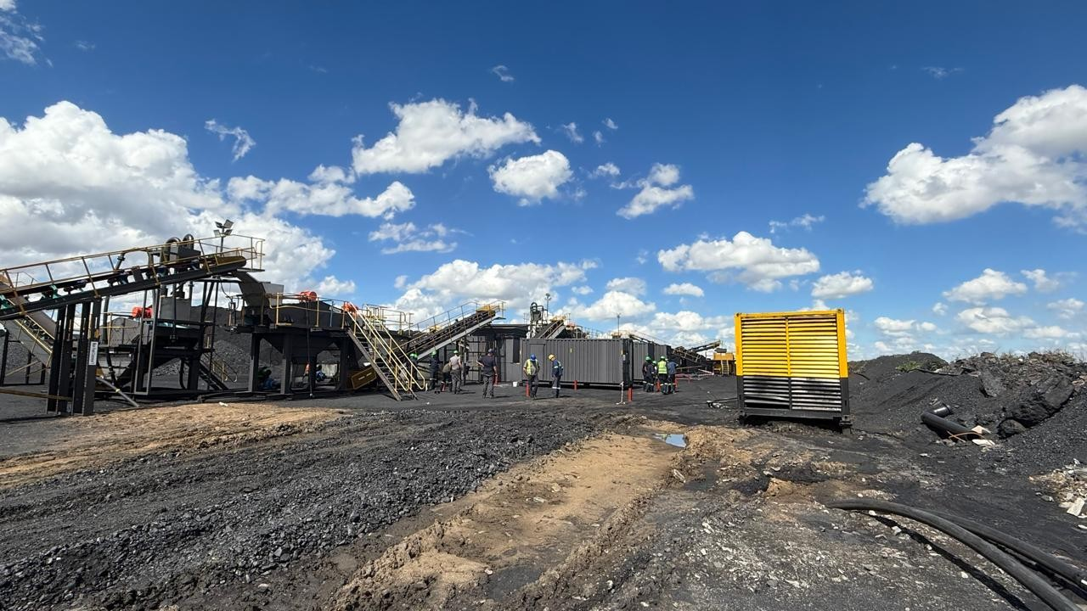
v

GitHub (2026). Understanding GitHub Actions. [online] GitHub Docs. Available at: https://docs.github.com/en/actions/learn-github-actions/understanding-github-actions [Accessed 17 August 2026].
Grassi, P.A., Fenton, J.L., Newton, E.M., Perlner, R.A., Regenscheid, A.R., Burr, W.E. and Richer, J.P. (2017). Digital Identity Guidelines: Authentication and Lifecycle Management. NIST Special Publication 800-63B. Gaithersburg, MD: National Institute of Standards and Technology. DOI: 10.6028/NIST.SP.800-63b.
Joint Task Force Transformation Initiative (2012). Guide for Conducting Risk Assessments. NIST Special Publication 800-30 Revision 1. Gaithersburg, MD: National Institute of Standards and Technology. DOI: 10.6028/NIST.SP.800-30r1.
OWASP (2021b). A03:2021 – Injection. OWASP Top 10:2021. [online] Available at: https://owasp.org/Top10/A03_2021-Injection/ [Accessed 17 August 2026].
OWASP (2025b). Cross-Site Request Forgery Prevention Cheat Sheet. OWASP Cheat Sheet Series. [online] Available at: https://cheatsheetseries.owasp.org/cheatsheets/Cross-Site_Request_Forgery_Prevention_Cheat_Sheet.html [Accessed 17 August 2026].
Saltzer, J.H. and Schroeder, M.D. (1975). 'The protection of information in computer systems'. Proceedings of the IEEE, 63(9), pp. 1278–1308. DOI: 10.1109/PROC.1975.9939.
Vitest (2026). Getting Started. [online] Available at: https://vitest.dev/guide/ [Accessed 17 August 2026].

